2022 SAN ANTONIO CLASSICAL SOCIETY

TSJCL AREA B ACADEMIC OLYMPICS

ANCIENT GEOGRAPHY AND MONUMENTS

Questions 1 – 12: quid appellatur nunc? Choose the modern equivalent for the ancient place or aquatic feature.

1. The city of Gades is now known as

a. Giza b. Cadiz c. Caen d. Coventry

2. The city of Camulodunum is now known as

a. Marseilles b. Campobasso c. Colchester d. Oxford

3. The Roman city of Lutetia is now known as

a. Paris b. London c. Madrid d. Antioch

4. The Roman city of Mediolanum is now known as

a. Monaco b. Milan c. Hamburg d. Barcelona

5. The Roman city of Singidunum is now known as

a. Sarajevo b. Seville c. Belgrade d. Budapest

6. The Roman city of Londinium is now known as

a. Brindisi b. Naples c. Lyon d. London

7. Known to the Romans as *mare internum* or simply *mare nostrum*, we call this body of water

a. Mediterranean b. the Nile c. the Black Sea d. The English Channel

8. The sea that the Romans called Pontus Euxinus is now called

a. the Dead Sea b. The Adriatic Sea c. the Black Sea d. The Red Sea

9. *flumen Padus* is now known by the name

a. Rubicon b. Seine c. Loire d. Po

10. The river called *Liger* by the Romans is now called

a. Danube b. Loire c. Thames d. Garonne

11. The province of Hibernia is now called

a. Ireland b. Scotland c. Turkey d. Tunisia

12. The province of Lycia is in modern-day

a. Egypt b. Hungary c. Turkey d. Azerbaijan

13. The sea known as Propontis is now known as

a. Aegean Sea b. sea of Marmara c. Black Sea d. Dead Sea

14. The province known as Lusitania is now called

a. Portugal b. Uzbekistan c. Tunisia d. Denmark

Questions 15 – 30: ubinam gentium est? Where in the world is this?

15. Mons Graupius

a. Hibernia b. Britannia c. Caledonia d. Gallia

16. mons Aetna

a. Sicilia b. Sardinia c. Corsica d. Italia

17. Sarmizegethusa

a. Pannonia b. Cilicia c. Arabia d. Dacia

18. Pergamum

a. Graecia b. Asia c. Aegyptus d. Mauretania

19. Massilia

a. Gallia b. Italia c. Corsica d. Graecia

20. *flumen Hebrus*

a. Dalmatia b. Iudaea c. Thracia d. Creta

21. *flumen Tiberis*

a. Gallia b. Helvetia c. Germania d. Italia

22. *flumen Nilus*

a. Aegyptus b. Sicilia c. Hispania d. Asia

23. ad septentriones – which is farthest north?

a. flumen Tagus b. flumen Danuvius c. flumen Nilus d. flumen Tigris

24. ad septentriones – which is farthest north?

a. Tarraco b. Vesontio c. Ostia d. Buthrotum

25. ad solem orientem – which is farthest east?

a. Olisipo b. Athenae c. Brundisium d. Ctesiphon

26. ad solem orientem – which is farthest east?

a. Mauretania b. Pannonia c. Noricum d. Lycia

27. ad solem occasum – which is farthest west?

a. Corsica b. Creta c. Sicilia d. Rhodus

28. ad solem occasum – which is farthest west?

a. mons Olympus b. montes Pyrraneis c. montes Alpes d. montes Apennines

29. ad austrina – which is most southern?

a. Moesia b. Raetia c. Cappadocia d. Cyrenaica

30. ad austrina - Which is most southern?

a. Tomis b. Turris c. Leptis Magna d. Mediolanum

Questions 31 – 34: Journey with Aulus Gabinus Barbatus the *raedarius* - he will take you anywhere in the *Imperium Romanum*! All he needs to know is *qua via iter facimus*? What road are we taking?

31. *Roma 🡪 Brundisium*

a. via Flaminia b. via Appia c. via Aurelia d. via Aemilia

32. *Roma 🡪 Ariminum*

a. via Flaminia b. via Salaria c. via Aurelia d. via Popilia

33. *Narbo* 🡪 *Tolosa*

a. via Aemilia b. via Flaminia c. via Aquitania d. via Claudia

34. *Roma* 🡪 *Pisa*

a. via Aemilia b. via Appia c. via Aurelia d. via Adriatica

Questions 35 - 38: Let’s visit the Acropolis! Use the map of the Acropolis below to identify the following buildings

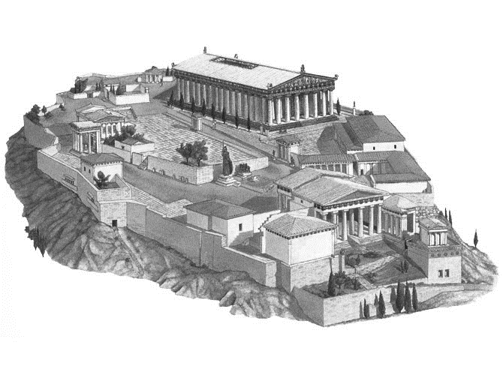

35. First, let’s visit the giant chryselephantine statue of Athena in the temple of Athena Parthenos, better known as the Parthenon.

a. building 1 b. building 2 c. building 3 d. building 4

36. While we’re at it, lets pray for victory at the temple of Athena Nike.

a. building 6 b. building 5 c. building 4 d. building 3

37. Oops! How did we get in here without going through the Propylaia?

a. building 6 b. building 5 c. building 1 d. building 4

38. I’ve always wanted to see the salt-sea spring of Poseidon and the olive tree of Athena, both of which are housed in the Erechtheum. Let’s end our trip there.

a. building 1 b. building 6 c. building 2 d. building 5

Questions 39 - 43: nunc eamus Romam! Let’s go to Rome!

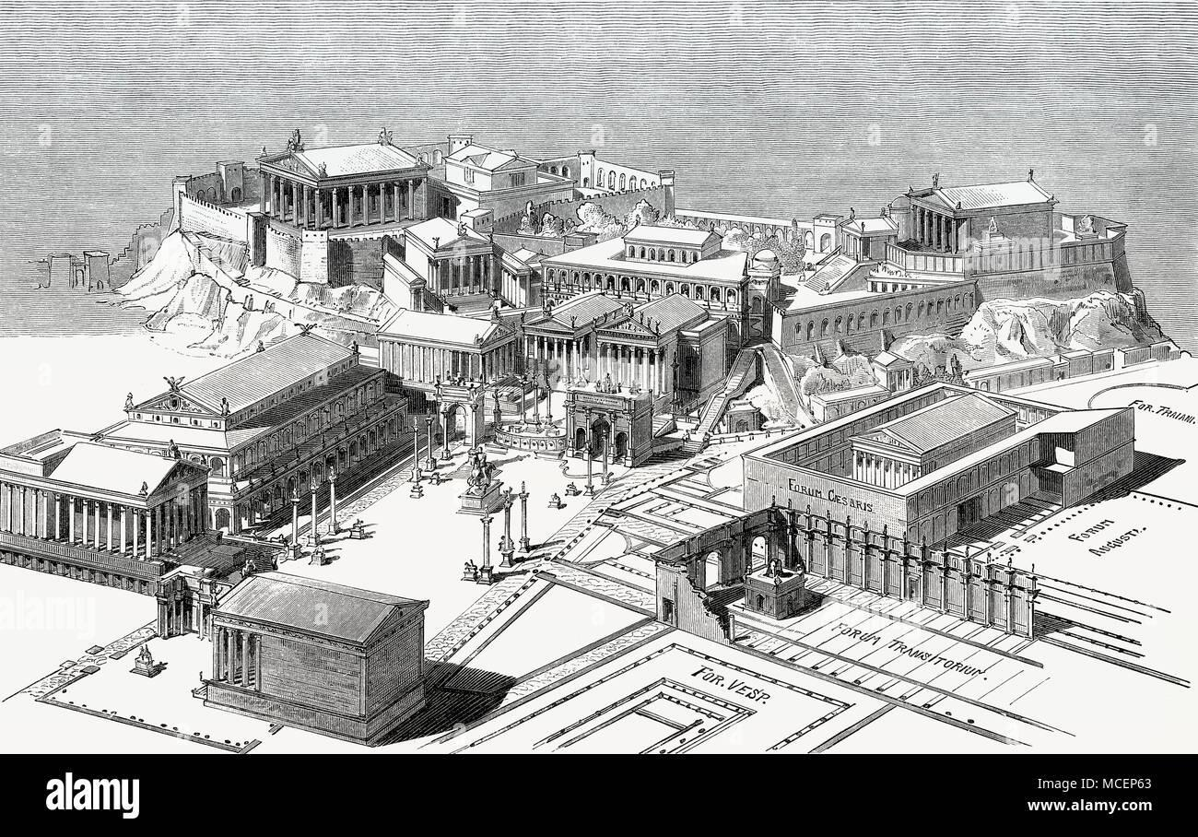

39. Let’s start out in the place where the sacred geese honked and saved the city of Rome from the Gauls early in Rome’s history: the temple of Juno Moneta.

a. #2 b. #4 c. #6 d. #8

40. Now where is the treasury of Rome? Oh, that’s right – the temple of Saturn.

a. #1 b. #3 c. #5 d. #7

41. This temple was built to commemorate the accord between the two social classes of Rome, the patricians and plebeians – the temple of Concord.

a. #7 b. #6 c. #5 d. #4

42. My cousin took the land my uncle left me in his will, so I have to visit the court of the *centumviri*, housed in the basilica Julia.

a. #1 b. #2 c. #3 d. #4

43. The best for last! We can’t leave the forum without seeing this temple: Jupiter Optimus Maximus.

a. #1 b. #5 c. #4 d. #2

Questions 44 – 48: ludi et spectacula! It’s time for entertainment.

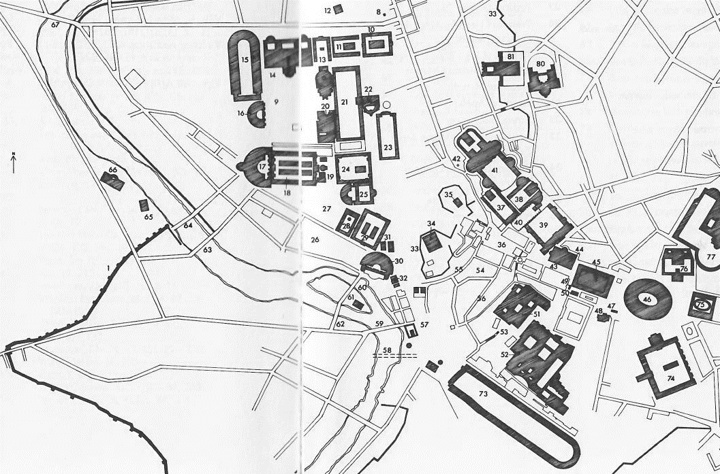

44. Of course we have to start with the most popular sport in Ancient Rome: chariot racing. Let’s go to the Circus Maximus.

a. 46 b. 74 c. 15 d. 73

45. Next, gladiators! This arena, improperly called the Colosseum, is actually the Flavian amphitheater.

a. 46 b. 77 c. 73 d. 30

46. We wander back through the forum and the vicus Iugarius and end up in #32. We are staring out at the beautiful Tibur river in front of us. What hill of Rome is behind us? (on which 34 & 35 are placed)?

a. Capitoline b. Palatine c. Aventine d. Caelian

47. There are huge crowds milling around here in #32 – it’s the forum holitorium! Everyone has baskets filled with their purchases. What have they bought here?

a. meat b. books c. vegetables d. wine

48. Time for one last show – what entertainment venue is immediately to our right on #30?

a. theater of Pompey b. theater of Marcellus c. circus Flaminius d. naumachia

Questions 49 – 54: Imperium Romanum: find the provinces

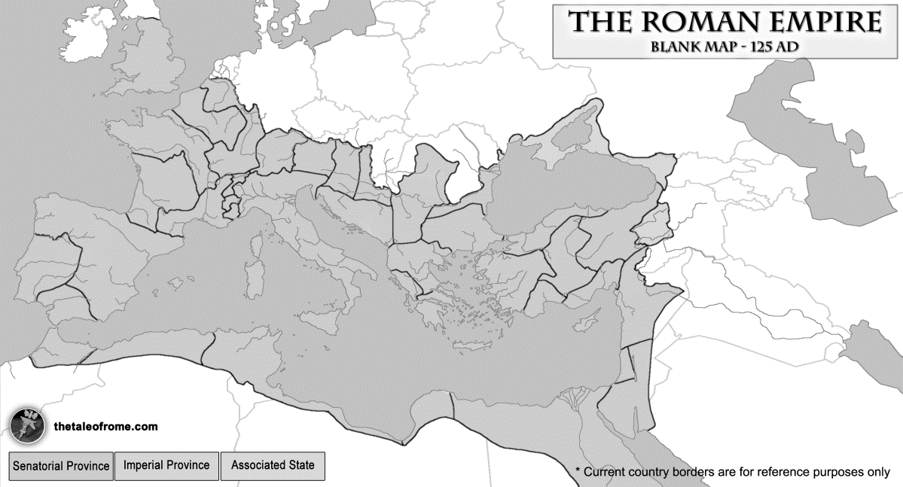

49. Dacia a. 6 b. 8 c. 9 d. 11

50. Thracia a. 2 b. 12 c. 10 d. 11

51. Narbonensis a. 4 b. 3 c. 1 d. 7

52. Britannia a. 2 b. 3 c. 4 d. 5

53. Tarraconensis a. 1 b. 2 c. 3 d. 13

54. Rhaetia a. 6 b. 7 c. 8 d. 9

monumenta! Let’s admire the amazing buildings of the ancient world!

55. Where was this building located?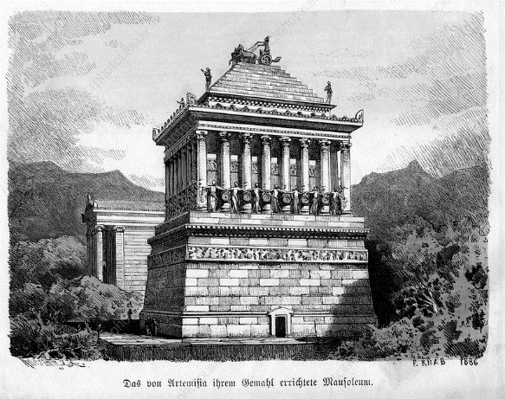

a. Rome b. Athens c. Halicarnassus

d. Tyre

56. What was its purpose?

a. a temple for worship b. a mausoleum of the dead c. a records hall d. a palace

57. Where was this building located?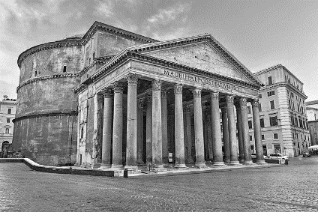

a. Rome b. Massilia c. Alexandria

d. Corinth

58. What was its purpose?

a. temple for worship b. mausoleum of the dead

c. treasury d. water cistern

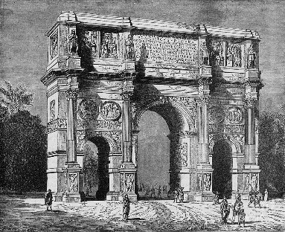

59. This is the arch of

a. Augustus b. Constantine c. Titus d. Septimius Severus

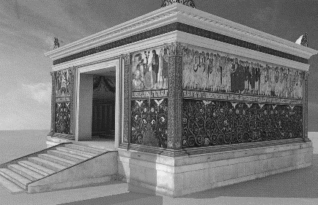

60. Which emperor commissioned this monument?

a. Augustus b. Domitian c. Hadrian d. Trajan

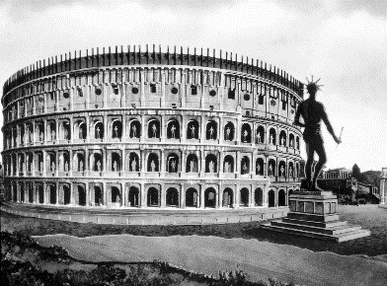

61. Who began construction of this building?

a. Augustus b. Caesar C. Nero d. Vespasian

62. Where is this building located?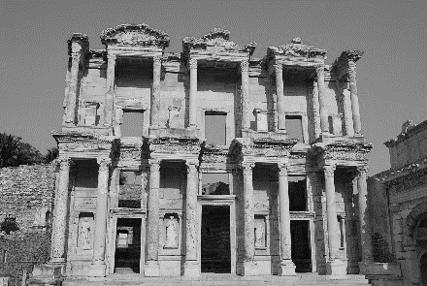

a. Leptis Magna b. Alexandria c. Athens d. Ephesus

63. What was its purpose?

a. temple for worship b. theater c. library d. shops

64. Where was this building located?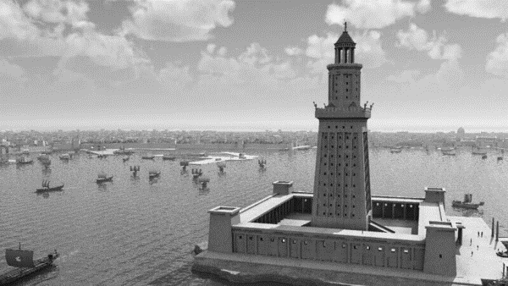

a. Athens b. Alexandria c. Brundisium d. Agrigentum

65. What was its purpose?

a. lighthouse b. prison c. palace d. mausoleum

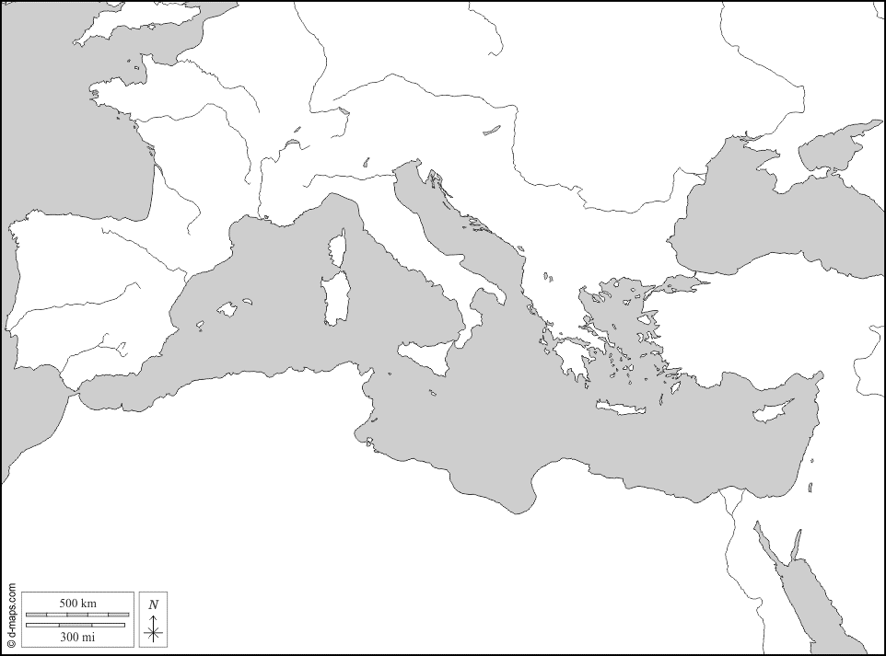

66. On which of these islands was the ancient city of Mytilene located?

a. 1 b. 3 c. 5 d. 7

67. Which of these islands is closest to the Ligurian sea?

a. 1 b. 2 c. 3 d. 6

68. On which of these islands was Mt. Etna located?

a. 3 b. 4 c. 5 d. 6

69. On which of these islands was the Colossus, a giant statue built to honor Helios and one of the seven wonders of the ancient world, located?

a. 2 b. 4 c. 6 d. 8

70. On which island was the city Knossos located?

a. 3 b. 4 c. 5 d. 6

TIE BREAKERS: Please mark the following answers 96 – 100 on your scantron. They will only be counted in the event of a tie.

96. In ancient times, this country was called Helvetia:

a. Sweden b. Austria c. Switzerland d. Ireland

97. What was associated with the Gemonian stairs in the city of Rome?

a. executions b. religious worship c. shopping d. musical performance

98. The Halys river bordered on which ancient province?

a. Cappadocia b. Aegyptus c. Dacia d. Pannonia

99. The Aedui tribe lived in what province?

a. Hispania b. Graecia c. Gallia d. Thracia

100. The most famous temple of Artemis, and one of the wonders of the ancient world, was located in what city?

a. Rome b. Athens c. Ephesus d. Babylon