2019 SAN ANTONIO CLASSICAL SOCIETY

TSJCL AREA B ACADEMIC OLYMPICS

**GEOGRAPHY OF THE ANCIENT WORLD TEST**

**DIRECTIONS**: Please mark the letter of the correct answer on your scantron answer sheet.

For questions 1-10, find the corresponding number in Map 1 and identify the location.

1. a. Basilica Aemilia b. Basilica Iulia c. Basilica of Maxentius d. Bibliotheca Ulpia

2. a. Temple of Divine Caesar b. Temple of Capitoline Augustus

c. Temple of Castor and Pollux d. Temple of Mars Ultor

3. a. House of the Vestals b. Curia c. Temple of Saturn d. Baths of Trajan

4. a. Basilica Iulia b. Basilica Aemilia c. Basilica of Maxentius d. Basilica Ulpia

5. a. Basilica Iulia b. Basilica Aemilia c. Basilica of Maxentius d. Basilica Ulpia

6. a. Temple of Deified Caesar b. Temple of Antoninus and Faustina

c. Temple of Castor and Pollux d. Tabularium

7. a. Basilica Iulia b. Basilica Aemilia c. Basilica Ulpia d. Basilica of Maxentius

8. a. Temple of Saturn b. Temple of Vesta c. Temple of Mars Ultor d. Temple of Concordia

9. a. Temple of Saturn b. Temple of Vesta c. Temple of Mars Ultor d. Temple of Concordia

10. a. Arch of Titus b. Arch of Septimius Severus

c. Arch of Constantine d. Arch of Augustus

Answer the following questions about ancient rivers.

11. The emperor Julian attacked the Persian capital of Ctesiphon after being joined by his troops traveling down what nearby river?

a. Jordan b. Euphrates c. Tigris d. Oxus

12. The ancient Roman city Augusta Taurinorum (modern Turin) can be found on which Italian river?

a. Po b. Tiber c. Plavis d. Arnus

13. The ancient Roman city of Ostia was built at the mouth of what Italian river?

a. Po b. Tiber c. Plavis d. Arnus

14. The river Ilisos ran just outside the walls of this ancient Greek city.

a. Sparta b. Thebes c. Corinth d. Athens

Please indicate into which sea each of the following rivers empties.

a. Mare Adriaticum b. Mare Ionium c. Mare Tyrrhenum d. Mare Aegaeum

15. Padus 16. Tiberis 17. Rubico 18. Haliakmon

19. Ebrus 20. Achelous 21. Plavis 22. Arnus

23. Bradanus 24. Axios 25.Truentus 26. Umbro

Questions 27-35 refer to Map 2.

27. What island was included in the jurisdiction for the Roman province at 27?

a. Sardinia b. Sicilia c. Rodi d. Creta

28. What did the Romans call the island at 28?

a. Iberia b. Hibernia c. Britannia d. Caledonia

29. The island at 29 is

a. Corsica b. Sardinia c. Creta d. Sicilia

30. The sea at 30 was called what in the ancient world?

a. Mare Internum b. Mare Caspium c. Pontus Euxinus d. Mare Nigrum

31. The geographical feature at 31 used to be called the

a. Hellespont b. Bosporus c. Pillars of Herakles d. Salamis

32. Which of the following would be found at the city located at 32?

a. Mausoleum of Mausolus b. Temple of Zeus at Olympia

c. Pnyx d. Temple of Apollo at Delphi

33. Magna Graecia most closely corresponds to what letter on the map?

a. A b. B c. C d. D

34. The province of Lusitania was closest to which of the following letters on the map?

a. G b. H c. I d. J

35. The city of Alesia would be found closest to which of the following letters on the map?

a. G b. H c. I d. J

For questions 36-50, indicate which of the following directions you would primarily travel

a. north b. south c. east d. west

if you moved...

36. FROM the Areopagus TO the Acropolis in Athens

37. FROM the Acropolis TO the Library of Hadrian in Athens

38. FROM the Libary of Hadrian in Athens TO Eleusis

39. FROM Eleusis TO Sparta 40. FROM Sparta TO Delphi

41. FROM Delphi TO Thebes 42. FROM Thebes TO Knossos

43. FROM Knossos TO Mt. Athos 44. FROM Mt. Athos TO Byzantium

45. FROM Byzantium TO Rhodes 46. FROM Rhodes TO Ephesus

47. FROM Ephesus TO Argos 48. FROM Argnos TO Syracuse

49. FROM Syracuse TO Naples 50. FROM Naples TO Leptis Magna

In questions 51-58, please indicate whether the thing named can be found in

a. Sparta b. Corinth c. Eleusis d. Delphi

51. Callichorum 52. Pythia

53. Sanctuary of Artemis Orthia 54. Peribolos of Apollo

55. Mt. Parnassus 56. Omphalos

57. The largest temple to Demeter in all Greece 58. Altar of Lykourgos

Please identify the following images.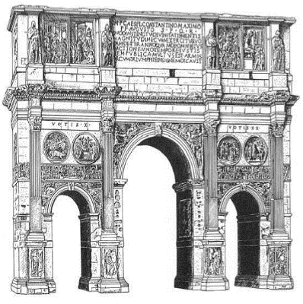

59.

a. Arch of Augustus

b. Arch of Titus

c. Arch of Septimius Severus

d. Arch of Constantine

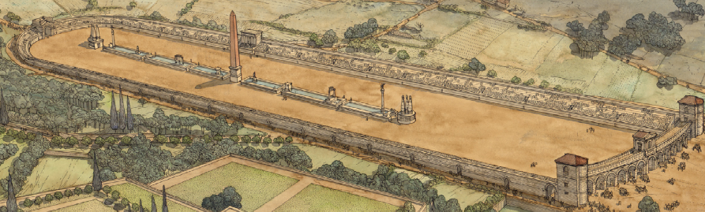

60.

a. Flavian Amphitheater

b. Circus Maximus

c. Colloseum

d. Theater of Pompey

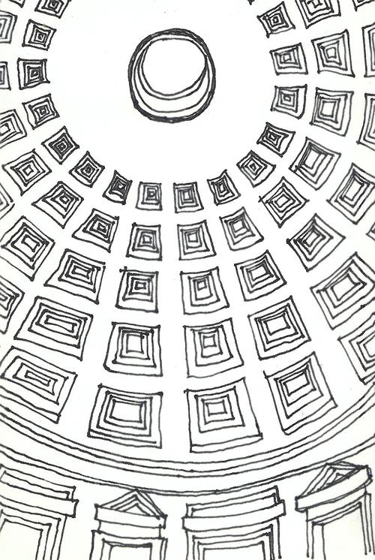

61. This is a view from the inside of

the

a. Parthenon

b. Pantheon

c. Mausoleum of Augustus

d. Temple of Apollo at Delphi

62.

a. Temple of Vesta

b. Temple of Hercules Victor

c. Mausoleum of Augustus

d. Temple of Antoninus and Faustina

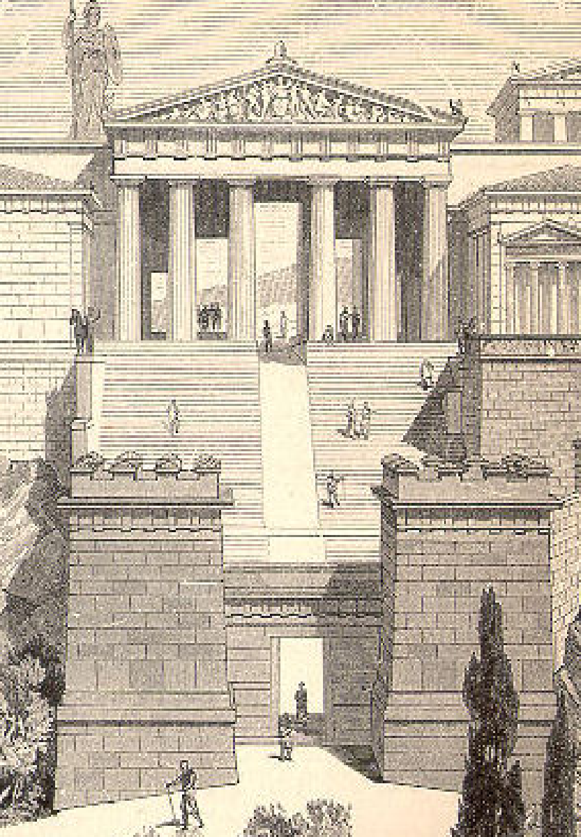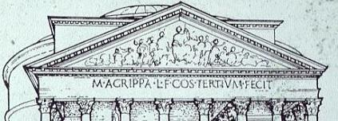

63. The Athenian

a. Pnyx

b. Areopagus

c. Curia

d. Propylaea

64.

a. Temple of Deified Caesar

b. Temple of Mars Ultor

c. Temple of Venus Genetrix

d. Pantheon

65. The defining characteristic of the Athenian Erechteon is its

a. round pediment b. Kariatyd colmns c. Doric-Ionic columnade d. 3 different marbles

66.What modern location would be called “Novum Eboricum” based on its Roman-era namesake?

a. New Jersey b. New Madrid c. New York d. New South Wales

67. In what modern country can the ruins of Aquincum be found?

a. Hungary b. Turkey c. Macedonia d. Slovenia

68.The river called “Sequana” by the Romans runs through what modern-day city?

a. Florence b. Paris c. London d. Seville

69. Which of the following Roman provinces would NOT have touched the Pyrenees?

a. Aquitania b. Gallia Lugdunensis c. Gallia Narbonensis d. Hispania Terraconensis

70. The Xerxes Canal would have been found closest to which mountain?

a. Mt. Olympus b. Mt. Parnassus c. Mt. Ida d. Mt. Athos

Tie-Breakers

96. The city of Knossos would have been found on what island?

a. Crete b. Sicily c. Naxos d. Rhodes

97. The gate leading out of Rome in the direction of Capua lies between the Aventine and what hill?

a. Quirinal b. Capitoline c. Esquiline d. Caelian

98. Which of the following north African cities lay farthest west?

a. Tingis b. Karthago c. Memphis d. Citra

99. Which of the following temples would NOT be found atop the Acropolis of Athens?

a. Erectheon b. Athena Nike c. Athena Pronaia d. Athena Parthenos

100. The Piazza Navona in modern Rome is located on what ancient site?

a. Baths of Caracalla b. Ara Pacis c. Circus Maximus d. Circus of Domitian