2018 SAN ANTONIO CLASSICAL SOCIETY

TSJCL AREA B ACADEMIC OLYMPICS

**GEOGRAPHY OF THE ANCIENT WORLD TEST**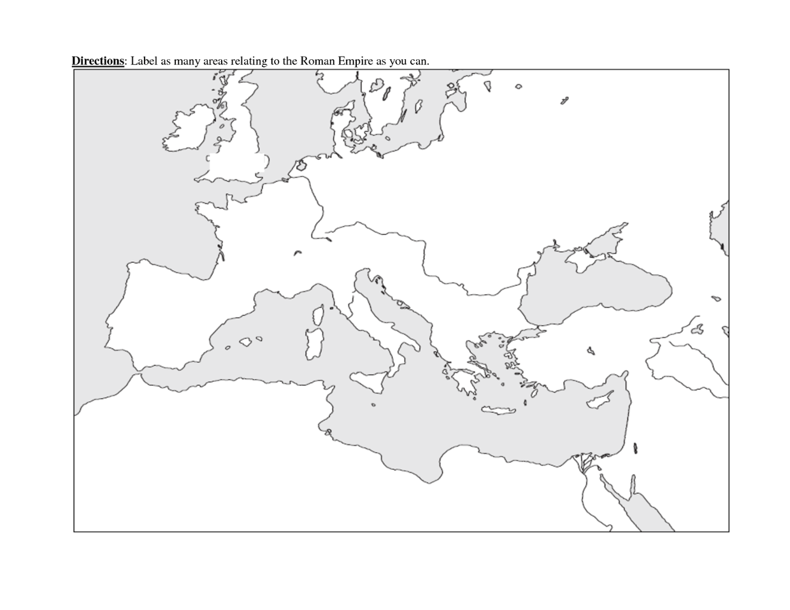

MAP A

**Use Map A to answer the following questions:**

1. Which of the following numbers represents Creta?
   1. 30
   2. 12
   3. 7
   4. 29
2. Which of the following numbers represents Sardinia?
   1. 30
   2. 31
   3. 12
   4. 8
3. Choose the number which represents Sicilia.
   1. 29
   2. 30
   3. 31
   4. 7
4. Choose the number which represents Hibernia.
   1. 24
   2. 29
   3. 25
   4. 27
5. Choose the number which represents Mare Nostrum.
   1. 13
   2. 14
   3. 15
   4. 16
6. What number is nearest to Carthage?
   1. 2
   2. 3
   3. 6
   4. 10
7. City number 32 is:
   1. Bithynia
   2. Jerusalem
   3. Cordoba
   4. Narbonensis
8. You would find Hadrian’s Wall nearest to number ______.
   1. 20
   2. 21
   3. 22
   4. 23
9. You would likely find the highest number of Macedonians around number __.
   1. 25
   2. 26
   3. 27
   4. 28
10. Aegyptus can be found at number ___.
    1. 33
    2. 34
    3. 35
    4. 36
11. Numidia is the closest to number ____.
    1. 33
    2. 34
    3. 35
    4. 36
12. Number 23 is best labelled _______.
    1. Britannia
    2. Pannonia
    3. Hibernia
    4. Noricum
13. Pannonia touches all of the following except ____.
14. Dacia
15. Dalmatia
16. Noricum
17. Hispania
18. The city that is home to the Parthenon is located at number ____.
    1. 4
    2. 5
    3. 8
    4. 9
19. Which of these does not belong?
    1. Aquileia
    2. Athens
    3. Miletus
    4. Ephesus
20. Which of these is closest to Syria?
    1. 9
    2. 10
    3. 11
    4. 12
21. Which of these provinces reaches the farthest east?
    1. Asia
    2. Galatia
    3. Cappadocia
    4. Mesopotamia
22. Noricum is closest to _____.
    1. Belgica
    2. Pannonia
    3. Dacia
    4. Armenia
23. Which of these does not belong?
    1. Ravenna
    2. Corsica
    3. Beneventum
    4. Ostia
24. Which of the following is NOT an island?
    1. Bithynia
    2. Creta
    3. Sicilia
    4. Cyprus
25. Which of the following cities is nearest to Londinium?
    1. Carthago Nova
    2. Roma
    3. Jerusalem
    4. Athens
26. What province is immediately south of Iudaea?
    1. Arabia Petraea
    2. Aegyptus
    3. Syria
    4. Assyria
27. Where is modern day Switzerland located?
    1. Britannia
    2. Helvetia
    3. Germania
    4. Belgica
28. The Mare Britannicum is on the _______ side of Britannia.
    1. north
    2. south
    3. east
    4. west
29. Lindum corresponds to the modern city of _____.
    1. London
    2. Lincoln
    3. York
    4. Liverpool
30. All of the following cities were located in Campania expect ____.
    1. Roma
    2. Pompeii
    3. Herculaneum
    4. Neapolis

MAP B

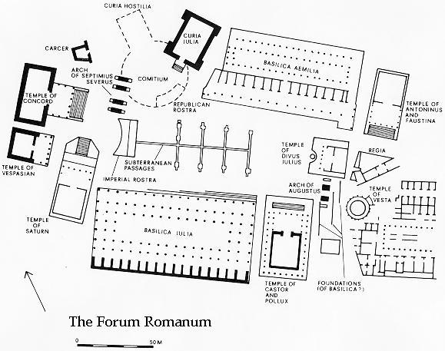

**Use Map B to answer the following questions:**

1. Who began the construction of building 7?
   1. Julius Caesar
   2. Augustus Caesar
   3. Tiberius
   4. Nero
2. Which of these monuments supposedly contained a statue of its namesake(s) which was hollow and filled with olive oil?
3. 6
4. 7
5. 8
6. 9
7. Which of these was an open-air meeting space for Romans to have public assemblies?
8. 1
9. 2
10. 15
11. 16
12. Which of these buildings had a flame which always had to be kept lit?
13. 8
14. 9
15. 10
16. 11
17. Which of these numbered locations was a headquarters for the kings of Rome and later for the Pontifex Maximus?
18. 10
19. 11
20. 12
21. 13
22. Which of these locations was the speaker’s platform?
23. 2
24. 4
25. 15
26. 16

**MAP C**

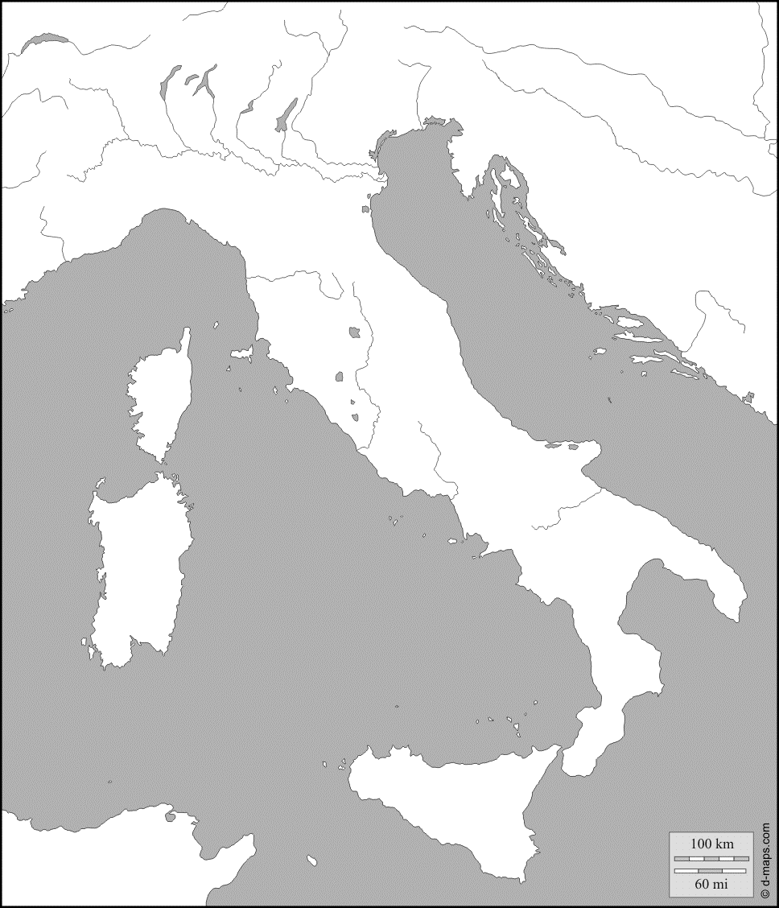

**Use Map C to answer the following questions:**

1. What city is number 19?
2. Aquileia
3. Roma
4. Syracusae
5. Regium
6. What is the name of the body of water in number 13?
7. Hadriaticum Mare
8. Internum Mare
9. Tyrrhenum Mare
10. Pontus Euxinus
11. What is the name of the body of water in number 14?
12. Hadriaticum Mare
13. Internum Mare
14. Tyrrhenum Mare
15. Pontus Euxinus
16. What is the name of the river in number 2?
17. Rhenus
18. Padus
19. Tiberis
20. Arnus
21. What is the name of the river in number 6?
22. Rhenus
23. Padus
24. Tiberis
25. Arnus
26. Which of these cities is closest to Mt. Vesuvius?
27. Syracusae
28. Mantua
29. Neapolis
30. Roma
31. Name the island in 16.
32. Corsica
33. Sicilia
34. Cyprus
35. Sardinia

**MAP D**

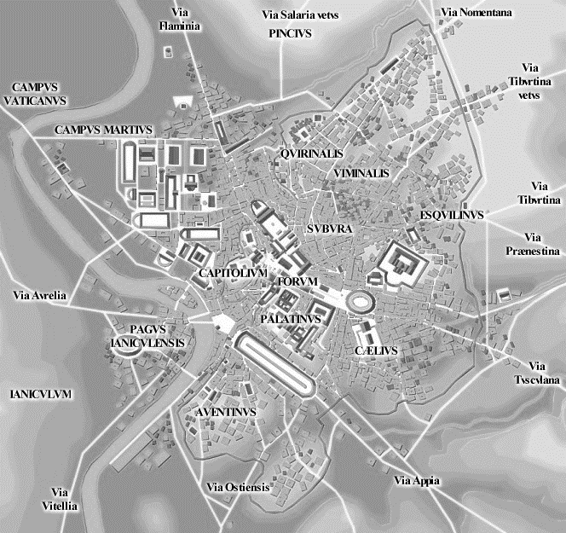

**Use Map D to Answer the Following Questions:**

1. What was location 9 used for?
2. Gladiator fights
3. Public market
4. Speaker’s platform
5. Chariot races
6. What was location 6 used for?
7. Gladiator fights
8. Public market
9. Speaker’s platform
10. Chariot races
11. Which of the Seven Hills of Rome was home to the hut of Romulus?
12. 6
13. 7
14. 8
15. 9
16. Which of these locations contained the *spina*?
17. 6
18. 9
19. 11
20. 12
21. The Roman forum was originally a ______.
22. marsh
23. hill
24. lake
25. forest
26. Which one of these numbers would you visit if you wanted to see naumachiae?
27. 6
28. 9
29. 11
30. 12

**General Knowledge Questions --**

1. Which of these does not belong?
   1. Mauretania
   2. Africa
   3. Numidia
   4. Mesopotamia
2. Which of these cities contains a famous lighthouse?
3. Brundisium
4. Corfinium
5. Alexandria
6. Roma
7. What is the modern name of the Pontus Euxinus?
8. Red Sea
9. Aegean Sea
10. Black Sea
11. Dead Sea
12. What island is Knossos located on?
13. Crete
14. Cyprus
15. Sicily
16. Corsica
17. Which island is part of the Cyclades?
18. Naxos
19. Cyprus
20. Sicily
21. Sardinia
22. Which Greek region contained Athens?
23. Boetia
24. Attica
25. Laconia
26. Ephyraea
27. In what province is modern day France located?
28. Belgica
29. Britannia
30. Gallia
31. Hispania
32. What river formed the border between the Belgae and Germani?
33. Rhine
34. Rhone
35. Danube
36. Po
37. In what province was the palace of Cogidubnus located?
38. Britannia
39. Gallia
40. Belgica
41. Germania
42. What modern day country contains the ancient city of Troy?
43. Italy
44. Bulgaria
45. Iraq
46. Turkey
47. What city is the home of the Flavian amphitheater?
48. Rome
49. Naples
50. Athens
51. Syracuse
52. Where is the house of the Iceni?
53. Rome
54. Greece
55. Milan
56. Britain
57. Where would you look to find Lacus Lemannus?
58. Geneva
59. Milan
60. Paris
61. Troy
62. ______ is the birthplace of the poet Virgil.
63. Mantua
64. Pompeii
65. Rome
66. Capri

**In the next section, identify the following monuments from the given images.**

1. 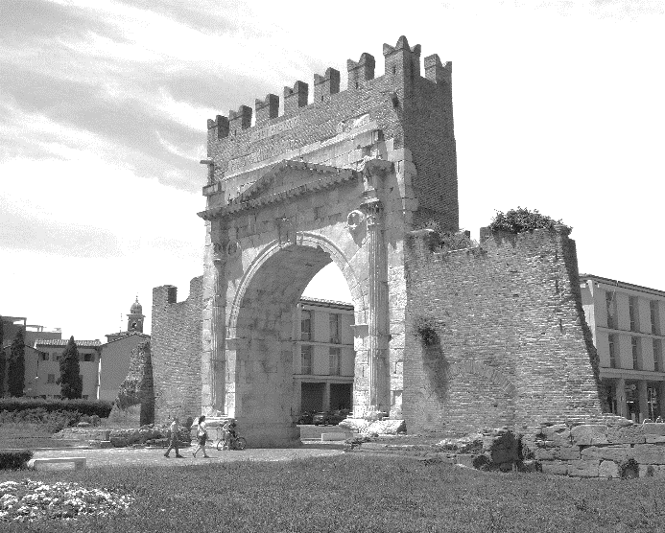
2. Arch of Titus
3. Arch of Constantine
4. Arch of Septimius Severus
5. Arch of Augustus
6. 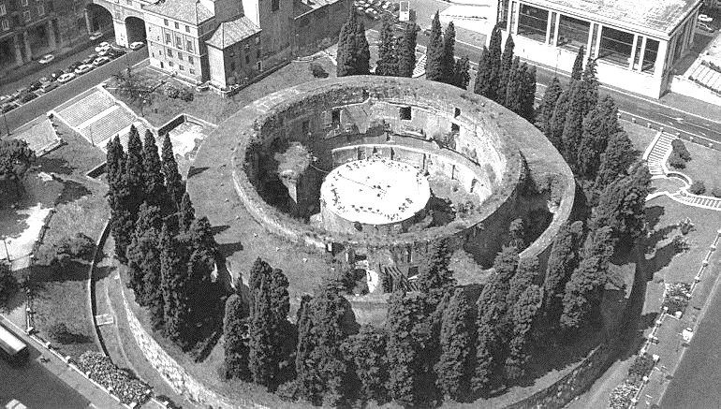
7. Temple of Vesta
8. Mausoleum of Augustus
9. Comitium
10. Curia
11. 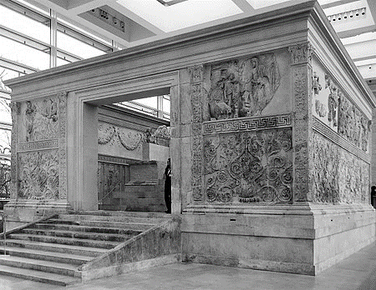
12. Ara Pacis
13. Baths of Trajan
14. Horologium
15. Pantheon
16. 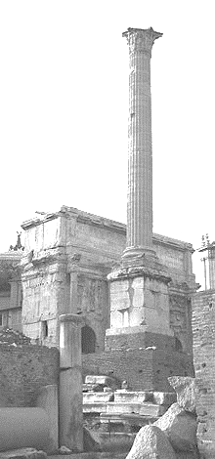
17. Horologium
18. Obelisk of Domitian
19. Column of Phocus
20. Trajan’s Column
21. 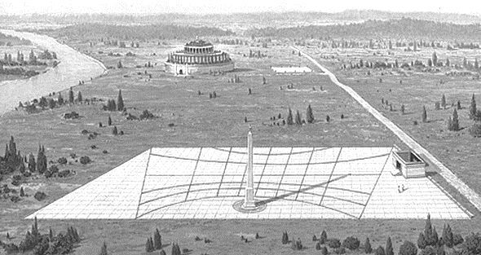
22. Horologium
23. Column of Phocus
24. Obelisk of Domitian
25. Trajan’s Column
26. 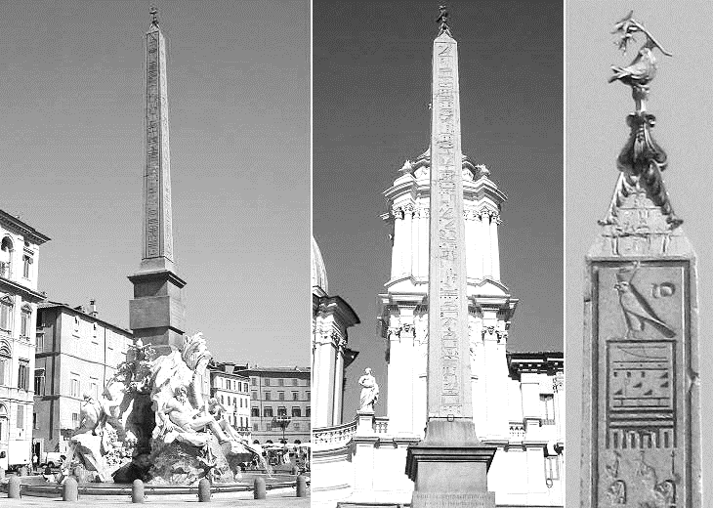
27. Trajan’s Column
28. Column of Phocus
29. Obelisk of Domitian
30. Horologium
31. 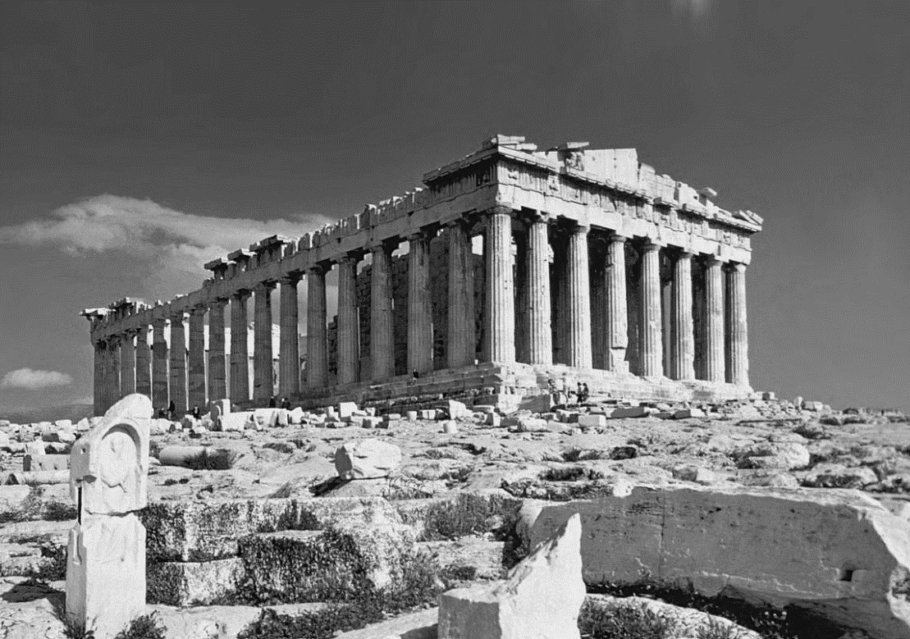
32. Temple of Castor and Pollux
33. Basilica Iulia
34. Pantheon
35. Parthenon
36. 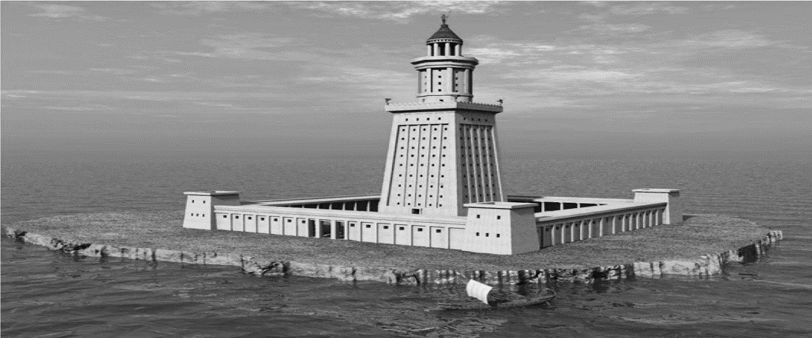
37. Pharos
38. Antinous Obelisk
39. Flaminio Obelisk
40. Palace of Cogidubnus
41. 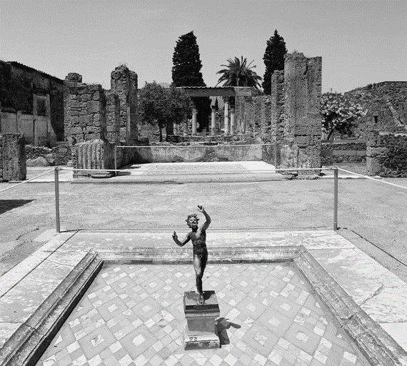
42. House of the Faun
43. Palace of Cogidubnus
44. The tomb of Vergil
45. The Via Sacra
46. 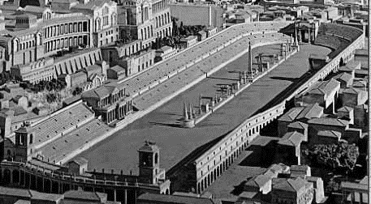
47. Via Sacra
48. Via Flaminia
49. Circus Maximus
50. Flavian Amphitheater
51. 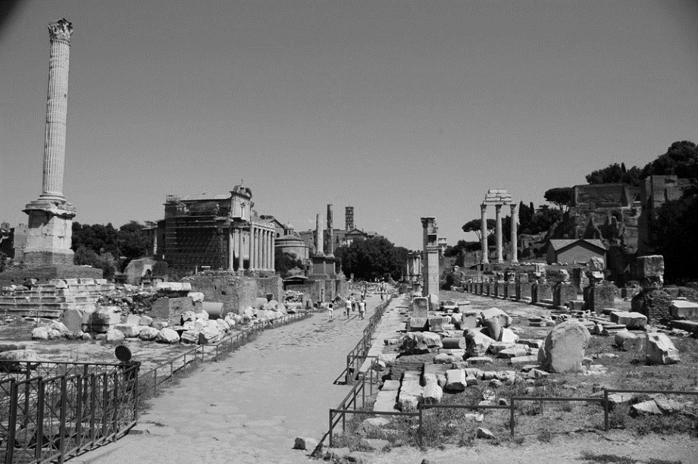
    * 1. Via Flaminia
      2. Via Sacra
      3. Via Aurelia
      4. Via Salaria

TIE BREAKERS:

96. What is this a picture of?

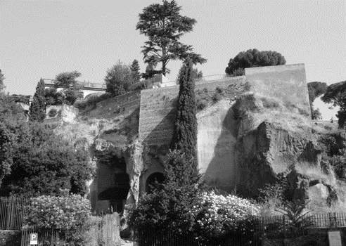

A. the Tarpeian Rock

B. The baths of Trajan

C. Hadrian’s Villa

D. Gate of Augustus

97. _____ is the birthplace of the philosopher Aristotle.

A. Athens

B. Stagia

C. Kos

D. Ephesus

98. Whose temple do these columns belong to? 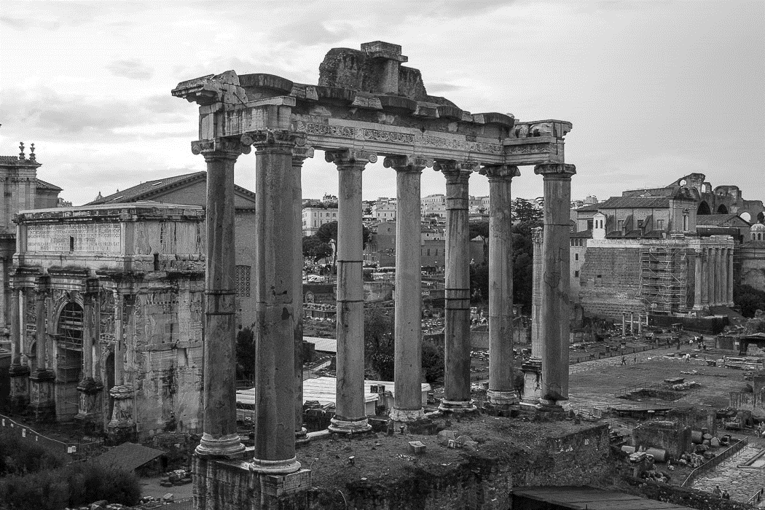

A. Jupiter

B. Juno

C. Castor and Pollux

D. Vesta

99. What modern country contains the ancient city of Tuburbo Maius?

A. Turkey

B. Greece

C. Tunisia

D. Macedonia

100. What Roman monument does the image below come from?

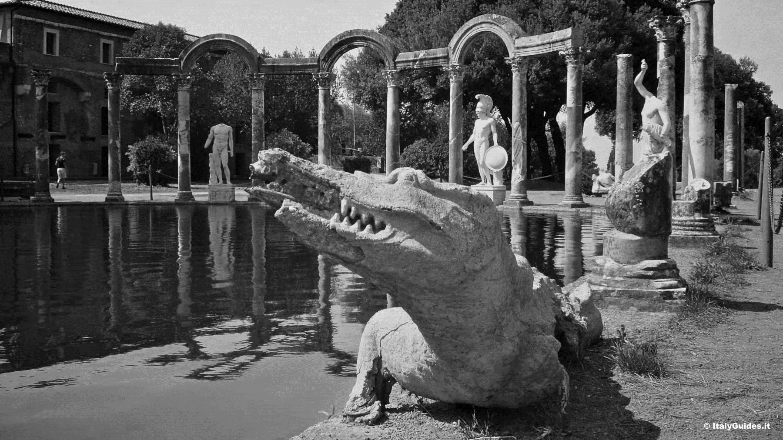

1. Hadrian’s Villa
2. Mausoleum of Augustus
3. Hadrian’s Mausoleum
4. Baths of Diocletian