**2019 SAN ANTONIO CLASSICAL SOCIETY**

**TSJCL AREA B ACADEMIC OLYMPICS**

**CLASSICAL ART TEST**

**Instructions*: Use the images attached to answer questions 1-35. The images will also appear in a PowerPoint at the front of the room. The moderator will show each image twice.***

1. Which of the following techniques does this cup demonstrate?
   1. *repoussé*
   2. red figure style
   3. molded glassblowing
   4. fresco
2. Where was this mask discovered?
   1. Athens
   2. Mycenae
   3. Pompeii
   4. Rome
3. A myth is depicted on this proto-Attic amphora. Which of the following literary works famously contains this myth?
   1. the Iliad
   2. the Odyssey
   3. the Aeneid
   4. the Theogony
4. Name the shape of this vessel depicting Dionysus on a sailboat.
   1. krater
   2. amphora
   3. kylix
   4. hydria
5. What is the name of this statue?
   1. Kouros
   2. Kore
   3. Krosios
   4. Kritios Boy
6. What period is this statue from?
   1. Archaic
   2. Hellenistic
   3. Classical
   4. Geometric
7. Who is depicted in the following mosaic?
   1. Alexander the Great
   2. Ptolemy
   3. Julius Caesar
   4. Augustus Caesar
8. This statue, Aphrodite of Knidos, is an example of ______.
   1. a work by Praxiteles
   2. one of the first female nudes in western sculpture
   3. contrapposto
   4. all of the above
9. This amphora was created using _____.
   1. the Orientalizing style
   2. red figure technique
   3. black figure technique
   4. white figure technique
10. What would this Pyxis have been used for?
    1. a drinking cup
    2. holding jewelry or trinkets
    3. holding perfume
    4. holding coins
11. This jar, imported to Italy in the 8th century BC, contains a very early synthetic pigment known for its blue hue. It was named for the region it came from. What was it called?
    1. Roman blue
    2. Tyrian blue
    3. Egyptian blue
    4. Syrian blue
12. What do the words on this Attic red figure cup communicate?
    1. it was the artist’s signature
    2. it explained how to use the vessel
    3. it tells us the date the vessel was created
    4. it tells us the name of the owner of the pot
13. The Riace Warrior is made of _____.
    1. marble
    2. bronze
    3. iron
    4. porphyry
14. There is a debate in the academic community about whether this statue represents ______ or ______.
    1. Zeus or Poseidon
    2. Agamemnon or Menelaus
    3. Dionysus or Bacchus
    4. Odysseus or Telemachus
15. This statue of Aphrodite, Cupid, and Pan is from the _____ Period.
    1. Archaic
    2. Geometric
    3. Classical
    4. Hellenistic
16. What type of column is depicted here?
    1. Doric
    2. Ionic
    3. Corinthian
    4. composite
17. This portrait is an example of ____.
    1. the Veristic style
    2. an idealized style
    3. contrapposto
    4. *repoussé*
18. This wall painting is from the cubiculum of Publius Fannius Synistor at Boscoreale. It is a notable example of the ___________ of Roman wall painting.
    1. First Style
    2. Second Style
    3. Third Style
    4. Fourth Style
19. The Ixion Room from the House of the Vettii is painted in the ________ of Roman wall painting.
    1. First Style
    2. Second Style
    3. Third Style
    4. Fourth Style
20. This tomb from the necropolis of Tarquinia is the product of which civilization?
    1. The Romans
    2. The Mycenaeans
    3. The Trojans
    4. The Etruscans
21. This type of portrait can be found ___.
    1. on mummies
    2. in everyday Roman homes
    3. in victory arches
    4. in Pompeiian wall frescoes
22. This Severan tondo contains an example of ______.
    1. *memento mori*
    2. *damnatio memoriae*
    3. Christian art
    4. Veristic portraiture
23. A ________ was used to carve the curls on this bust of a Flavian woman.
    1. strigil
    2. hammer
    3. chisel
    4. hand drill
24. Whose foot is this?
    1. Zeus
    2. Polyphemus
    3. Constantine
    4. Nero
25. This fresco from the catacombs of 3rd century Rome contains a religious image. Who is depicted here?
    1. Apollo
    2. Asclepius
    3. Christ
    4. King David
26. This relief from the Arch of Titus commemorates Roman soldiers carrying away the spoils of the city they had just sacked under Titus’ leadership. What city was that?
    1. Athens
    2. Alexandria
    3. Londinium
    4. Jerusalem
27. To whom was this building dedicated?
    1. Jupiter
    2. Augustus Caesar
    3. Marcus Agrippa
    4. all the gods
28. What are these architectural features called?
    1. flying buttresses
    2. coffers
    3. amulets
    4. spolia
29. Who is this?
    1. Augustus
    2. Caligula
    3. Tiberius
    4. Claudius
30. Who built this?
    1. Augustus
    2. Cleopatra
    3. Tiberius
    4. Julius Caesar
31. This mosaic depicts _____.
    1. poetic scenes from Roman agricultural life
    2. Romulus and Remus being raised by Lupa
    3. twin boys worshipping the Roman wolf goddess
    4. a person transforming into a werewolf
32. What was the primary purpose of a signet ring like this one from the second century?
    1. authenticating documents for legal purposes
    2. bribing officials
    3. scaring others with cursed images
    4. increasing the damage to opponents in a physical fight
33. Who is this?
    1. Nero
    2. Marcus Aurelius
    3. Commodus
    4. Hadrian
34. The portrait of the Four Tetrarchs exemplifies the ________ style of portraiture.
    1. Republican
    2. Veristic
    3. Imperial
    4. Late Imperial
35. This 6th century sarcophagus was found in an Etruscan necropolis. Today it resides in the Louvre in Paris. What material is it made of?
    1. terracotta
    2. marble
    3. sandstone
    4. bronze

*The remainder of the questions on this test do not have slides. Bonam fortunam!*

1. Many of the artistically significant Etruscan sites we have preserved are ____.
   1. *tumuli*
   2. sewers
   3. houses
   4. farms
2. Etruscan art shows there was a relatively positive relationship between _____ and _____.
   1. men and gods
   2. adults and children
   3. men and women
   4. slaves and freedmen
3. In which period of Greek art do statues often wear a small smile?
   1. Geometric
   2. Archaic
   3. Classical
   4. Hellenistic
4. Which period of Greek art produced the most life-like statuary?
   1. Geometric
   2. Archaic
   3. Classical
   4. Hellenistic
5. Which order of columns is the simplest in design?
   1. Doric
   2. Ionic
   3. Corinthian
   4. composite
6. Which of these buildings is made of concrete?
   1. the Parthenon
   2. the Pantheon
   3. the Mausoleum of Halicarnassus
   4. the Great Pyramids of Giza
7. How do most people know the Flavian amphitheater today?
   1. the Colosseum
   2. the Vatican
   3. the Castel Sant’Angelo
   4. the Circus Maximus
8. Which emperor said, “I found Rome a city of bricks and left it a city of marble”?
   1. Nero
   2. Hadrian
   3. Augustus
   4. Trajan
9. What is unique about Trajan’s column?
   1. it is covered in narrative bas relief
   2. it is extremely tall
   3. it was built by Trajan’s enemies
   4. it is made of glass
10. ______ was more important than _____ in late imperial portraiture.
    1. symbolism; realism
    2. realism; symbolism
    3. realism; beauty
    4. beauty; realism
11. The Third Pompeiian Style of Roman Wall Painting was characterized by _____.
    1. flat, monochromatic panels of color with small details
    2. faux marble designs
    3. elaborate scenes mimicking architecture
    4. scenes from mythology
12. The First style of Pompeiian wall painting was characterized by ______.
    1. flat, monochromatic panels of color with small details
    2. faux marble designs
    3. elaborate scenes mimicking architecture
    4. scenes from mythology
13. _______ is the modern name of one of the most important Etruscan settlements ever discovered. At its height, between 25, 00 and 40,000 lived there.
    1. Cerveteri
    2. Capri
    3. Naples
    4. Rome
14. Emperor Commodus is often depicted wearing a lion skin, as he believed he was the incarnation of _____.
    1. a lion
    2. Hercules
    3. Jason
    4. Apollo
15. Which emperor is known for sporting hair in the shape of “crab claws”?
    1. Augustus
    2. Claudius
    3. Nero
    4. Caligula
16. Which of the following structures built by the Romans still holds the record for the world’s largest concrete dome?
    1. the Duomo
    2. the Pantheon
    3. the Parthenon
    4. the Mausoleum of Augustus
17. To which god are Pyramids and Obelisks monuments?
    1. Isis
    2. Ra
    3. Apollo
    4. Anubis
18. In an equestrian portrait (like the famous one of Marcus Aurelius), the subject is always doing this.
    1. fighting a battle
    2. looking realistic
    3. wearing fine clothing
    4. riding a horse
19. What are *tesserae*?
    1. the small tiles that make up a mosaic
    2. the bricks that are used under marble facades
    3. a kind of Greek pot
    4. stones used in signet rings
20. What was the most prominent color in Roman wall painting?
    1. red
    2. yellow
    3. white
    4. green
21. What style of Roman wall painting is also called the “Intricate Style”?
    1. First Style
    2. Second Style
    3. Third Style
    4. Fourth Style
22. Which ancient civilization produced the Lion’s Gate?
    1. the Mycenaeans
    2. the Trojans
    3. the Minoans
    4. the Etruscans
23. _______ flourished towards the end of the Greek Dark Ages, from 900 – 700 BC.
    1. Geometric Art
    2. Archaic Art
    3. Classical Art
    4. Hellenistic Art
24. The figures in ________ vase painting tend to be fleshier, and appear in more emotional scenes than in previous eras.
    1. Geometric
    2. Archaic
    3. Classical
    4. Hellenistic
25. The figures in this style of Greek pottery started to be painted with a brush rather than incised with a chisel, which allowed for finer detail work.
    1. Orientalizing style
    2. Geometric style
    3. Black figure style
    4. Red figure style
26. During the _____, Romans valued realism over idealism in their portraiture.
    1. monarchy
    2. republic
    3. empire
    4. tetrarchy
27. This capital is characterized by the use of volutes.
    1. Doric
    2. Ionic
    3. Corinthian
    4. Etruscan
28. If you want to see the original Parthenon marbles today, where do you have to go?
    1. the Acropolis at Athens
    2. the British Museum
    3. Rome, Italy
    4. the Estate of Lord Elgin
29. If you were to look at an archaic *kore*, what would you expect to see?
    1. a girl
    2. a Greek temple
    3. a boy
    4. a sarcophagus
30. What is the name of the famous archaeologist who used Homer’s *Iliad* to discover the actual site of Troy?
    1. Indiana Jones
    2. Hiram Bingham
    3. Heinrich Schliemann
    4. Lord Carnarvon
31. Which one of Cleopatra’s features, not believed to be conventionally attractive at the time, is apparent from realistic Roman-style likenesses of her found on coins as well as statuary?
    1. her small eyes
    2. her large lips
    3. her large nose
    4. her weak chin
32. What is the name for the study of coins?
    1. epigraphy
    2. numismatics
    3. heraldry
    4. archaeology
33. The Baths of Diocletian are notable for being ____.
    1. the largest baths in Rome
    2. the oldest baths in Rome
    3. the cleanest baths in Rome
    4. the most popular baths in Rome
34. Nero’s portraits can be easily identified due to his distinctive____.
    1. neck beard
    2. long nose
    3. mustache
    4. bald spot
35. The Circus Maximus was decorated with ___.
    1. dolphins
    2. eggs
    3. obelisks
    4. all of the above

**TIE BREAKERS (96-100) – Be sure to bubble these in questions 96-100 on your scantron!**

96. Fayum portraits are painted using which of the following techniques?

a. encaustic (pigments in hot wax) b. tempera (egg-based paints)

c. both a & b d. none of the above

97. From the ground up, name the orders used in the construction of the Colosseum.

a. Doric, Ionic, Corinthian b. Ionic, Doric, Corinthian

c. Doric, Doric, Doric d. Ionic, Ionic, Corinthian

98. What is the subject matter of the wall paintings of the triclinium in the House of the Vettii?

a. cupids performing various tasks b. the love affair of Venus and Mars

c. Ganymede captured by Jupiter d. Apollo and Daphne

99. Which Roman author, remarking on Rome’s obsession with Greek art and culture, remarked, “Conquered Greece led her proud conqueror captive.”

a. Ovid b. Vergil c. Juvenal d. Horace

100. Which of the following scenes is NOT on the Ara Pacis?

a. Romulus and Remus discovered by Faustulus

b. Augustus *capite velato* as pontifex maximus

c. a personification of Rome as a goddess

d. Jupiter blessing his temple

1. 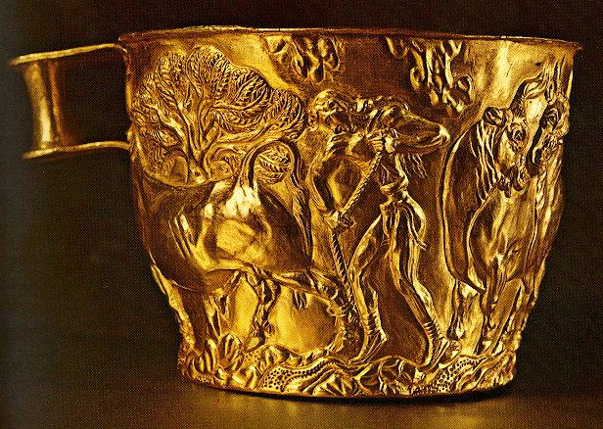
2. 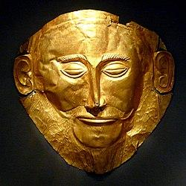
3. 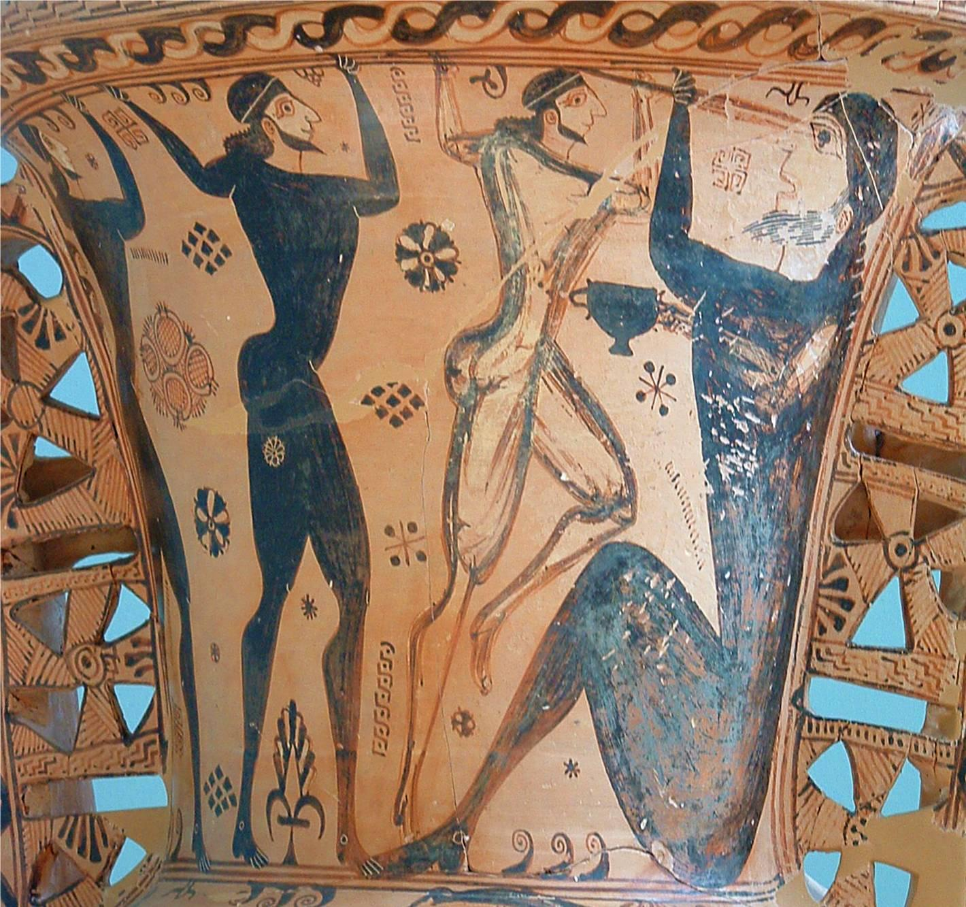
4. 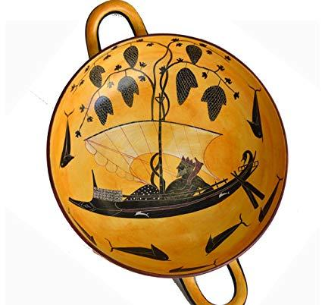
5. 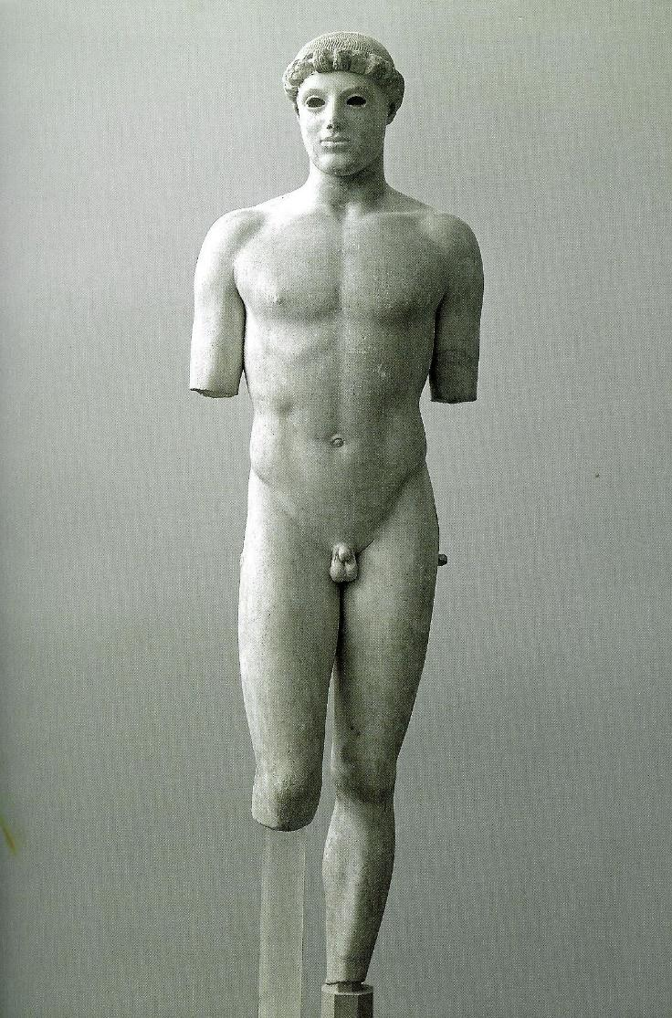
6. 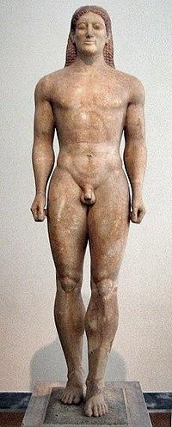
7. 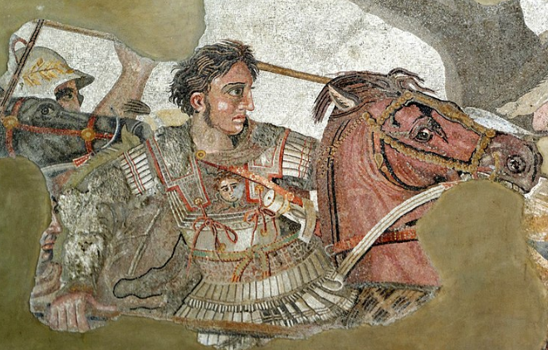
8. 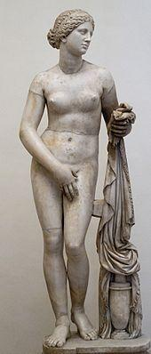
9. 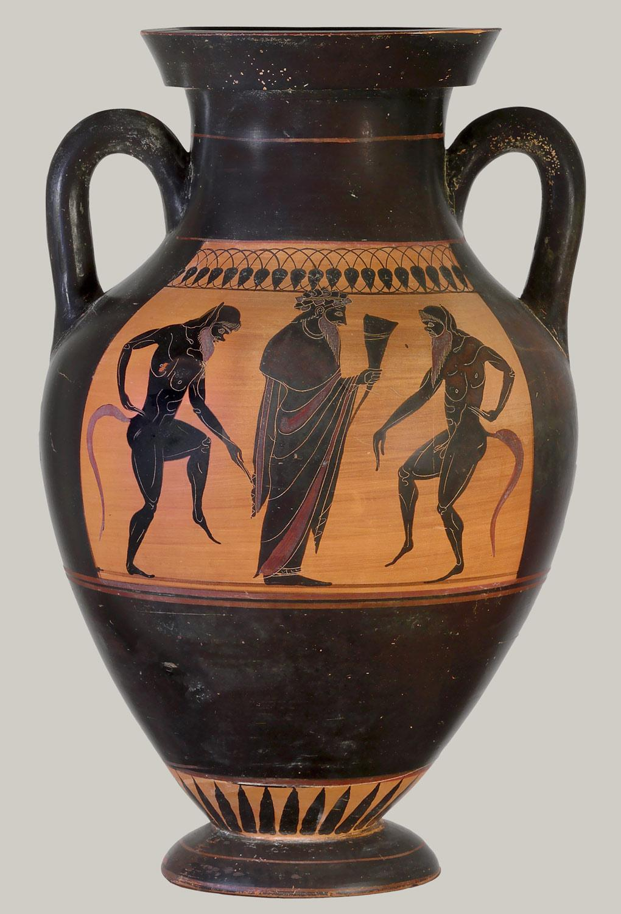
10. 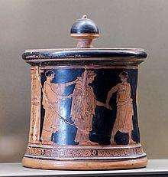
11. 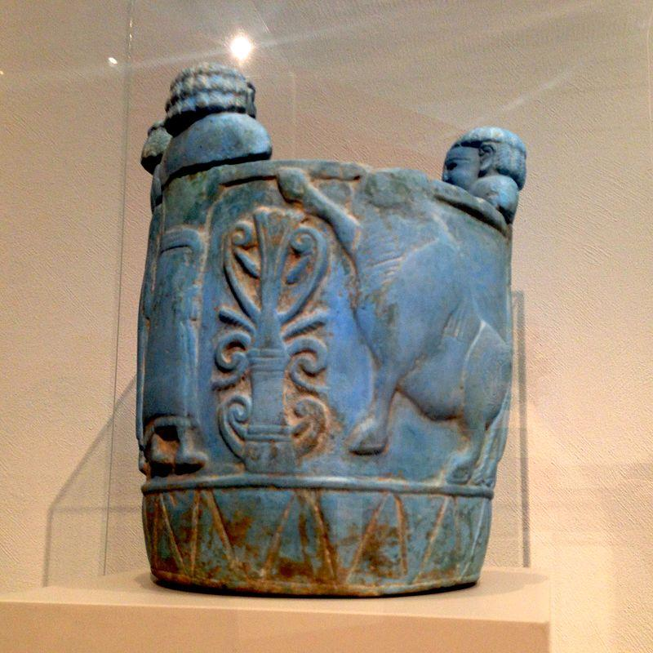
12. 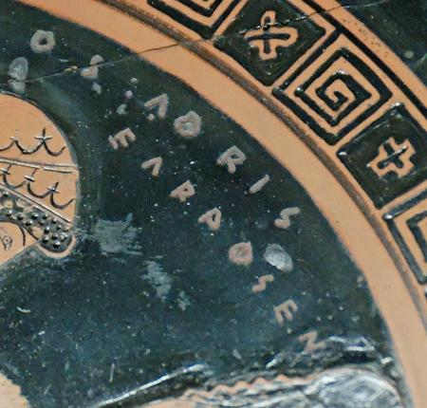
13. 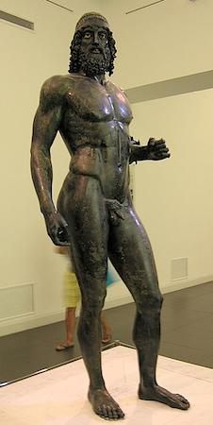
14. 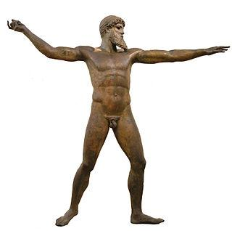
15. 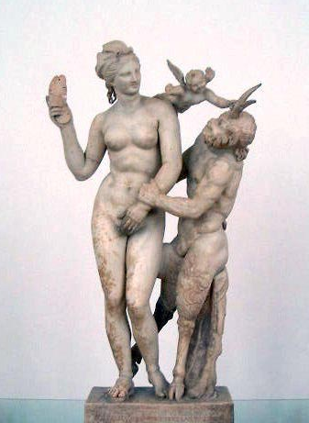
16. 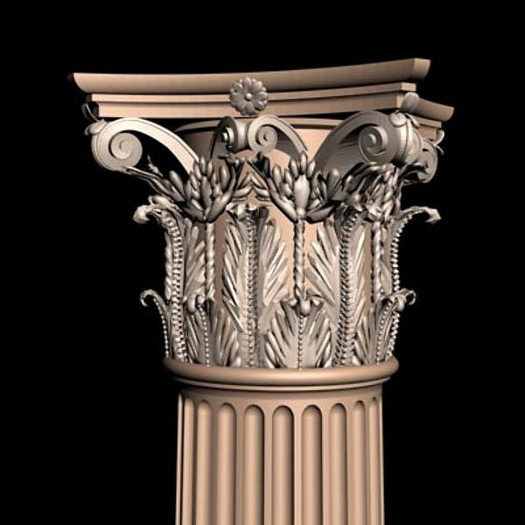
17. 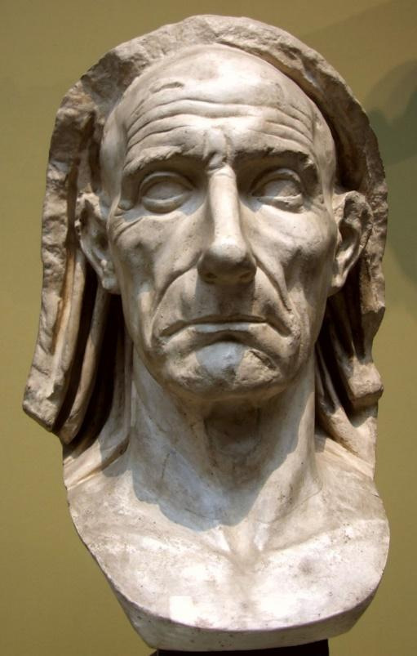
18. 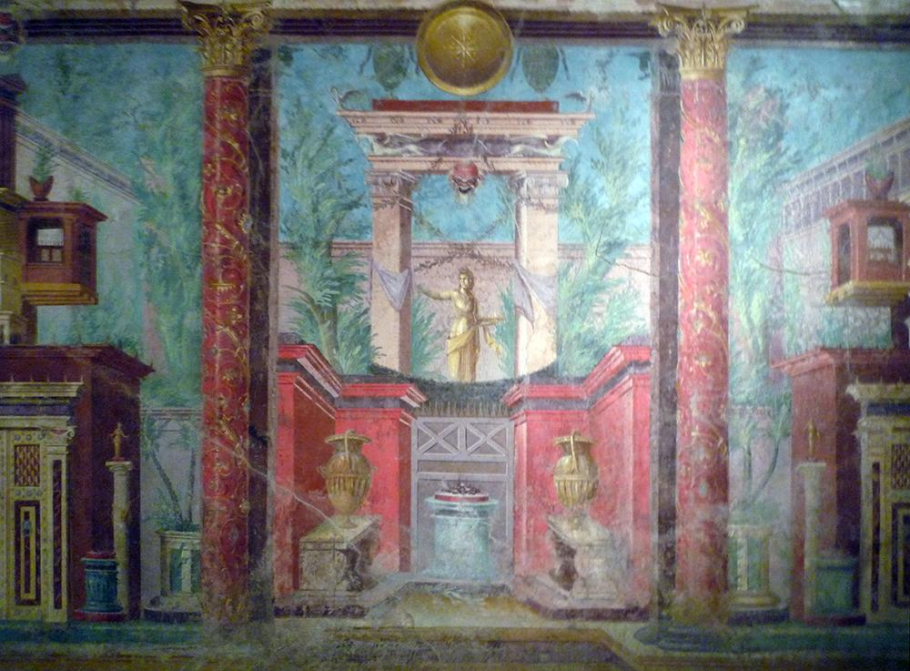
19. 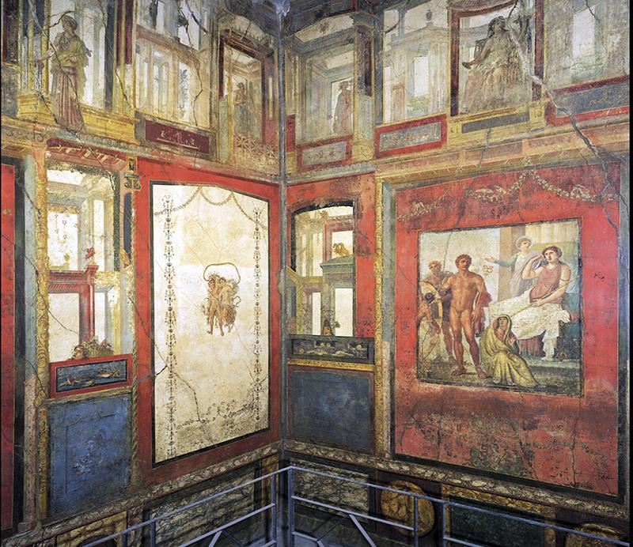
20. 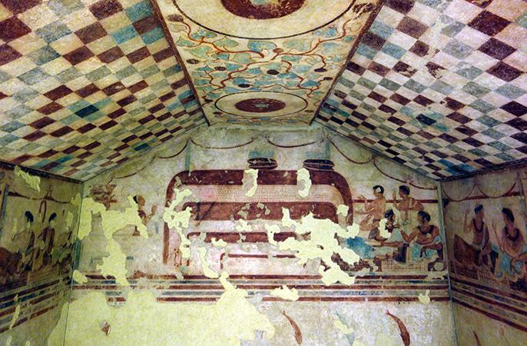
21. 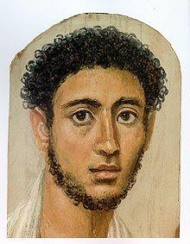
22. 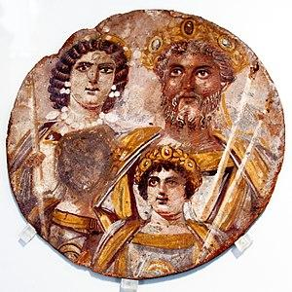
23. 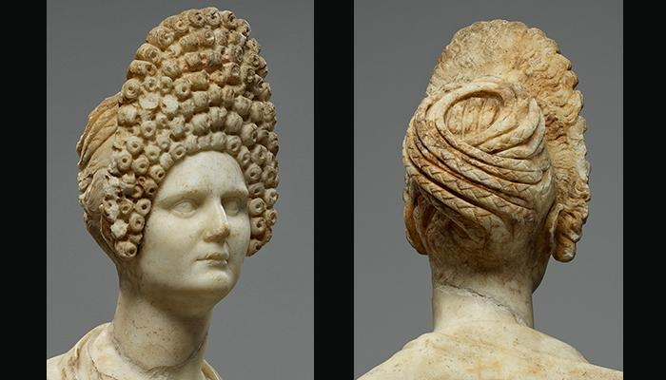
24. 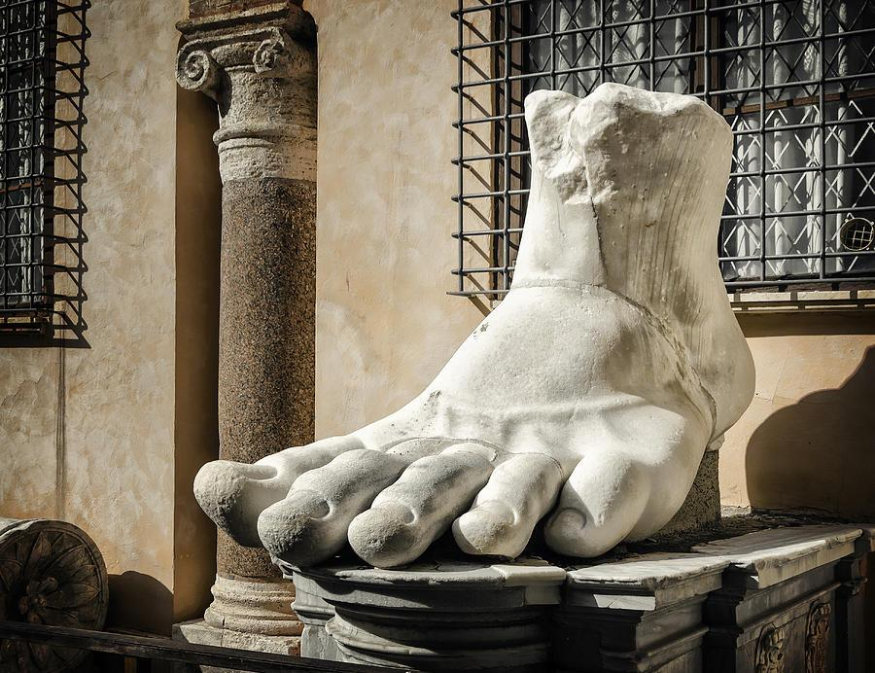
25. 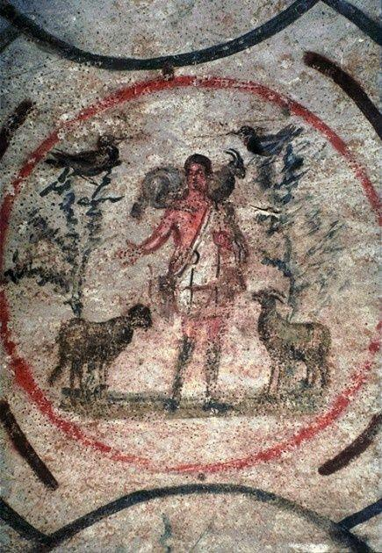
26. 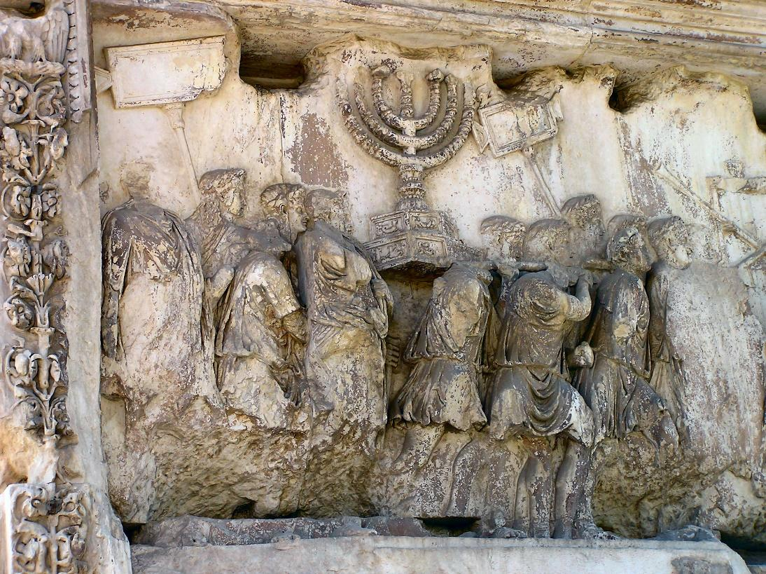
27. 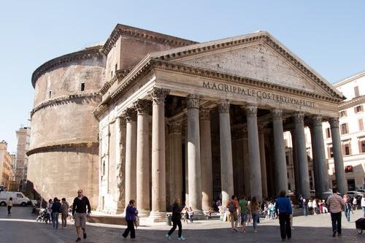
28. 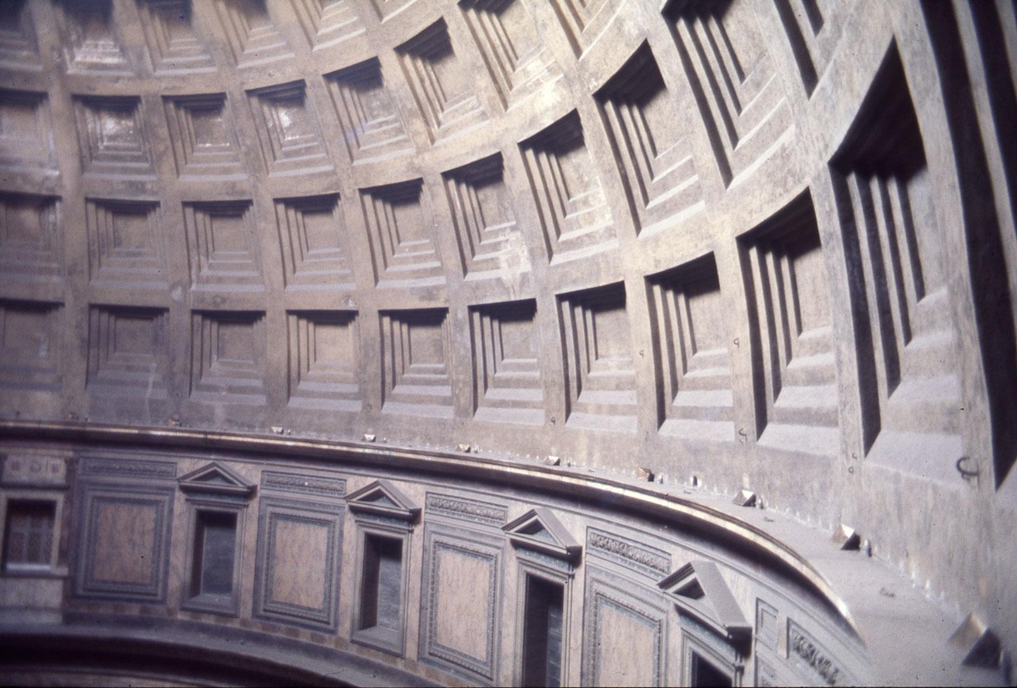
29. 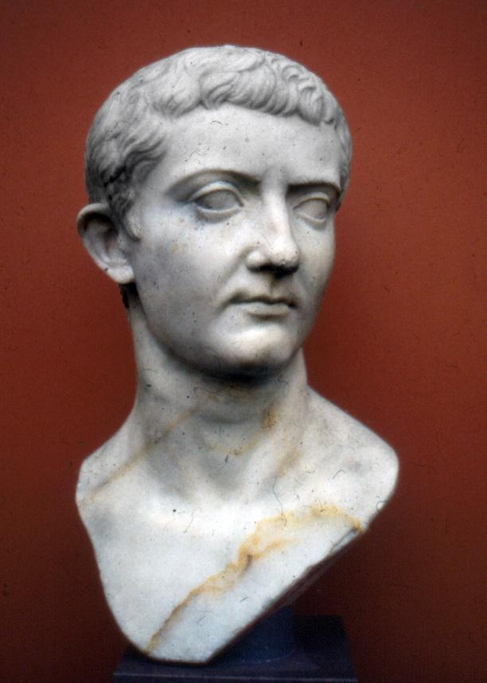
30. 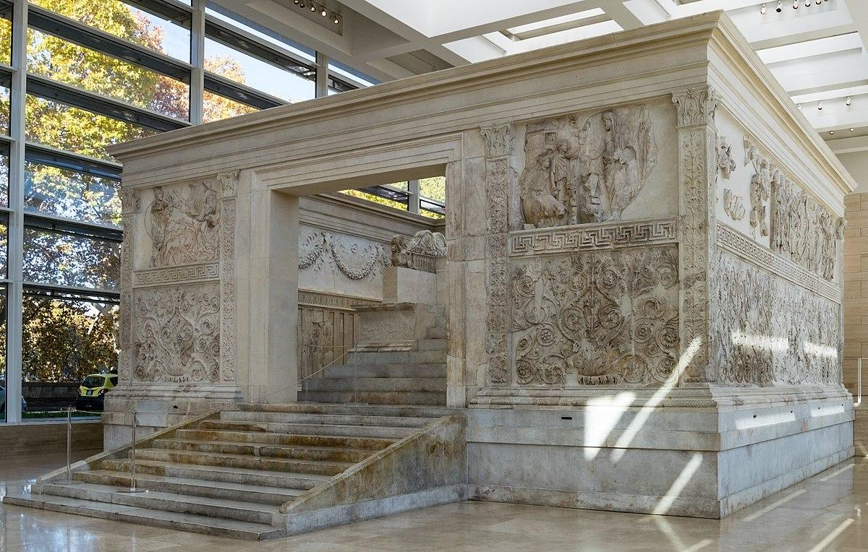
31. 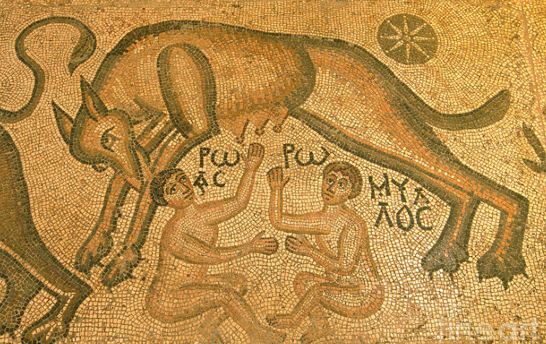
32. 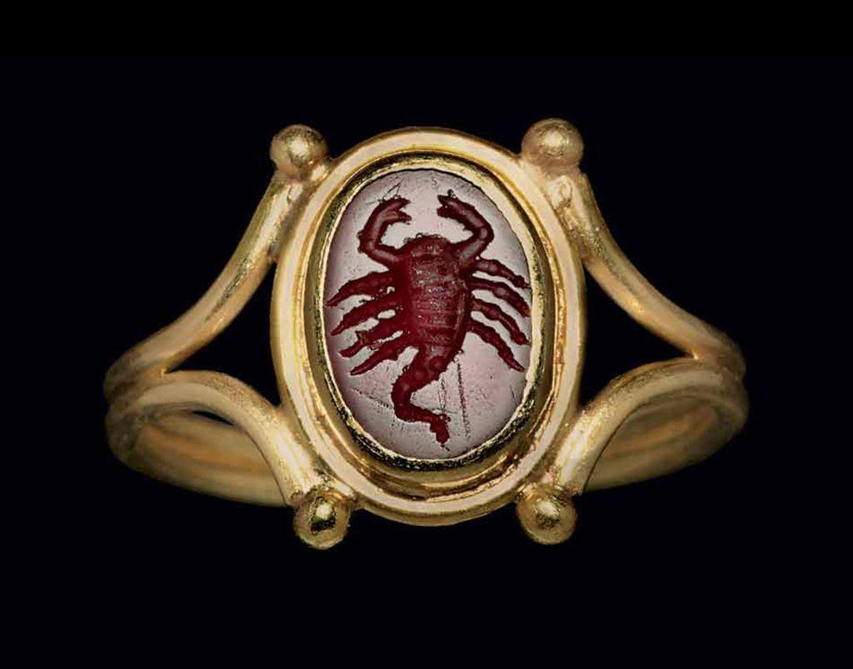
33. 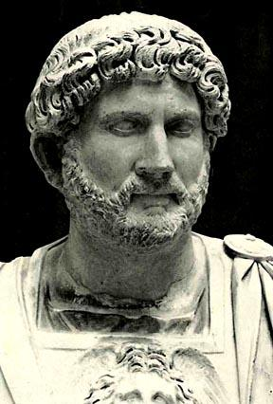
34. 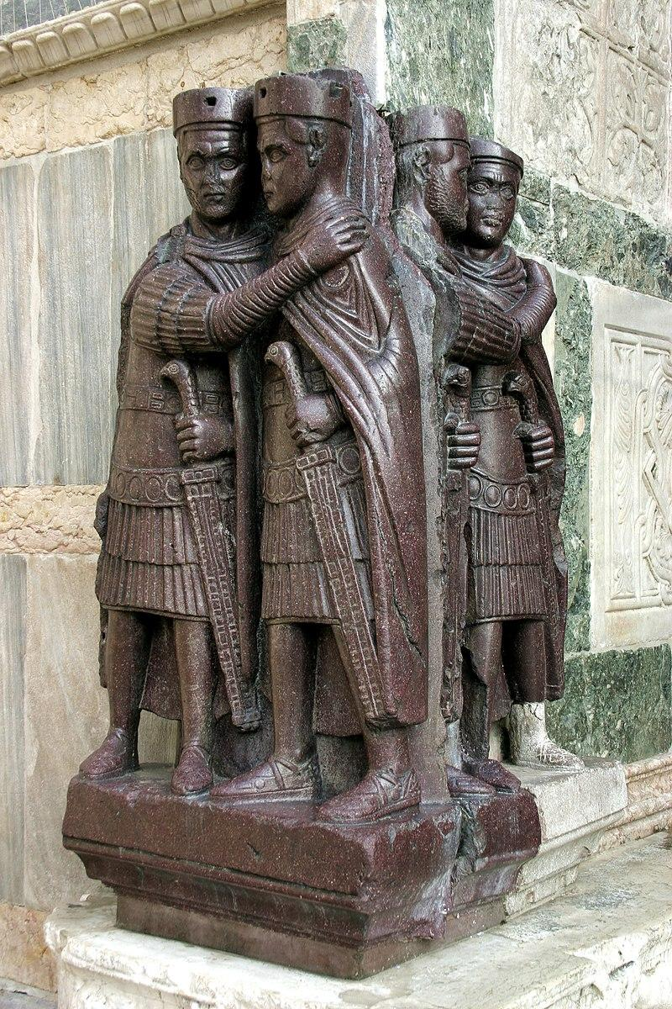
35. 