Email to: Lester.Teichman@Toyota.com | 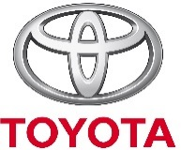

Coordinator Checklist for TMAA Events

Event INFORMATION
Coordinator Name:
Coordinator Contact Number:
Brief Description of Event:
Specify Target # of TMs:
Date of Event:
What is being requested from TMAA: | Food? Prizes? Supplies?

CHECKLIST
Event Name:
Name of Organization Responsible for Event:
Address:
Name & Position of Contact Person:
Telephone Number of Contact Person:
Email Address:

