April 15th MACA Board Minutes
April 15, 2026 at 6:00pm (rescheduled from April 8, 2026)

Board of Directors:
President - Sean “Smitty” Smith-present
Vice President – Stacy Asher-present
Secretary – Lisa Brager

Treasurer – Sherry Grove

Committees:
Violations – McCall Daniels
Webmaster - Stephen McGill
Architectural - Hector Araujo

AGENDA
Call to order [Sean] Meeting called to order at 6:02pm.
- Roll Call and Introductions (Board of Directors, Volunteers, Guests) [Sean]
Guests: Nancy Pierce/Suddeth, Charles
- Approve Minutes for Previous Month [Sean] Stacy moved to approve the minutes from February and March, Sherry seconded and all members voted in favor to approve.
***Insurance Review:::
Charles from Farmers Presented an analysis and proposal for insurance-board had already reviewed .
*Coverage of Main Topics:
-New Policy would include same overage as current policy + additional coverage at a lower cost
Current Policy: no current coverage for sign, mailboxes, any additional lighting (signs).Charles reviewed our current policy and looked into what Farmers could provide to see if there were any advantages available. He included the same coverages that we currently have. Due to the time period that had passed since our last insurance claims on the mailboxes and trees; he was able to look at different coverage options.
-The Proposed blanket business policy but would include $50k coverage in outdoor signs (which is coverage that wasn’t included before and doesn’t change the premium) $50k mailboxes coverage. Total premium and fees for additional coverage is less cost than what we are currently paying.
Motion made by Smitty to switch policies from the existing policy to Farmers. Stacy seconded the motion and all members voted to approve. The first premium payment will be due to put into policy into place. Stacy and Sherri will work with Charles to make payment. Charles will work with them to facilitate changing the policy and continue to provide reviews on-going.

3. Treasurer’s Report [Sherry]
-Current Balances:
-Checking $31,892.82
-Reserve: 39,262.93
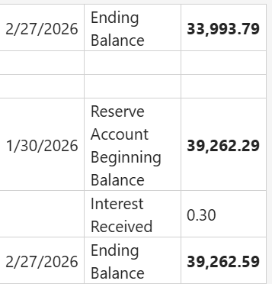

-2 weeks away from 1st week of May. Sean is willing to talk to the certain homeowners that may be delinquent.
-Maintenance repair at Lot 97 still needs to be addressed. Email was received with pictures. Next step would be to provide clarification of what is the homeowners responsibility and the HOA since there is not a distinct fence-line as there are in the other common areas. Smitty will reach out to the homeowners.
4. Meridian Acres Community Association Insurance [Sherry]
5. Committee Updates:
a. Architectural [Hector]
-Sherri received a paint request from homeowner that will be forwarded to Hector.
b. Landscape, Lighting [Sean]
1. Arborist (Lot 80 and stormwater ponds) (Lot 97) (Stormwater 5 work) Drainage areas: they have added rock and cleaned up the area. Next step is to contact the landscaper again. County tries to make it out 2x a year to maintain the areas. Stacy said she can give a call out to the county to see if they have anything planned within the next month, if not we can reach out to either the landscaper or the community to see how to address.
2. Lighting (Entrances) (working) purchasing one lamp post per entrance (trial)
c. Technology [Stephen]
Stephen noted he can have custom homeowner dues links
Requested the Spring Fling photos; Stacy will send them.

d. Violations [Sean]
Focus: Landscaping (HOA and homeowner) and abandoned vehicles
- Further discussion revolving around general keeping of yards and them morphing into industrial/ construction zones
- Smitty will meet with McCall regarding violations; noted that the stationary vehicle has been moved onto homeowner property.
-Not able to contact homeowners for recent tips of violations (letter)
e. Events [Stacy]
1. Spring Fling, March 28, 2026 on Lot 80 from 11am – 1pm. (update)
-Stacy commented regarding rebuilding Lot 80 community sign
-Smitty would like to “Thank You” card to the people who came out to the Spring Fling; Stacy will send him the list
6. Open Forum:
-Nancy and Mel discussed how their neighbors have helped out with yard work
-Smitty greeted Marcel
-Smitty shared about some touching personal connection moments, and appreciates our comradery

-Adjourn [Sean] The next meeting is scheduled for May 20, 2026 at 6:00pm

