Annual Homeowners Meeting (in-person and virtual)
Lacey City Hall, 420 College Street SE, Lacey, WA 98503
January 17, 2026 at 9:00am

Board of Directors:
President - Sean “Smitty” Smith-present
Vice President – Stacy Asher-present
Secretary – Lisa Brager-present
Treasurer – Sherry Grove

Committees:
Violations – William “Bill” Johnston-present
Webmaster - Stephen McGill-present (online)
Architectural - Hector Araujo - present

Community Attendees:
Taeko Skrivanek, 215
Nicole Foos, 115
Gin Mathis,
Carrie +Dan Flores, 98
Brian House, 256
Bill Johnston, 15
Rick Wollach, 152
Kevin Ryan, 200
Karen E Johnston, 235
Dean Peterson, 235
Mcall Daniels, 198
Charles Hayward, 168
Marcel Leveque, 119
Online:
Pete Zahn, 147

AGENDA
Call to order [Sean]
-meeting called to order at 9:05am
1. Introductions, Overview and Roll Call (Board of Directors, Volunteers, Guests) [Sean]
-reviewed that we meet the 2nd Wednesday of every month virtually at 6:00pm and the link is on our website.
2. Approve Minutes for Previous Month [Board]
-Smitty made motion to approve December 2025 minutes, Stacy seconded and all voted in favor.
3. 2024-2025 Goals and Accomplishments [Sean]

- Repair community owned fences: repaired the fence along the stormwater pond on Steilacoom
- Reduce speed in our community: Bill Johnston headed this endeavor. There was a study done that did identify our area as having a speed problem. We were not approved for 2025 but were approved for 2026. Once Thurston County approved their budget they will let us know and what work will be done.

4. 2025 Updates and Accomplishments [Sean]

- Repaired community owned fences = Fencing replaced on Steilacoom Rd.
- Reduce speed in the community = Traffic calming approved for 2026

5. 2026 Goals [Sean]

a. Annual Homeowner Dues (overdue): reaching out to individuals that have been overdue to reduce the number of outstanding dues
b. Stormwater Facility Maintenance: we have 5 in our development. Smitty is working with the County to determine what maintenance needs to be done
c. Tree maintenance on Lot #97: looking at trees that are dead, overgrown, or may have fallen. Along Steilacoom and Dutterow, it is the homeowners responsibility to maintain from the fence to the sidewalk-it is the HOA and the county’s responsibility beyond that.
c. Landscape and Area Maintenance
d. Lighting (entrances and mailboxes): intent is to purchase LED and motion/solar lights for the three entrances and have them installed. Next will be to address lighting at the mailboxes.

6. Annual Dues [Sean]

- 2026 Annual Dues

During the last meeting, The Board of Directors voted to Approve a 5% increase to the Annual Homeowner Dues. The result of this change increased the cost from $147 to $154 and will be effective in January 2026. There was no Annual Assessment in 2024. As a Board we are allowed to increase dues every year. Our HOA dues compared to similar HOA groups falls in the lower end.

7. Treasurer’s Report Stacy
- Current Account Balances: Reserve Account Balance $39,261.97
- 2025 Financial Review
-anything left over from our proposed 2025 budget goes over to our savings account and we start the next year “fresh”
-Landscaping increase in April for the Ivy overgrowth that needed to be removed
-Increase in miscellaneous Expenses in August for emergency gate and fencing repair
-hospitality: we had a Spring Fling and a Trunk or Treat-some expenses were reimbursed for volunteers that made purchases out of pocket
-We are working on building up or savings account so we are not taken by surprise by anything that dips too far into our budget

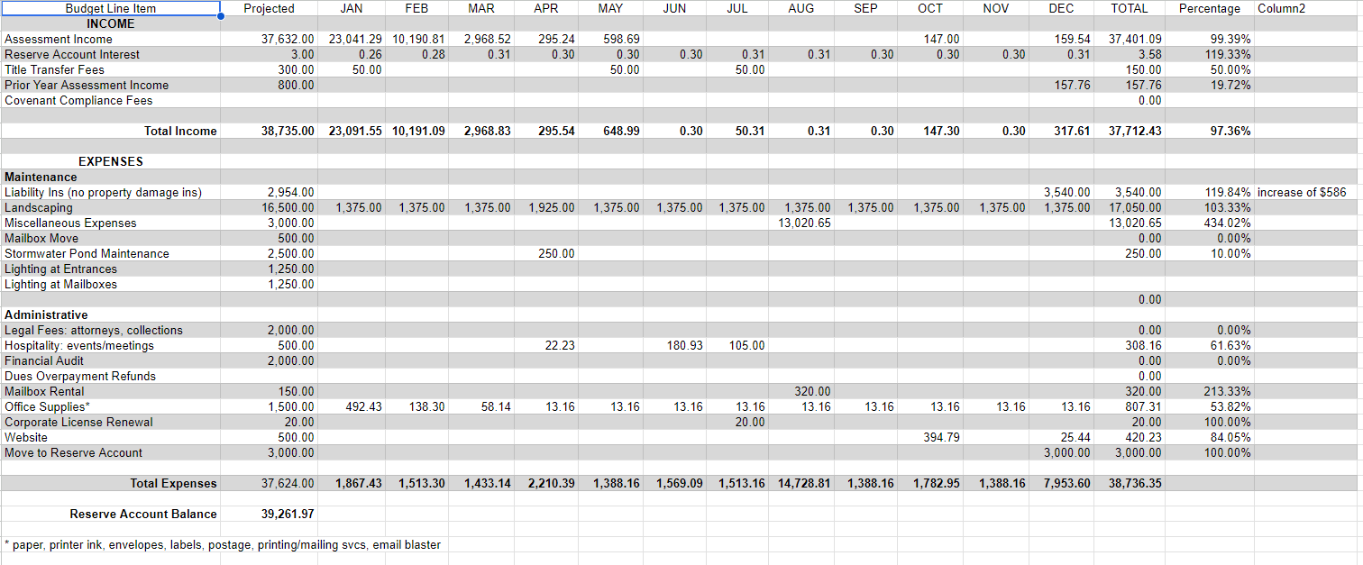
- 2026 Proposed Budget: 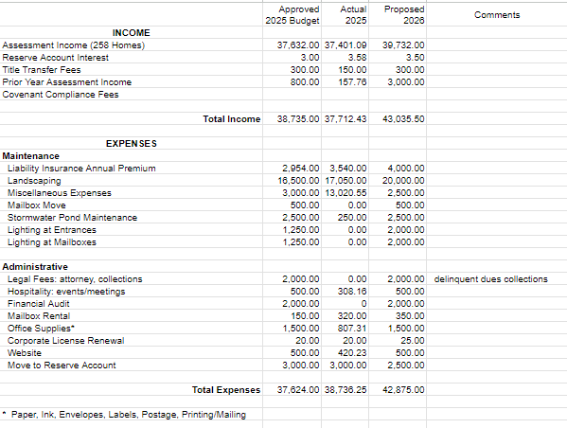
- Vote for Approval of 2026 Budget: Stacy motioned to approve the 2026 Budget, Smitty seconded, all voted in approval.

8. Committee Updates:

- Architectural [Hector]

-Currently a committee of one
-This committee reviews requests from homeowners for proposed home improvements
-Time Requirements: requests must be approved within 30 days of receipt

- Landscaping [Sean]

-Currently no committee
-Landscaper maintains common areas specified in the current contract
-Current contract is under review (new contract will have emphasis on Lots 80 and 97)
-Making sure that common areas are safe and not inviting the “wrong” activity or inhabitants

- Technology [Stephen]

-Currently a committee of one
-Website, HOA residents can pay their annual dues via the website
(calendar, notifications, architectural requests, CCR’s, trash/recycle pick-up, newsletter)
-Storage of digital records: posting minutes (posted following month after approval)

- Violations [Bill]

-Currently committee of one (tentatively) (we need a volunteer to take over from Bill)
-This committee reviews violations that oppose the current CC&Rs
-Common Violations

-Parking on grass/roadways
-Not maintaining lawn
-Excessive moss on roofs
-Items parked/placed forward of the front fence (garbage/recycle cans, trailers)

- Events [Stacy]

-Not currently a committee
-This committee would plan events in our community (Easter, Summer Social, etc.)
-Updates: Easter Egg Hunt, Trunk or Treat (Do you have ideas for events?)
-Want to volunteer? Please email us at meridianacres@yahoo.com

9. General Updates: [Sean]

Crime Watch:
(within 1 mile of Meridian Acres)
2025 2024
-Assault = 131 30
-Theft = 197 30
-Burglary = 48 7
-Robbery = 3 1
-Vandalism = 17 0

Last year we received reports of homeless individuals trying to camp on Lot #80.

Good Neighbor:

-Safety/Security = look out for each other
-Property = home and lawn maintenance
-Traffic = speeding and thoroughfare
-Pets = leash, collecting/disposing of waste
-Noise = music and barking dogs
-Signage = election and signs other than real estate

Property Value:

In 2025, approximately 50 properties were sold in our area. The average sale price of these properties is $480,000.

Volunteers:

Want to volunteer for the HOA? Please email us at meridianacres@yahoo.com

City of Lacey HOA Quarterly Meeting:

The City of Lacey hosts a Quarterly HOA community meeting at Lacey City Hall. Although we reside in unincorporated Thurston County (Lacey Urban Growth Area), the information provided and the connections made are valuable.

-The next Lacey HOA Quarterly Meeting is January 22, 2026 from 6:30pm to 8:00pm
(Lacey City Hall, 420 College Street SE, Lacey, WA 98503)

Mailing Address:

Our new mailing address is 1420 Marvin Rd. NE, Suite C, PMB 302, Lacey, WA 98516

10. Open Forum

NOTE: Please treat everyone with dignity and respect. Unruly behavior will not be tolerated.

-What are your thoughts about utilizing a property management company?
-Feedback: very strict enforcement of CCRs and the risk of losing the “community”/personal aspect that is important to members.
-Smitty asked for a show of hands to ask who would not want a Property Management Company-all except 2 people raised their hands
-What are your ideas for Lot #80?
-Looking at a different trash can solution for Lot 80.
-Lot 80 improvements: make sure any improvements aren’t inviting undesirable activity
-
-What are your ideas for the Newsletter?
*Quarterly newsletter goes out digitally through constant contact, physical letter is mailed in December
-Suggestion made to include in the newsletter to remind people that if they are burning wood to make sure that it is “seasoned wood” not green wood for air quality.
-There should be a number that you can call to request a street sweeper to come out
-“Beautification Committee”: updating the board on lot 80 need a volunteer
-Question about possibility of having a security company to monitor our community. Comes down to funding and involvement.
-Landscaping: what is the scope of their work during the winter if we are paying the same amount each month. Is there a way that we can utilize them as an “on-call” when we have large storms, etc… Have discussion with company to be more proactive than reactive. Landscaping is currently the largest expense that we have in the budget.
-Look at doing a “community clean-up” event
-Look at changing the CCR’s to allow home owners to own up to 3 chickens. Concerns for livestock: noise, smell, upkeep.
-Question: are BeeHives allowed on the property within the CCR or are they considered “livestock”
-Question: Who is responsible for the storm drains? The city is responsible for the storm drains and they come out 2x a year. Smitty is going to mention it to the landscapers.
-There has been an increase in door-to-door sales people. You can put a non-solicitation sign on your door.
-Leash Law: right of way 5-10 ft into your yard which is why we do not have fences in the front of our properties. Leashes are required. Asked to include in next newsletter.
-Asked about having a gate at one of the entrances. We would have to look at cost and figure out logistics of where to put the gate.
-What does the CCRs outline about burning

-Adjourn [Sean]: meeting adjourned at 11:02 am

Meeting Schedule
-The Board of Directors meets virtually the second Wednesday of every month. The link is available on the Meridian Acres Website.

The next HOA meeting is scheduled for February 11, 2025 at 6:00pm

