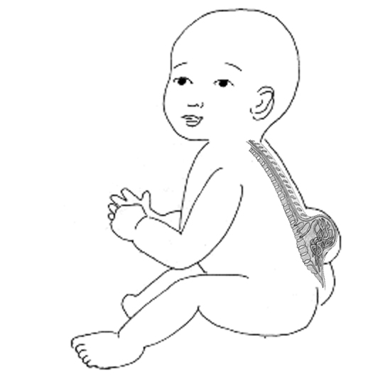
What is Spina Bifida?
Spina Bifida is caused when the spine does not form properly very early in development, before a baby is born. Then when the baby is born this problem in their back leads to weakness in their legs and toileting difficulties.

Prevention
Folic acid is a natural supplement found in food that prevents Spina Bifida in most babies if taken by women before conception and early in pregnancy.
Movement
People with Spina Bifida often cannot use their feet or legs. But with the help of braces, crutches, or wheelchairs, nearly all people with Spina Bifida can become mobile.
Incontinence
Spina Bifida often causes a lack of bowel and bladder control. Fortunately, this can be addressed. Even young children can learn how to keep themselves clean and dry.

Spina Bifida ni nini?
Spina bifida inatokea wakati ambapo uti wa mgongo haukamiliki au hauumbiki vyema mtoto anaokuwa tumboni mwa mama yake. Kisha mtoto anapozaliwa taizo la mgongo wao husababisha udhaifu kwenye miguu na ugumu wa kudhibiti haja ndogo na kubwa.
Kuzuia
Spina bifida inawezakuzuiliwa kwa asilimia kubwa mama akitumia Tembe za folic acid ambazo ni madini yanayotolewa kwenye vyakula vya asili.
Kutembea
Sehemu kubwa ya watu ambao wana spina bifida wanatumia miguu yao kutembea kwa msaada wa viatu maalumu, mikongojo ya kutembelea na ama kiti cha magurudumu. Karibia watu wote ambao wana spina bifida hujitegemea wanapotembea.
Kuzuilia haja
Spina bifida inaweza kusababisha mtu asiwe na uwezo wa kuzuilia haja ndogo na au kubwa, lakini kwa msaada maalumu wa kimatibabu watu wazima na watoto wadogo manaweza kujimudu na kuwa wasafi!

