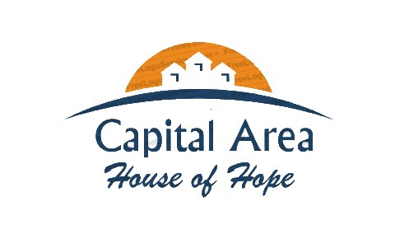

An alcohol and drug-free living environment for temporary and long-term housing located in Sherwood Forest Subdivision near Old Hammond Highway.

Whom We Serve

Men in need of an inclusive, affordable living environment. Men who are looking for transitional housing. Independent senior citizens that desire a low-cost living space. Also, men battling with substance abuse and mental health conditions.

**What is the Price**?

$550.00 for shared rooms and $600 for individual rooms / $25.00 Processing Fee

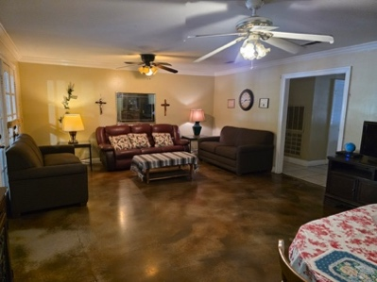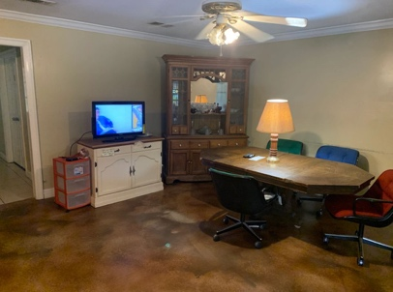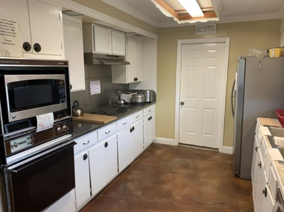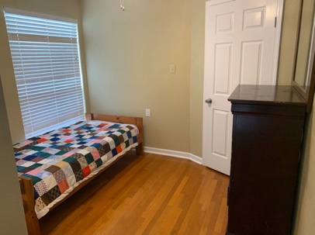

**What is Included?**

* Furnished Units with Kitchen Appliances, Utensils and All Cookware
* Computer and Internet Access with Printing Capabilities
* All Utilities
* Basic Cable
* Washer/Dryer
* Huge Closets
* Convenient Bus Line Route
* Individual Room Key
* Counseling and Day Programs
* Exercise Equipment
* In Room Refrigerator

Screening - Fully completed application, pass an interview with at least one Capital Area House of Hope staff, photo identification must be available, verification of ability to maintain financial obligations. Ability to pass a drug test.

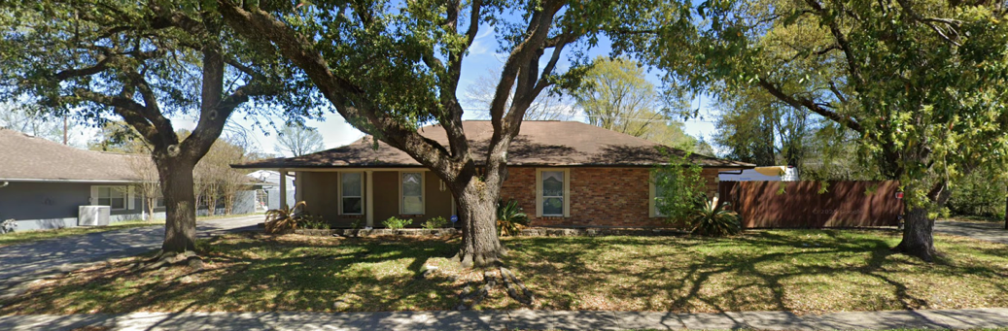Dr. Alice James, PSY.D, MSW, CSW

Executive Director

PO Box 15005

Baton Rouge, LA 70895

225-421-1495 Ext 3 or 225-954-0161

Fax: 1-866-521-7031

EM: [caifs2015@yahoo.com](mailto:caifs2015@yahoo.com)