
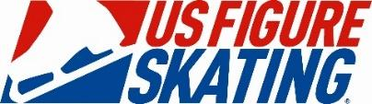
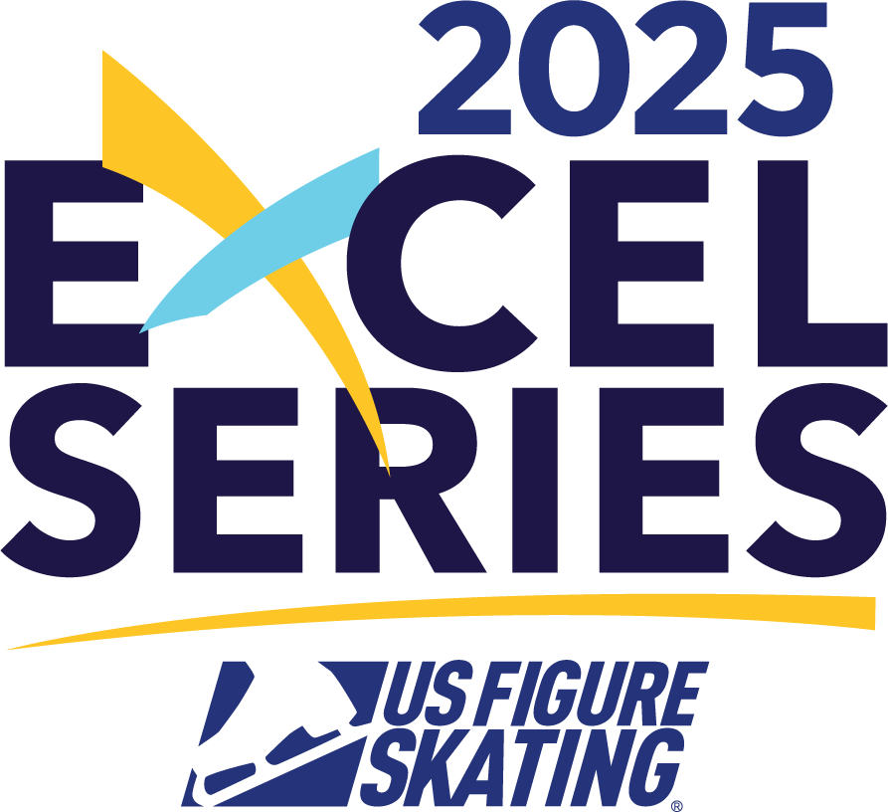

​​​​

\

The Sikumi Figure Skating Club Announces:
2025 Sikumi Invitational – April 12th & 13th
Hosted By: Sikumi Figure Skating Club
Klick Lewis Arena | Annville, PA 17003

I. COMPETITION OVERVIEW

The SIKUMI INVITATIONAL will be conducted in accordance with the rules and regulations of U.S. Figure Skating, as set forth in the current rulebook, and/or current Compete USA handbook as well as any pertinent updates that have been posted on the U.S. Figure Skating website.

This competition is open to all eligible, restricted, reinstated or readmitted persons as defined by the Eligibility Rules.

Skaters must be a currently registered member of a U.S. Figure Skating member club, or a Learn to Skate USA® member, a collegiate club or who is an individual member in accordance with the current rulebook. For non-U.S. citizens, please refer to the rulebook for more information.

2025 Excel Series:
This competition has been approved as a 2025 Excel Series host. Skaters must register to participate in the Excel Series prior to competition at designated competitions in order to have their points recorded and seen in standings. Excel Series Registration | Excel Series Information

II. ELIGIBILITY

Singles: Excel and Well-Balanced Events:
- Skaters must meet at least the minimum singles test requirements for the event’s level. A skater’s singles test level may be higher than the minimum requirement.
  - Skate Up: skaters may skate up one level higher than their minimum test requirement allows.
- Skaters may not register for an event level lower than allowed by their competitive floor. An athlete’s competitive floor is set by one of the following scenarios:
  - If an athlete has a paid EMS series application for the NQS series, the event level registered for in the most recent NQS will become the lowest level they may compete at in any U.S. Figure Skating sanctioned event.
  - If an athlete has a paid EMS series application for the Excel Series, the event level registered for in the most recent Excel series will become the lowest level they may compete in any Excel event. For Well-Balanced and Specialty events the skater will be permitted to register at one level lower than the “floor” set by their excel series entry.
  - If an athlete has never had a paid EMS series application in the NQS or Excel series, the athlete may select their level based on their goals and technical skills as long as the minimum test requirements are met.
- Skaters are not permitted to enter an Excel free skate and a Well-Balanced free skate event at the same competition (example: Juvenile Girls Free Skate and Juvenile Girls Excel Free Skate). However, they are permitted to enter an Excel and a Well-Balanced event of different types such as a short program (if stand-alone event option), specialty or showcase events (example: Intermediate Women Short Program and Intermediate Women Excel Free Skate).
- For more details about establishing event levels, refer to the information sheet HERE or email events@usfigureskating.org.

All other singles and partner events (such as Adults, Pairs, Ice Dance):
Skaters must meet the minimum test requirements for the events level, but not exceed the maximum permissible test requirement.

Age restrictions/requirements: Singles free skate events (Well Balanced Program) have the following requirements.
Juvenile: Girls – 12 years of age or younger; Boys – 13 years of age or younger
Open Juvenile: Girls – 13 years of age or older; Boys – 14 years of age or older
Intermediate must be under the age of 18
Adults must be 21 years of age or older

Skaters entering pre-juvenile and lower events will be divided as closely as possible by age, should the number of entries warrant more than one group.

EVENTS OFFERED:

- U.S. Figure Skating Program Requirements: usfigureskating.org --> Skate --> Compete --> Program Requirements
- Compete USA Program Requirements: learntoskateusa.com/competeusa
- Skating Accommodation Memorandum (S.A.M.): Skaters using a S.A.M. must submit their S.A.M. to the competition chair via email at EMAIL ADDRESS.
  - Click here for more information about S.A.Ms.
  - If you have questions about on how to support skaters using S.A.Ms, email events@usfigureskating.org.

On the program requirements page linked above, competitions that fall within the date range beside the program requirements must use those requirements.
** Entry fees for events are listed below. Please note the below fees are not based on the order in which you select your events. The event with the highest fee will be considered your first event. Subsequent events beyond the first two events is also provided.

SINGLES | JUDGING | 1st Event Price | 2nd Event Price
Excel Free Skate (Pre-Preliminary – Senior) | IJS | $175
Well Balanced Short Program (Juvenile – Senior) | IJS | $175 | $120
Well Balanced Free Skate (Pre-Juvenile – Senior) | IJS | $175
Adult Free Skate (Adult Pre-Bronze – Master Jr/Sr) | IJS | $175
Adult Beginner & High Beginner Free Skate | 6.0 | $125
ATHLETE DEVELOPMENT | JUDGING | 1st Event Price | 2nd Event Price
Compulsory Moves (Level 1 - 8) | 6.0 | $125 | $75
SHOWCASE | JUDGING | 1st Event Price | 2nd Event Price
Emotional Performance (Preliminary – Senior, Adult) | CJS | $125 | $75
Lyrical Pop (Preliminary - Senior, Adult) | CJS | $125 | $75
Character Performance (Preliminary - Senior, Adult) | CJS | $125 | $75
COMPETE USA EVENTS | JUDGING | 1st Event Price | 2nd Event Price
Snowplow Sam-Basic 6 Program w/ Music | 6.0 | $90 | $60
Aspire 1-4 Program w/ Music | 6.0 | $90 | $60
Pre-Preliminary – Preliminary Free Skate | 6.0 | $90 | $60
Adult 1-6 Program w/ Music | 6.0 | $90 | $60
Snowplow Sam – Basic 6 Elements | 6.0 | $90 | $60
Adult 1-6 Compulsory Moves | 6.0 | $90 | $60
Compete USA – Showcase | 6.0 | $90 | $60

OUR COMMUNITY:
U.S. Figure Skating is dedicated to fostering a culture of belonging and community that is welcoming for all individuals. We are committed to championing diversity, equity and inclusion and understand its value in combating discrimination and challenging inequalities necessary to develop champions both on and off the ice. We are actively working toward developing equitable practices and policies that foster safety and empower all individuals to authentically pursue their unique path in all areas of our sport. We stand firmly on the belief that our members are the most important asset to our organization and that our differences are meaningful and strengthen our sport. We believe that skating is for everyone.

NON-DISCRIMINATION:
U.S. Figure Skating commits in policy, principle and practice to sustain a non-discriminatory approach on and off the ice for all members. We strive to provide equal opportunity for all despite their varied backgrounds, experiences and identities, and want all members to feel valued and respected at every level of organization. U.S. Figure Skating’s SkateSafe® Program receives, investigates and addresses allegations of discrimination or harassment throughout its membership and the organization. Please refer to the SkateSafe® Program Handbook for further definition of harassment, discrimination and abuse.

By attending this event, all participants are willingly committing to upholding U.S. Figure Skating’s Code of Ethics (GR 1.01) and Code of Conduct (GR 1.02), as detailed within the U.S. Figure Skating Rulebook.

To report a concern of discrimination or harassment to U.S. Figure Skating, please visit www.USFigureSkating.org/SkateSafe or email SkateSafe@USFigureSkating.org.

ATHLETE ASSISTANCE/ACCOMMODATIONS:
Should a skater with disabilities require any specific accommodations or assistance for their competitive event, please submit your approved S.A.M to the Competition Chair by the registration deadline at sfscclubmatters@gmail.com

COMPLIANCE:

COACHES
To be an eligible coach at a nonqualifying competition, coaches must meet the applicable compliance requirements and verified by U.S. Figure Skating. Coach compliance falls into two categories, Coach Compliance (includes choreographers) and Learn to Skate USA® Instructor Compliance. Details regarding compliance requirements can be found HERE. All compliance requirements must be met at the time of check-in to access the competition, no exceptions.
Coaches of foreign athletes: If you are a coach of a foreign athlete only, you are not subject to U.S. Figure Skating coach compliance and will only be asked to provide a letter of good standing for the federation your athlete represents.
With EMS, coaches must be included within a skater/team’s registration or updated through their EMS Skater Portal via “My Coaches” or “Team Personnel.” All coaches declared at the time of registration will be included in the registration confirmation email. Note: There is no registration approval process within EMS as the data (membership and test level) is tied to the U.S. Figure Skating database. Non-compliant coaches will receive automated email reminders through the start of the competition.
EMS Coach Resources (not SYS or TOI):
- My Competitions
- My Skaters
- Coach Schedule

EMS Coach Resources (SYS or TOI only):
- Team Management Guide

III. REGISTRATION INFORMATION

ONLINE REGISTRATION VIA EMS:
Online registrations will be accepted via EMS. Payment must be made at the time of registration by credit card only. Each transaction includes a 3% transaction fee.

Registration Deadline: 03/14/2025 at 11:59PM EST
Late Registration Deadline: 03/21/2025 at 11:59PM EST + $30 Late Fee
*The host club reserves the right to close registration at any time if event capacity is met

- Go to www.usfsaonline.org
- Enter your U.S. Figure Skating or if Compete USA events are offered, your Learn to Skate USA® member number and password
  - If you need assistance with your member number and password, contact Member Services at memberservices@usfigureskating.org.
- Click EMS then “Competition Registration”
- Choose 2025 Sikumi Invitational from the list of nonqualifying competitions.
  - If you need assistance completing your registration, contact productsupport@usfigureskating.org.

FOREIGN SKATERS:
Non-U.S. skaters intending to register for this competition must set up a non-member account prior to registering for the competition (click here for HOW TO). This can be done by choosing the “Non-Member? Create Account” option on the Members Only login page.

MUSIC SUBMISSION/UPLOAD:

EMS MUSIC UPLOAD: Competitors participating in events with music are required to upload their music to EMS no later than 3/28/2025 at 11:59PM EST. After this date, skaters will be locked out of this feature and subject to a $30 late fee. The late fee will automatically be added to each skater's cart who doesn't meet this requirement by the deadline. Late fees will not be removed under any circumstances and must be paid prior to receiving the skater credential onsite.
DEADLINE: 3/28/2025 at 11:59PM EST
EMS SKATER MUSIC UPLOAD HOW TO: CLICK HERE
If you need assistance, email productsupport@usfigureskating.org
Competitors must also have available a backup copy of their competition music on a cell phone, and it must be immediately available rink side whenever the skater competes. If the phone does not have the standard round headset connector, an appropriate adapter, such as an Apple Lightning connector or Samsung USB-C adapter is required to be attached. The phone should be presented to the music person with the file ready to play, phone in airplane mode and volume turned to maximum.

PLANNED PROGRAM CONTENT (PPC) SUBMISSION/UPLOAD – FOR IJS EVENTS ONLY:

EMS PLANNED PROGRAM CONTENT (PPC) – Competitors participating in IJS events are required to submit PPC in EMS no later than 3/28/2025 at 11:59PM EST. After this date, skaters will be locked out of this feature in EMS and subject to a $30 late fee. The late fee will automatically be added to each skater’s cart who doesn’t meet this requirement by the deadline. Late fees will not be removed under any circumstances and must be paid prior to receiving the skater credential onsite.
DEADLINE: 3/28/2025 at 11:59PM EST
EMS PPC UPLOAD HOW TO: CLICK HERE
If you need assistance, email productsupport@usfigureskating.org
REFUND POLICY
Registration Deadline: 03/14/2025 at 11:59PM EST
Late Registration Deadline: 03/21/2025 at 11:59PM EST + $30 Late Fee
Late Registrations will be allowed at the discretion of the competition chair
*The host club reserves the right to close registration at any time if event capacity is met
**Refunds will not be permitted after the close of registration on 3/14/2025. Refunds for medical reasons will not be guaranteed and will be approved at the discretion of the competition chair**

LIABILITY:
U.S. Figure Skating, Learn to Skate USA®, Sikumi Figure Skating Club and Klick Lewis Arena accept no responsibility for injury or damage sustained by any participant in this competition. This is in accordance with Rule 1600 of the official U.S. Figure Skating Rulebook.

IV. COMPETITION DETAILS

FACILITIES:
KLICK LEWIS ARENA
101 LANDINGS DRIVE, ANNVILLE, PA 17003
https://www.klicklewisarena.com/
The ice surface measures 85’ by 200’ with rounded corners.

LOCKER ROOMS AND CHANGING AREAS:
Locker rooms and changing areas at U.S. Figure Skating competitive events are for athletes only and will be labeled with regard to specific use and where identified will be gender specific. An exception can be made for athletes under 11 years old that will allow for one parent of the same sex to assist their child immediately prior to and after their skating event(s). Please review the Locker Room and Changing Area Policy in the SkateSafe® Handbook.

U.S. Figure Skating Travel Policy:
All travel must strictly adhere to Two-Deep Leadership requirements. An Adult Participant cannot transport a Minor Athlete one-on-one and Two-Deep Leadership requirements must be adhered to at all times during In-Program travel, by transporting at least two minors or a second Adult Participant. An Adult Participant cannot share a hotel room or other sleeping arrangement with a Minor Athlete(s). Full details of the SkateSafe® Travel Policy and any exceptions can be found starting on page 12 of the SkateSafe® Handbook.
OFFICIAL WEBSITE & UPDATES:
It is the responsibility of each competitor, parent and coach to check the competition web page frequently for any schedule changes and/or additional information pertaining to the competition. Participants may use the following link to access the information about the competition: https://sikumifigureskatingclub.com/2025-sikumi-invitational

Event Results will be posted online. A QR Code and URL link will be made available on the competition web page and onsite at the rink that can be used to access and view competition results. Results will not be posted in the rink.

SCHEDULE
Competitors may be scheduled on any day or time during the announced dates of the competition. The competition and practice ice schedule will be available after the close of entries. All participants will be notified via email once available.

PRACTICE ICE:

Pre-Purchase Practice Ice Credits: Practice ice credits may be purchased after participants complete their event registration, via the EMS Competition Portal. Skaters who purchase credits during the pre-purchase period will be able to select sessions during the selection period, after the schedule has been completed and posted.
- Click Here for a Pre-Purchase How-To Document
- Open: 02/21/2025
- Close: 03/21/2025
- Cost per credit: $20

Pre-Purchase Selection: After the close of entries and shortly after the competition schedule is published, skaters will receive an email with notice of the practice ice schedule and the date/time when pre purchased credits can be scheduled via EMS.
- Click Here for a Selection How-To Document
- Open: 03/28/2025
- Close: 04/02/2025

Open Sales: Practice Ice sessions will be available after the schedule has been published. Skaters will be able to purchase open sessions available to them.
- Click Here for an Open Sales How-To Document
- Open: 4/3/2025
- Close: 4/13/2025
- Cost per session: $20

ONSITE CHECK-IN:
Check-in will open on 4/12/2025 in the Main Lobby of the Arena at the Skate Rental window.

If you are participating in a role requiring compliance, please be sure to download or print your compliance card to verify your compliance status on-site, if requested. If you believe your compliance card does not accurately reflect your compliance status, please contact skatesafe@usfigureskating.org at least 2 business days prior to the competition for assistance.

AWARDS:
Medals for 1st, 2nd and 3rd place and 4th place ribbons will be distributed on site. Traditional ceremony and podium presentation for all events will be scheduled and communicated based on the final event schedule. Medals will not be handed out early all participants are asked to stay for their medal ceremony.

PHOTO/VIDEO:
A video of your performance is included with your registration fee.

CONTACT INFORMATION:
Competition website: https://sikumifigureskatingclub.com/2025-sikumi-invitational
For questions, please contact the following individuals:

Competition Chair: | Stacie Burkhart | sfscclubmatters@gmail.com | 717-419-5241
Chief Referee: | Rebecca Hilgers | hersheyett@aol.com
Practice Ice Chair: | Doris Papenfuss | sfscclubmatters@gmail.com

