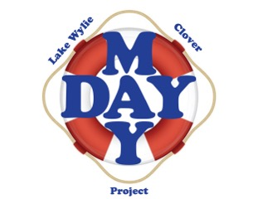

**Lake Wylie/Clover Mayday Project**

www.maydayproject.org  
**Charity Golf Tournament**

**Title Sponsor**

**October 10, 2022 – River Hills Country Club**

**RAFFLE ITEM CONTRIBUTION**

**We will have a raffle for items with a value of at least $50. What would you like to contribute to support our organization?**

___________________________________________________________________________________________________________________________________________________________________________________________________________________Value $_________________

**COMPLETE:**

**Contact Name:**  ___________________________________________________________

**Business Name:** ___________________________________________________________

**Address:**  _________________________________________________________________

**E-mail:** ___________________________________ **Phone:**( ) _____- _____________

**Donations are tax-deductible as a contribution to a 501(c)(3) charitable organization.**

Make checks payable to: **Lake Wylie/Clover Mayday Project** and mail to:

**Lake Wylie/Clover Mayday Project, 168 Highway 274 #332, Lake Wylie, SC 29710**

**OFFICE USE:**

***Mayday Committee Member***: ______________________ **PHONE:** ___________________