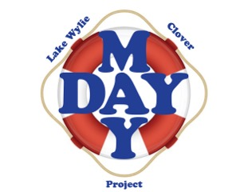**Lake Wylie/Clover Mayday Project**

**Charity Golf Tournament**



**Title Sponsor**

**SPONSOR LEVEL INFORMATION**

|  |  |  |  |  |  |  |
| --- | --- | --- | --- | --- | --- | --- |
| **Donation Amount:** | **$150** | **$300** |  | **$500** | **$1,000** | **$5,000** |
| **Sponsor Level:** | **Golf Hole** | **Life Preserver** |  | **\*Life Line** | **\*Life Boat** | **\*Title Sponsor** |
|  |  |  |  |  |  | **\*Special Sponsor** |
| **Sponsor List to Golfers** | **ü** | **ü** |  | ü | ü | ü |
| **Display Sign on Tee** | **ü** | **ü** |  | ü | ü | ü |
| **Included on Slide Show\*** |  | **ü** |  | ü | ü | ü |
| **1 Golfer and 1 Awards Party** |  | **ü** |  |  |  |  |
| **2 Golfers and 2 Awards Party** |  |  |  | ü |  |  |
| **4 Golfers and 4 Awards Party** |  |  |  |  | ü | ü |
| **Display Business on Assigned Hole** |  |  |  | ü | ü | ü |
| **Greet Golfers on Assigned Hole** |  |  |  |  | ü | ü |

**CONTEST SPONSOR RAFFLE SUPPORT**

|  |  |  |
| --- | --- | --- |
| **Closest to the Pin - Longest Drive - Straightest Drive**  **$100 Donation** |  | **Donations with Minimum of $50 Value** |
|  |
|  |

* Life Line Sponsors and higher will have their logos posted on the Mayday website, Golf Tournament website, Social Media, and the event slide show. E-mail your logo to: pam@pathfinderplanningllc.com

**IRS Donations are tax deductible as a contribution to a 501(c)(3) charitable organization.**

**Register online at:** [**www.maydayprojectgolf.com**](http://www.maydayprojectgolf.com)