IXL Learning: https://www.ixl.com/

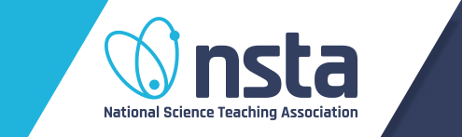
National Science Teaching Association - Interactive eBooks, available with free membership: https://www.nsta.org/ebooks/

American Museum of Natural History - Science website for kids
https://www.amnh.org/explore/ology?src=h_nc

Smithsonian Institute - Fun stuff for kids online: https://www.si.edu/kids

