B.A.A.T.C
BALTIMORE AFRICAN AMERICAN TOURISM COUNCIL, INC,.

Centennial Golf Tournament
Friday, September 25, 2026
Join us for a memorable day on the green celebrating 100 years of community, connection, and friendly competition.
Event Details | What to Expect
Date: September 25, 2026  Time: Registration opens at 8:30AM  Location: Forest Park Golf Course, est 1926  Format: Scramble / Best Ball / Individual Team Play | 18 Holes, Beginners Golf Clinic w/Golf Pros  Continental Breakfast & Memorial Luncheon  Awards, Prizes and Trophies  Raffles, Contests, Sponsor Recognition  Networking and Centennial Celebration

Registration
Golfers, teams, and sponsors are welcome. Reserve your spot early for this special Centennial celebration. Space is limited. Golf Fees include 18 Hole Scramble Play, Swag Bag, Luncheon, Cart fees.
- Individual golfer: $125pp, Foursome $500
- Beginners Golf Clinic: $125pp, Luncheon Tickets: $45
- Deadline to register: August 31, 2026
- Register by contacting: Cheryl A. Coles, bbhtours.cac@gmail.com/ 202-744-4946

Sponsorship Opportunities
Show your support and gain visibility with players, guests, and community members through sponsorship opportunities. Make checks payable to BAATC, P.0. Box 3014, Baltimore, MD 21229. Zelle/Cash App
- Title Sponsor: $5000, MVP $4000, All-Stars $3000 Gold $2500, Silver $2000, Bronze $1750. Souvenir Program Booklet (5x8) Full Page $1500, Half Page $1200. Quarter Page $675 .
- Hole Sponsor: $500
- Contest Sponsor: $500
- Prizes or raffle donations welcome
Sign up today and be part of the Centennial celebration!
Questions? Lou Fields, 443.983.7974 | email: bbhtours@gmail.com

B.A.A.T.C
BALTIMORE AFRICAN AMERICAN TOURISM COUNCIL, INC.

Centennial Golf Tournament
Friday, September 25, 2026
Join us for a memorable day on the green celebrating 100 years of community, connection, and friendly competition.
CASH PRIZES * Awards Luncheon
8AM SHOTGUN 4 PERSON SCRAMBLE
BEGINNERS GOLF CLINIC
A CELEBRATION OF 100 YEARS OF GOLF
@
FOREST PARK GOLF CLUB
2900 HILLSDALE AVE
BALTIMORE, MD 21207
Presented by Baltimore African American Tourism Council, Inc.
REGISTRATION AND SPONSROSHIP INFORMATION: Lou Fields 443.983.7974
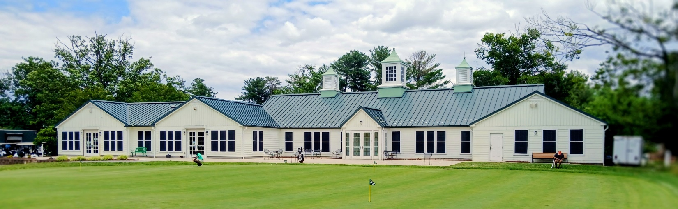
Information Release June 22, 2026
Centennial Golf Tournament to Celebrate Forest Park Golf Course Rich Legacy

Contact: Lou Fields, 443.983.7974 | Email: bbhtours@gmail.com
Tournament Registration Information: cheryl_a_coles@yahoo.com
Event Name: Centennial Celebration Golf Tournament
Location: Forest Park Golf Course, 2900 Hillsdale Road, Baltimore, MD 21207
Date: Friday, September 25, 2026
Time: 8:00 a.m.–4:00 p.m.
Summary: The Centennial Celebration Golf Tournament will honor the 100-year legacy of the Forest Park Golf Association with a full day of golf, instruction, fellowship, and recognition at the Forest Park Golf Course. The event will feature an 18-hole scramble, a beginner-friendly golf clinic, continental breakfast, awards luncheon, trophies, prizes, and special honors for individuals connected to the course’s rich history. Golfers, teams, and supporters are encouraged to register early for this once-in-a-century celebration. In recognition of the centennial anniversary of the Forest Park Golf Association, Lou Fields, President of the Baltimore African American Tourism Council, Inc. is organizing a daylong celebration at the Forest Park Golf Course.
Teams of four will compete in an 18-hole scramble format for trophies and prizes. A team of golf professionals will also lead an educational clinic designed to help beginners and amateur golfers improve their skills and techniques. JRS Catering will provide a continental breakfast and awards luncheon.
Awards will be presented to golf coach and 1967 CIAA champion golfers Allen Wilson & Tim McReady, Pitch and Putt Club President Angela Morgan, and Charles “Chuck” Sperandeo, a USGTF master teaching professional Instructor. In 1926, Sperandeo’s father, Dr. Frank Sperandeo, was one of the original eleven founding members of the Forest Park Golf Association.
The Forest Park Golf Club was incorporated in 1934. The course is an 18-hole public course in Baltimore known for its tree-lined narrow fairways, elevated greens, clubhouse, banquet facilities, practice areas, and long-standing role in the city’s golf community. Over the years, notable golfers including Jack Lowe, Jimmy Flattery, Mary Ann Downey, Spencer Overton, Pete Brown, Calvin Peete, Samuel Stewart, Charlie Sifford, Clyde Martin, Joe Louis, and Willie Adams played the course. Richard Sheppard currently serves as the golf pro.
Registration information is currently available via email at bbhtours@gmail.com. An online registration portal will be available soon.
FMI: call or text Lou Fields @ 443.983.7974, email bbhtours@gmail.com, or visit www.bdxlive.biz.
CENTENNIAL GOLF TOURNAMENT PLAYER REGISTRATION
Friday, September 25, 2026, Forest Park Golf Course, 2900 Hillsdale Avenue, Baltimore, MD 21207
Registration: 8:00AM * Shotgun: 8:30AM * Golf Clinic: 9:00AM * Luncheon 12-4PM * Awards 2pm
Golfers receive: 18 rounds, cart, luncheon. $125 Individual * 4some $500 * Golf Clinic: $125pp
Luncheon Only: $45each Number of Tickets ______ Total Amount Included $ __________
Make Checks payable to BAATC, P.O. Box 3014, Baltimore, MD 21229 Attn: L Fields 92526
ZELLE 443 983 7974 CASH APP: $LCFBDX Invoice via Email ____
Cash Prizes for Winning Team, Longest Putt, Longest Drive, Hole-in-One, Closest to the Pin
Date: ______________ Total Amount Enclosed $ _______________
Name
Organization
Address
C/S/Z
Phone
Email
Name of team
Team Players (Includes 18 rounds, golf cart, luncheon, continental breakfast, swag bag
1.
2.
3.
4.
Golf Clinic with Pro Instructors
1.
2.
Luncheon Tickets $45each (no golf)
1.
2.
3.
FMI: call or text Lou Fields @ 443.983.7974, email bbhtours@gmail.com, or visit www.bdxlive.biz.

