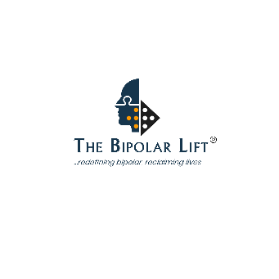
The Bipolar Lift CIC
Mental Health Awareness & Understanding Bipolar
2 hrs CPD Accredited Course Enquiry Form

Name of School:
Type of School:
Main Contact Name:
School Address / Postcode

Main Contact’s Telephone Number:
Email:
Where did you hear about Bipolar Lift?
No. of delegates / Enquiry:

Please complete and return to: support@bipolarlift.org

