Reflexology consultation Form

Name: Telephone number:
Address :
Postcode: Occupation: DOB:
Email: Doctor:
Emergency Contact: Relationship: Phone
Health Information

Are you taking any medications? ☐ yes ☐ no
If yes, please list name and use: _____________________
_______________________________________________
Are you currently pregnant? ☐ yes ☐ no
If yes, how far along? ______________________________
Any high risk factors? ______________________________

Do you have any allergies or sensitivities? ☐ yes ☐ no
Please explain ________________________________
Have you had any recent injuries? ☐ yes ☐ no
If yes, please list: ________________________________

Please indicate any of the following that apply to you.
☐ Cancer
☐ Headaches/Migraines
☐ Arthritis
☐ Diabetes
☐ Joint Replacement(s)
☐ High/Low Blood Pressure
☐ Neuropathy
☐ Fibromyalgia
☐ Stroke
☐ Heart Attack
☐ Kidney Dysfunction
☐ Blood Clots
☐ Numbness
☐Sprains or Strains
Explain any conditions you have marked above:
________________________________________________
________________________________________________
Please rate the following on a scale of 1(bad) – 5(excellent)
Quality of Sleep 1 2 3 4 5
Energy Levels 1 2 3 4 5
Stress Levels 1 2 3 4 5
Quality of Nutrition 1 2 3 4 5
Exercise Habits 1 2 3 4 5
Treatment Information

Have you had Reflexology before? ☐ yes ☐ no
Why are you seeking Reflexology today?
________________________________________________
________________________________________________
What are your goals for this session?
_____________________________________________
Please circle any areas of discomfort:

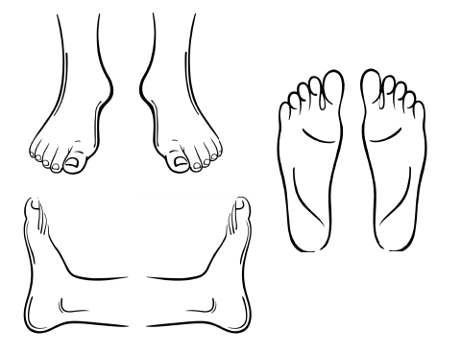

By signing below, you agree to the following.

I have completed this form to the best of my ability and knowledge and agree to inform my Reflexologist if any of the above information changes at any time.

Client Signature ____________ Date __________

Reflexologist Signature
_____________________ Date _________

