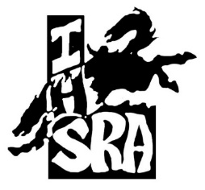
2021-2022
District 2 Sponsors…

Corporate:
Jordan Valley Rodeo Cowboys for Christ
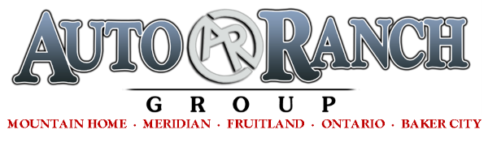
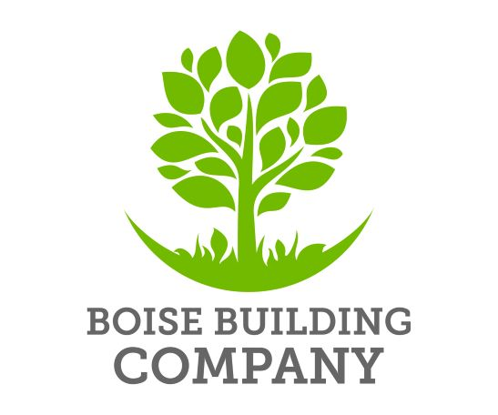
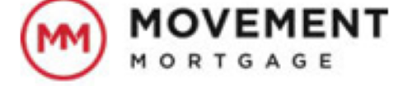
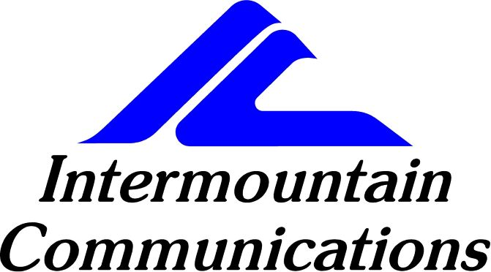
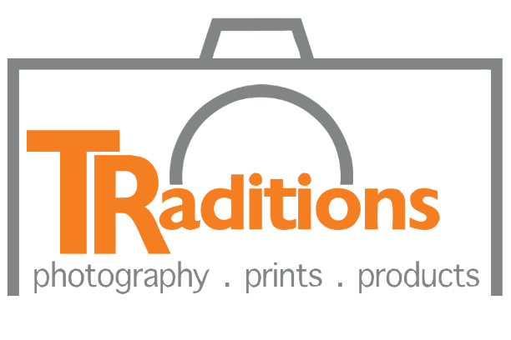

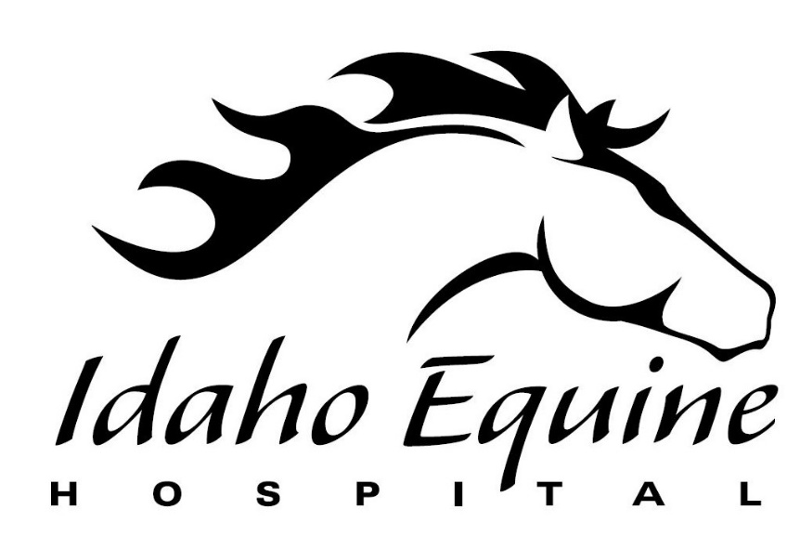
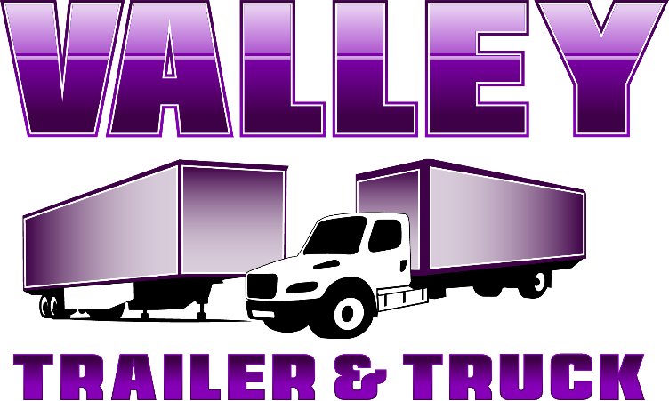

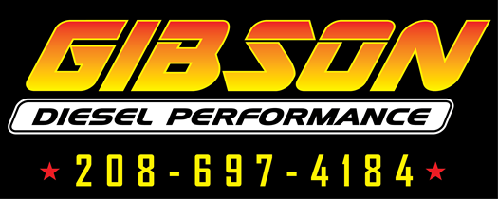
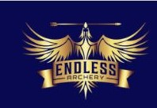

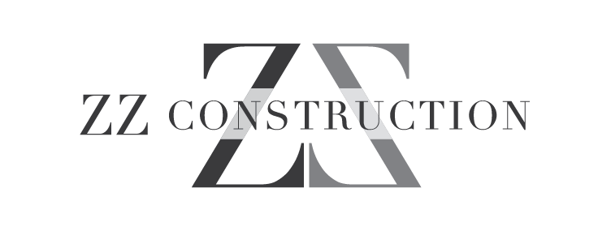
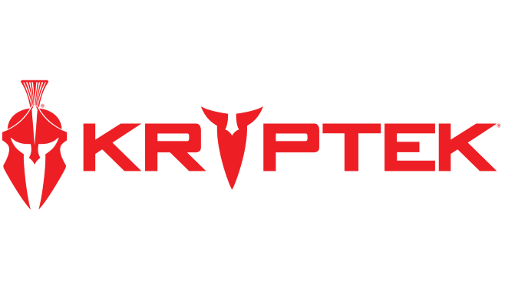
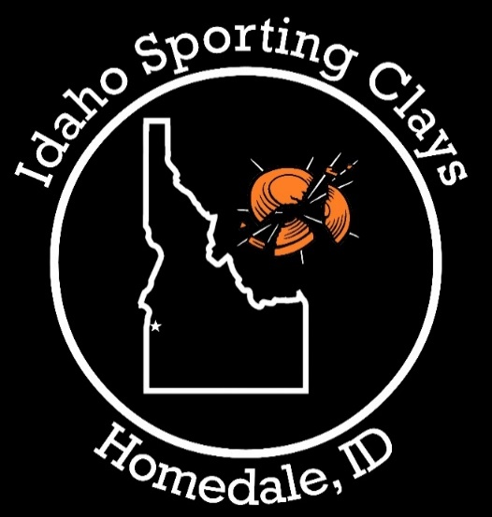
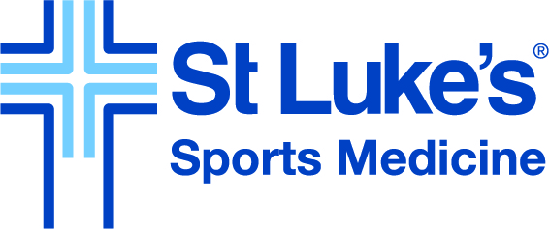

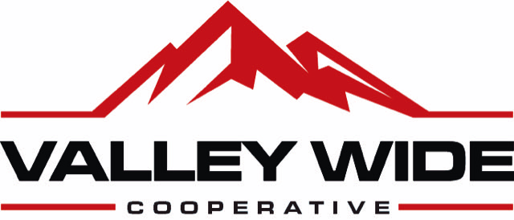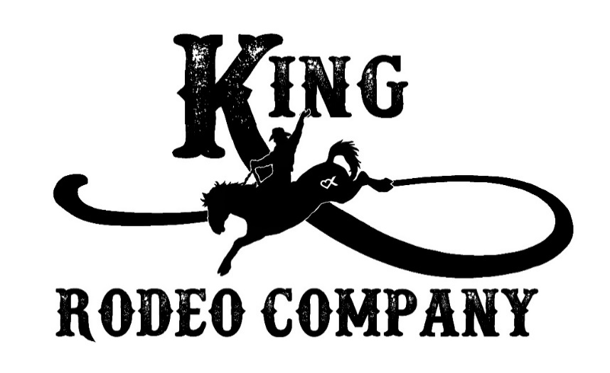

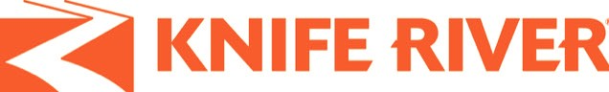

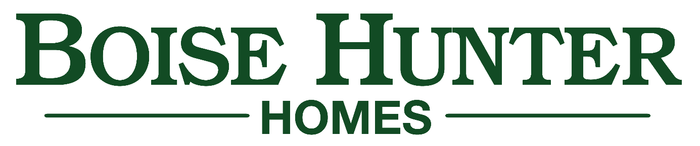

Platinum:
Parma Post & Pole Fall Creek Custom Homes
Canyon Truck Upfitters
Gold:
“R” Mom’s Lemonade Boise Hunter Homes, LLC Dennis Dillon Auto Group F/U Livestock Idaho Pizza-Homedale JC Watson Packing Company Olson’s Rodeo Bulls R & R Construction & Excavation Nau Family Fisher Club Lambs Silvercreek Realty—Debbie Hundoble Shoulder Clinic of Idaho Borders Equine Clinic Obendorf Farms Outback Stallion Station Red Aspen Roque Concrete Rogers Asphalt & Paving Renu Medispa Schmidt Construction Company Inc
The LARISON Team-- Bob & Jan Larison The LARISON Team—Marca Robinson
Team Moffis/Team Realty

Silver:
44 Livestock & Pet Supply Allstar Spray & Landscape
Amy Lee Photography Angela Yancy
Arriola Farms Bayes Real Estate LLC
Border’s Equine Clinic Caldwell Family Dentistry Connie & Frank Status Crooked 8 Events D & S Tires DeRuyter Dairy Eagle Eye Photography Heather Dietz FootHills Psychiatry
Herb & Patti Foust Idaho Shooting Sports
Idaho Pediatric Dentistry Idaho Sleigh Rides Island Express Lube and Car Wash Jon-Ramie Post Justin Christensen Farms Kavanaugh Transportation Kent Murray Construction Kuna Lumber Les Schwab Ontario Matthew Dietz Farmers Insurance Mech Tech Services Nyssa Mercantile RC Bean Saddlery Ridley’s
Shaffer Construction Shawn Deal Performance Horses Shipman Painting Skinplicity Tipton Family Tom & Debbie Shearn Top Concrete TRC Building Ultimate Heating & Air Young’s Riverfront Ranch Zimmerman Horse Training
Thank you to everyone that has contributed to IHSRA District 2 Rodeo!

THANK YOU to our arena’s that we ride at and for our tractor donations at these venues….
Owyhee County Rodeo Gem County Fairgrounds
SRC Badiola Arena Crooked 8 Arena
- King Rodeo Company for providing rough stock
- Our announcer, timer’s, judges……

A SPECIAL THANK you to all our families for supporting your rodeo athletes and for getting them to and from the rodeos.

**THANK YOU** to every one of our volunteers that help put the rodeo on both “boots on the ground” and our behind-the-scenes people that make things happen for our youth athletes.
ORDER OF EVENTS

- HS Barrels
- JH Barrels
- JH Chute Dogging
- HS Steer Wrestling
- JH Girls Breakaway
- HS Bronc Riding
- JH Bull Riding
- HS Breakaway
- JH Boys Breakaway
- HS Bull Riding
- HS Tie Down Roping
- JH Tie Down Roping
- JH Ribbon Roping
- HS Goat Tying
- JH Girls Goat Tying
- JH Boys Goat Tying
- HS Team Roping
- JH Team Roping
- HS Poles
- JH Poles

