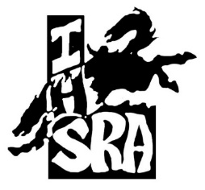
2022-2023
District 2 Sponsors…

Corporate:
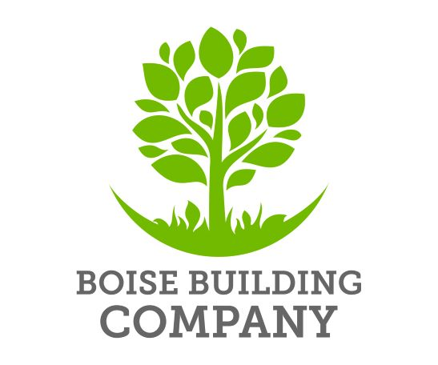
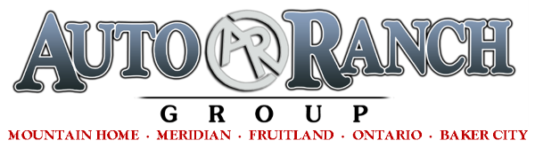
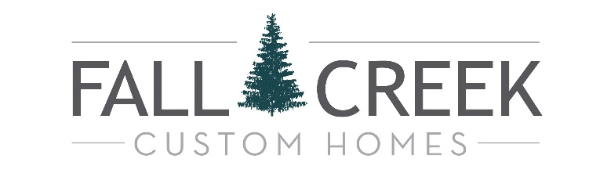
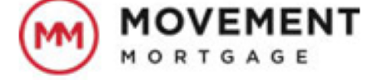
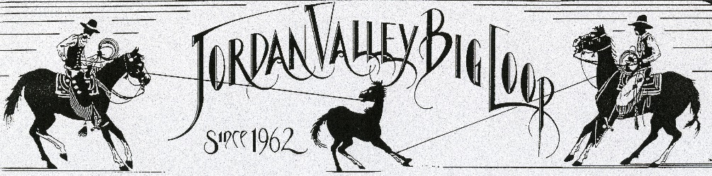
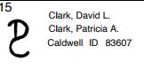
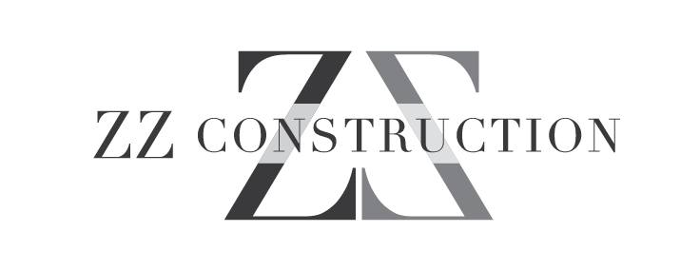 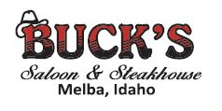 IDAHOSPORTS.com
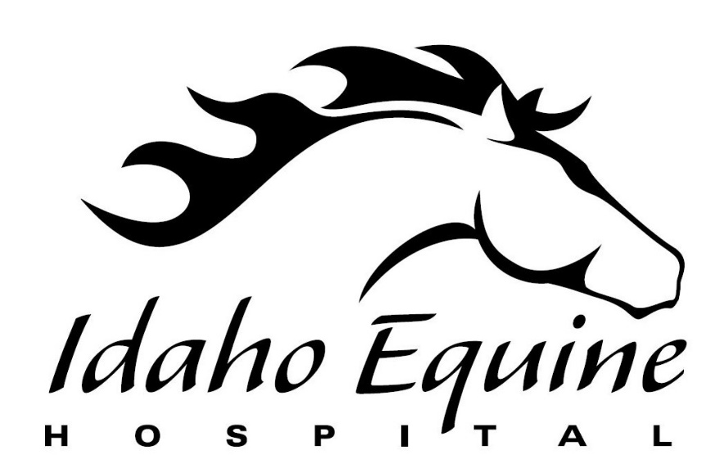

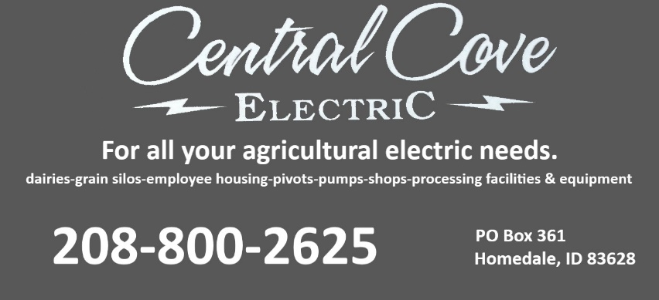

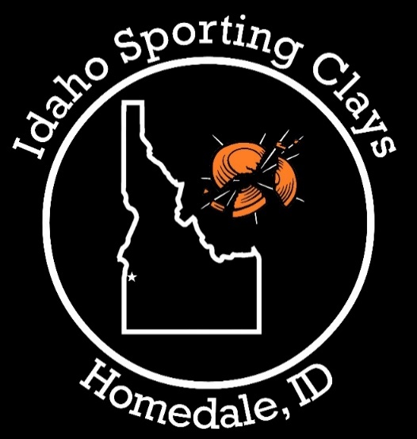
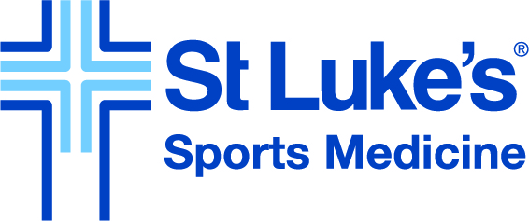
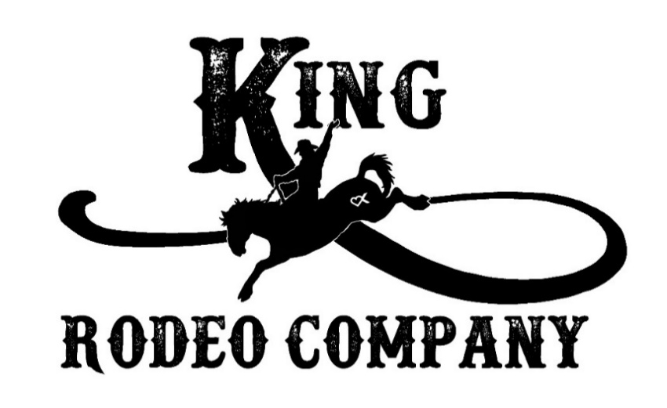
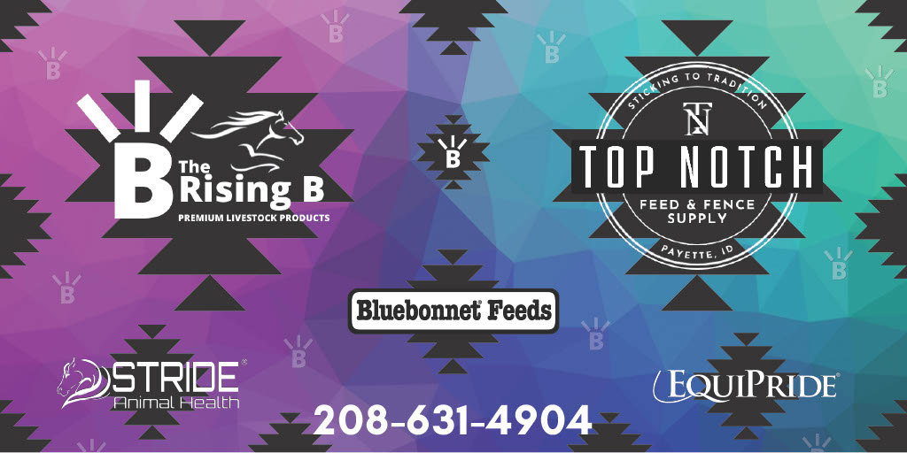
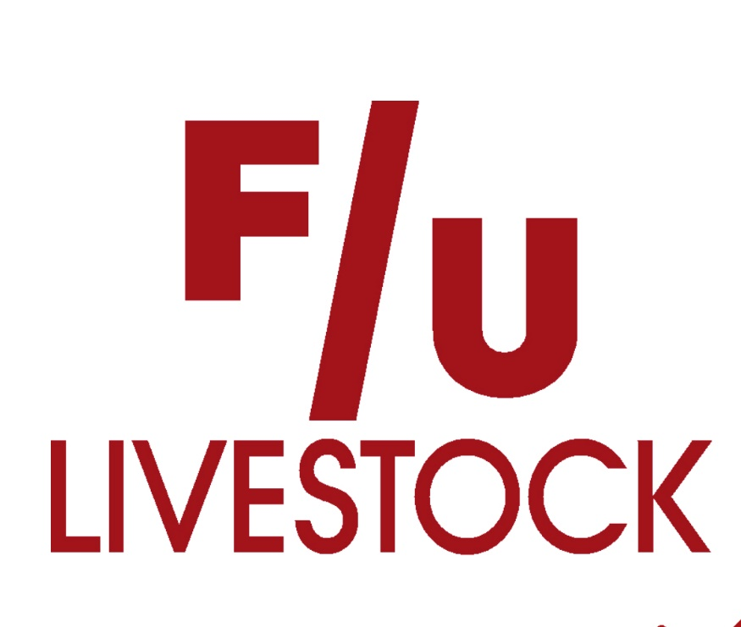
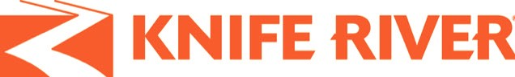
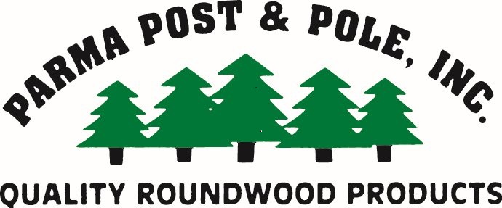
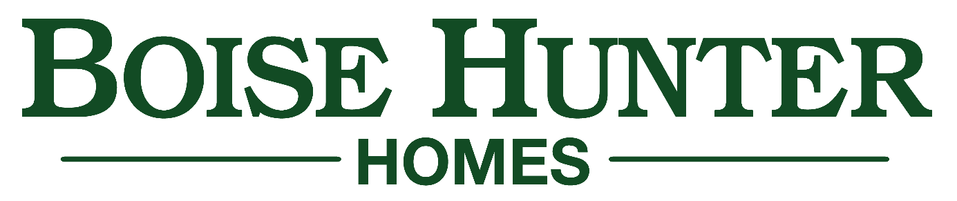

Platinum:
Central Cove Construction Harper Tarentaise
Wilson Point S Tire

Gold:
Alliance Title Anthony Verdino
Bar 20 Cowboy Stuff Dirt Monkey Excavation, LLC
Edward Jones-Annie Smith Este Vista Farms
Excel Equipment Company Fisher Club Lambs
Foothills Cabinet Company Hopper Electric Co.
Idaho Power Idaho Pizza
Johnstone Ranch JC Watson Packing Company Obendorf Farms Olson’s Rodeo Bulls Moffis Investments Renu Medispa
R Mom’s Lemonade Rod Fivecoat Auctions, LLC
Rogers Asphalt & Paving R & R Construction & Excavation
Sasquatch Contracting Trim Pro Todd Rossman Law Schmidt Construction Company Inc
The LARISON Team-- Bob & Jan Larison The LARISON Team—Marca Robinson
Trenching Services Valley Glass Co
Vassar Enterprises

Silver:
44 Livestock & Pet Supply 413 Cattle Company
Allstar Spray Landscape American Furniture Mart
Amy Lee Photography Aqua Irrigation Technologies, LLC
Arriola Farms Avalon Dental
BK Farms Caldwell Family Dentistry
Carmen Bengoa Counseling Cattle Drive Coffee & Grill
CED Claudia Crutcher
Connie & Frank Stauts Coughing Cowgirl Equine Services Cowgirls Catering Crooked 8 Events Dan’s Ferry Service Darren & Angie Layne
Dillion’s Place Doggie Detailing Garrett’s Dry Cleaning
Herb & Patti Foust Idaho Sleigh Rides
Intermountain Communications Island Express Lube and Car Wash
Jared and Mindi Gebauer JDF Electric
JL Cattle Jon and Ramie Post
Jordan Performance Horses Joslin Custom Meats
Kelly and Vicky Kramer Kevin and Katherine Smith
Kuna Lumber Lazy L Ranch
Lazy Loop Goat Roping Life Chiropractic Center
Lockhart-Cape Ranch Wes McCoshum & Cassie Hammer
McGehee Family Nutrien Ag Solutions
Neutra Bac-PH~Danielle Jennings One Digital
Performance Plumbing & Heating Premium Elevator Co
Rafter H Building RC Bean Saddlery
Real South Idaho Real Estate Rock Bottom Dairy
Rodeo Trippin’ Rusty Star Ranch Supplements & Wellness
Sara Hackler Shawn Deal Performance Horses
Skinplicity Super Smiles Orthodontics
Tipton Family Tona Andrade Horse Training
Top Concrete Travis & Lindy Gorham
The Insurance Group Valspec Painting
Venom Transport Waite Family
Weaver Masonry Wendal Family
Wilson Creek Cattle Feeders Zimmerman Horse Training
Thank you to everyone that has contributed to IHSRA District 2 Rodeo!

THANK YOU to our arena’s that we ride at and for each donation and volunteer at these venues….
Owyhee County Rodeo Crooked 8 Arena
SRC Badiola Arena
- King Rodeo Company for providing rough stock
- All our stock providers, thank you!
- Our announcer, timer’s, judges……

A SPECIAL THANK you to all our families for supporting your rodeo athletes and for getting them to and from the rodeos.

**THANK YOU** to every one of our volunteers that help put the rodeo on both “boots on the ground” and our behind-the-scenes people that make things happen for our youth athletes.
ORDER OF EVENTS

1 – HS Barrel Racing
2 – JH Barrel Racing
3 – JH Chute Dogging
4 – HS Steer Wrestling
5 – JH Girls Breakaway
6 – HS Saddle Bronc
7 – JH Bull Riding
8 – HS Breakaway
9 – JH Boys Breakaway
10 – HS Bull Riding
11 – HS Tie Down
12 – JH Tie Down
13 – JH Ribbon Roping
14 – HS Goat Tying
15 – JH Girls Goat Tying
16 – JH Boys Goat Tying
17 – HS Team Roping
18 – JH Team Roping
19 – HS Pole Bending
20 – JH Pole Bending

