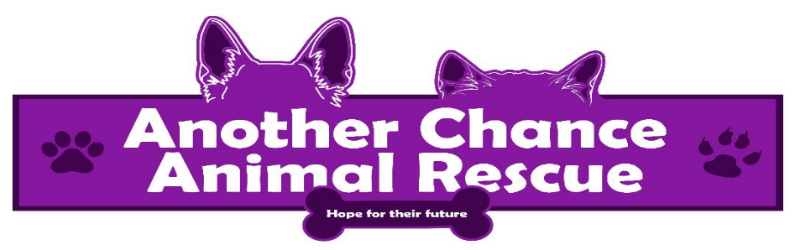

**Adoption Application**

Date:__________

Name of animal interested in (if applicable):___________ Dog_____Cat______(check one)

Applicants Name:(Print legibly) _______________________

Address:______________________(Street)____________________(City)_________(State)

Phone Number:___________ Email:______________ Employer:__________________

Do you Rent or Own (circle one) If you rent please list contact information for Landlord or Development Manager:________________________(name and number)

Current Animals: (please fill this section out in detail)

Name:________________ Breed:______________ Age:____________ M/F:___ Fixed:______

Vaccine History:________________________________________

Name:________________ Breed:______________ Age:____________ M/F:___ Fixed:______

Vaccine History:________________________________________

Name:________________ Breed:______________ Age:____________ M/F:___ Fixed:______

Vaccine History:________________________________________

Name:________________ Breed:______________ Age:____________ M/F:___ Fixed:______

Vaccine History:________________________________________

If you have dogs, are they on heartworm preventative? (yes or no) Please list the preventative:________

Is your yard fenced in? Yes___ No____ If so, how high is it?__________

Where will the animals live during the day?__________________________

Where will the animals sleep at night?_______________________________

Have you ever relinquished an animal over to Animal Control, shelter or re-homed and animal?_______________ If so, why?__________________________________________

How many pets have you owned in the past 10 years?_____________________________

Please list the Veterinarian we may contact for those animals:_____________________(Name/Number)

Do you have a current Veterinarian? Yes____ No_____ Name:____________________________

Phone:________________________ If not, who will you use?_______________________

Have you considered the expense of this animal, both routine and unexpected illness? Yes___ No___

Do you have any children living in the home? Yes___ No____ If yes, how many and how old are they?____________________________________________________________________________

Do children visit your home? Yes___ No___ If yes, how often?____________________

If interested in adopting a cat, do you plan to declaw this cat? Yes______No_______

Are you aware of the leash laws in PA and that you MUST have control of your pet at all times? Yes__ No__ Are you aware that ALL cats and dogs over 3 months of age MUST have a current rabies vaccine in PA? Yes__ No__ Are you aware that ALL dogs over 3 months of age MUST be licensed in PA? Yes__ No__

Are you 21 years of age? Yes__ No___

Applicant Signature:_____________________

*Please allow 24 hours upon receipt of the application to be reviewed before a rescue representative call you back*