*Fertilized Eggs Available*

# March 5th, 2018

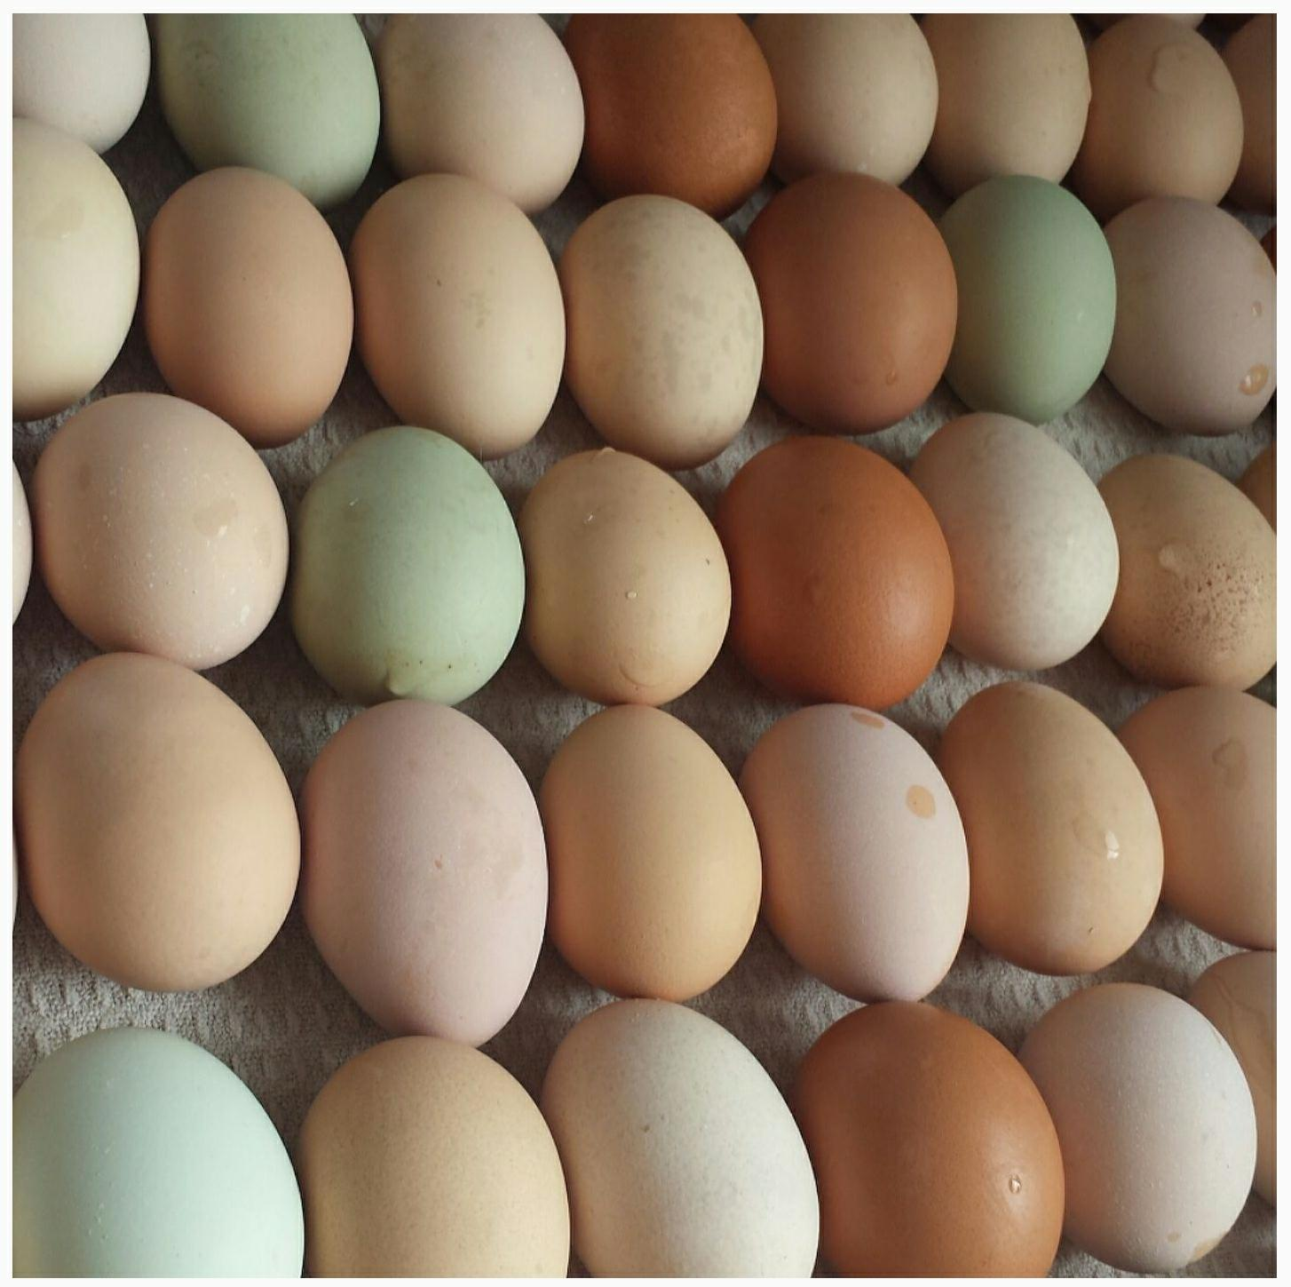We will have fertilized eggs for hatching all summer! Quantities are limited so contact us soon to reserve yours! Olive Eggers and Easter Eggers are $18 a dozen and we also have Barnyard Mix for $10 a dozen - Red Orpington Rooster with Buff Orpingtons, Golden Comets, Blue Laced Red Wyandotte, and a few other girls in the mix ;)