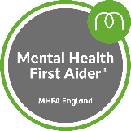

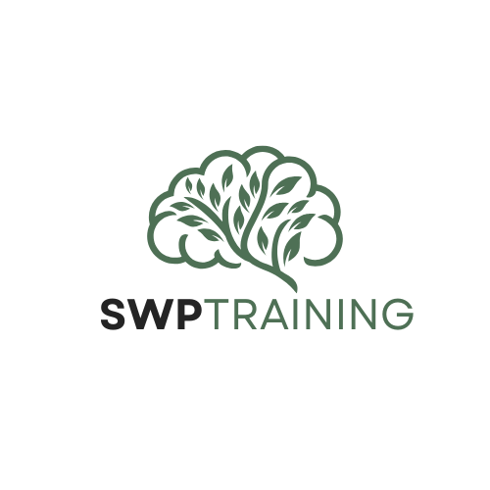
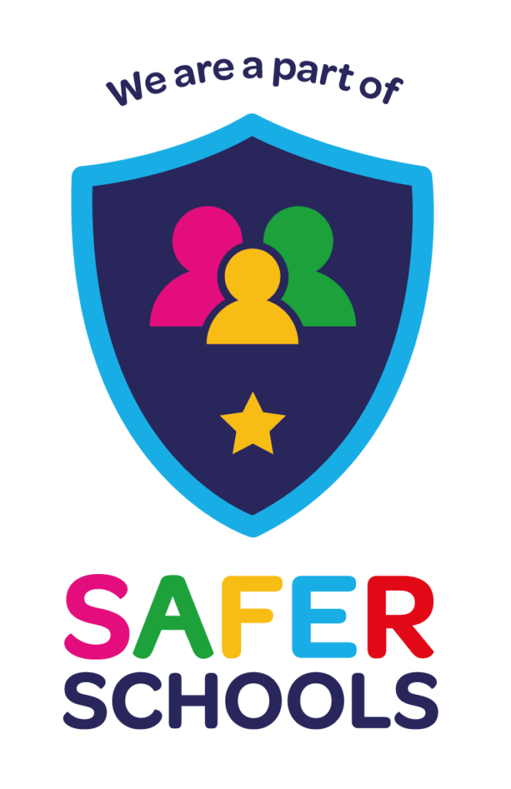
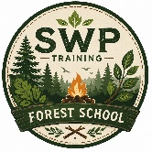

office@SWP-training.com Wendy (Director) -07378636213 Jada (Hive)- 07378372071 Rhia (Loft) -07460192004
SWP Training Information Sheet for Referrers June 2026.
SWP is a new alternative provision for 11–16-year-olds creating a safe, nurturing environment where young people feel respected, understood, and valued. Strong relational approaches are at the heart of our service, with consistent staff who build trust and model positive behaviour. Learning is flexible, practical, and relevant, offering hands-on experiences that re-engage students and build confidence. Clear routines and high expectations provide stability, while personalised support addresses social, emotional, and academic needs. Effective communication with families and schools ensures continuity and shared goals. Most importantly, a great provision focuses on strengths, helping each young person develop resilience, skills, and a renewed sense of purpose.

SWP Training is a small, specialist Nottinghamshire Alternative Provision for young people aged 11–16, delivering high-quality core subjects with a particular strength in STEAM (Science, Maths and Media Arts). Our experienced team hold PGCE (QTLS) and CertEd (QTLS) qualifications, alongside specialist credentials in SEND, including a qualified SENCO, TIS(UK) practitioners and MHFA-trained staff. We are passionate about providing a rigorous, curriculum-based education built on strong engagement and meaningful relationships.

We have a GCSE exam centre (28171), a Vocational Centre (NCFE-9002843), our own Arts Award centre (75497) and STEM CREST centre (2831). Based in Mansfield Woodhouse and Kirkby, we also work within the local community across Ashfield, Mansfield, Bassetlaw, Gedling and Nottingham where required. We have a Forest School site based in Kirkby and a bespoke horticulture (inc Bee hives) and sports area. We also have staff who work/volunteer at the Sherwood Observatory and Planetarium. We have strong partnership links with ‘Little Roos’ Nursery and Felley Ranch Animal Therapy.

Our centres offer well-equipped tutoring rooms, salon, a professional sound studio, gym, e-sports suites, games room and dedicated sensory spaces, enabling flexible and personalised learning pathways.

At SWP, young people are supported within a safe, nurturing environment where they feel respected and understood. Consistent staff build trust, model positive behaviour and maintain high expectations. Learning is practical and relevant, re-engaging students and rebuilding confidence while addressing academic, social and emotional needs.
We welcome referrals and invite schools and professionals to contact us to discuss how we can support your young people.

OUR BASES

We have two bases,

The Hive (Mansfield Woodhouse)
Core GCSE’s. Functional skills, Vocational Centre (Occupational Studies eg Hairdressing Salon, Food and Nutrition, Childcare, Barberry etc) Also Exam Centre and registered Vocational Hub.

The Loft Wellbeing Centre
Core GCSE’s. Functional skills, Vocational Centre (Occupational Studies eg Sports, Food and nutrition, STEM, Media, Wellbeing etc) We are also a registered Centre for Arts award and Crest Awards. The Loft specialises in positive activities

OUR STAFF TEAM

At SWP we have a diverse and highly experienced staff team that consists of,

6 x Qualified Teachers (QTS and QTLS)
1 x SENDCO
1 x Psychologist
1 x Therapist (Trauma Informed Schools UK)
1 x Registered Social Worker
1 x Exam Officer
2 x L4 assessors for Vocation Verification
1 x Forest School Qualified Staff
9 x Mental Health First Aiders
Vocational specialist

RESOURCES

We have an Exam Centre (28171)
We are NCFE registered (9002843), though looking at Btec registration also
We are an Arts Award Centre (75497)
We deliver Mental Health First Aid to staff and students
We are a Trauma Informed Schools (UK) Centre
We have a fully equipped Gym (with qualified Personal Trainer)
We have a Wellbeing Hub with qualified Graduate Psychologist
Two fully equipped e-sports rooms
A fully equipped music and media studio
A Forest School bespoke area
A Horticultural bespoke area

QUALIFICATIONS
(We have two exam centres 1st approved and 2nd going through approval)

NCFE (Vocational, Occupational Studies)
GCSE’s (English, Maths and Science)
Functional Skills (Entry to L1 & L2)
Arts Award (Bronze, Silver, Gold)
CREST Awards Centre

PARTNERSHIPS (Developed and WIP)
(Including potential work placements)

-Litle Roos nursery – Working with Children
-Haywood House (Dementia / Elderly Peoples Home) – Care (Elderly)
-Felley Ranch (Animal care)
-Sherwood Observatory (STEM based) – Catering and Tourism
-Happy Days – Day care for Dementia
-Stone Bridge Farm – Animal care and Tourism
-Notts County Football club and foundation
-Bridge Mentoring – post 16 education
-ATTFE - various

