Marc Daniels

Portfolio

Table of Contents
Resume……………………………………………………………………………………………………………………….…………… 4

Network Security
~CIS 481 (Intro to Information Security)~
Wireshark…………………………………………………………………………………..……………………………………………. 5
Zenmap……………………………………………………………………………………………………………………………………. 6
Local Group Policy Editor……………………………………………………………….………………………………………... 7
Active Directory Users and Computers……………………………………………………………………………………… 8

Database Design & Architecture
~CIS 310 (Database Design) & CIS 350 (Infrastructure Technology)~
ERD………………………………………………………………………..………………………………………………………………… 9
Windows Batch/Script Files………………………….………………………………………………………………………… 10

UML (Unified Modeling Language) & OOP (Object-oriented Programming)
~CIS 320 (Systems Analysis & Design)~
ERD Prototype……………………………………………………………………………………………………………………….. 12
Sequence Diagram…………………………………………………….…………………………………………………………… 13
Use Case………………………………………………………………………………………………………………..………………. 14

IS Management
~CIS 410 (Management of Information Systems)~
Business Case…………………………………..…………………………………………………………………………………….. 18

SRC Project
~CIS 320 & CIS 420 (CIS Development Project)~
Final ERD…………….………………………………………………………………………………………………………………….. 26
Demo Website……………………………………………………………………………………………………………………….. 27

Excel & Access
~CIS 250 (Intro to Data/Information Management) & CIS 300 (Computer Information Systems)
Excel Pivot Tables………………………………………………………………………………………………………………..… 30
Access Queries, Forms, and Reports……………………………………………………………………………………… 31
Professional Business Writing
~BUS 301 (Business Communication)~
Long Form Business Report…………………………………………………………………………………………………… 34

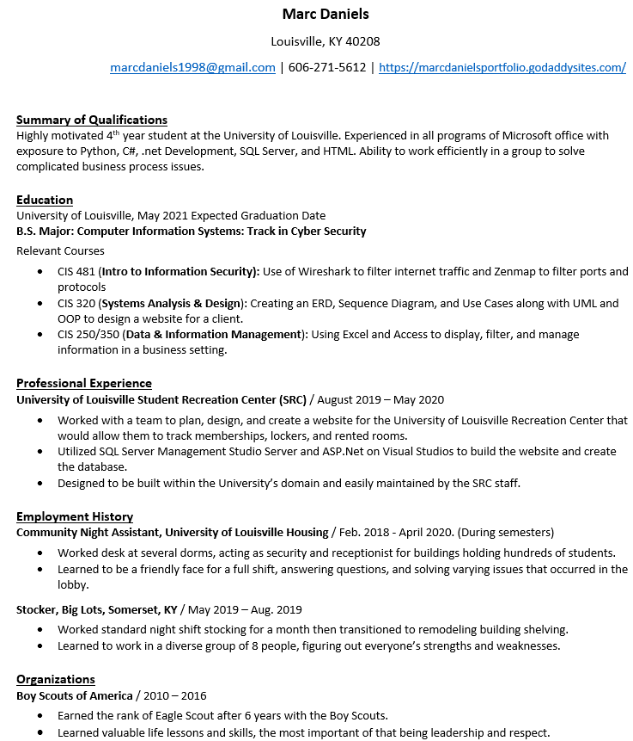

Information Security
~CIS 481 (Intro to Information Security)~
Wireshark
Using Wireshark to filter through internet IPv4 traffic
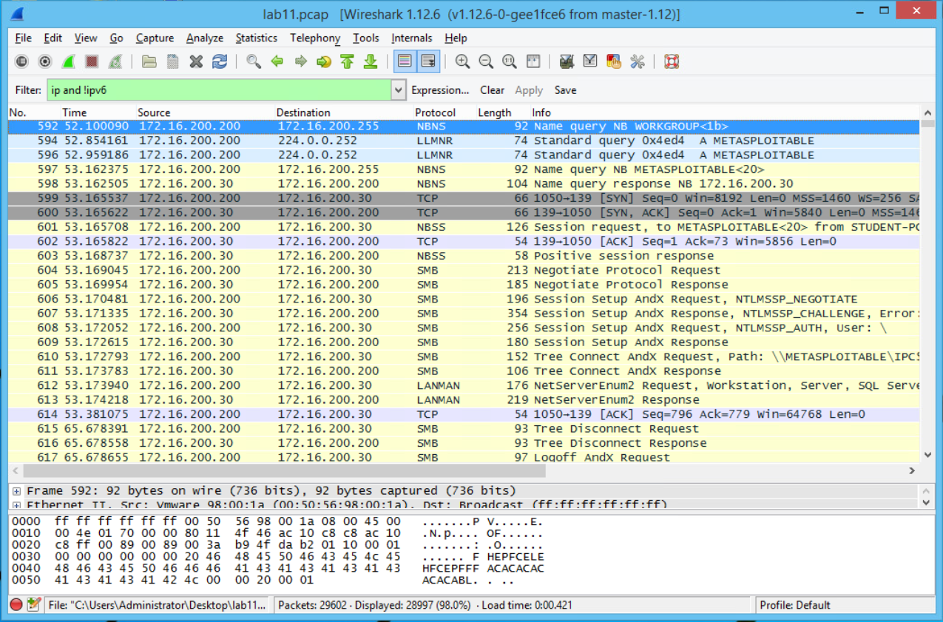

Zenmap
Using Zenmap to view open and closed ports on a system
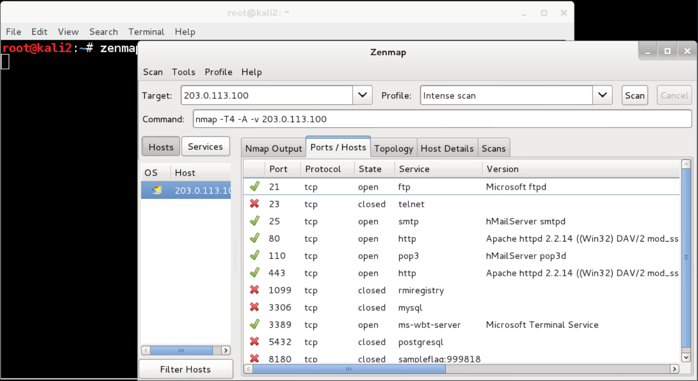

Local Group Policy Editor
Using the Local Group Policy Editor to view and edit security policies on a system
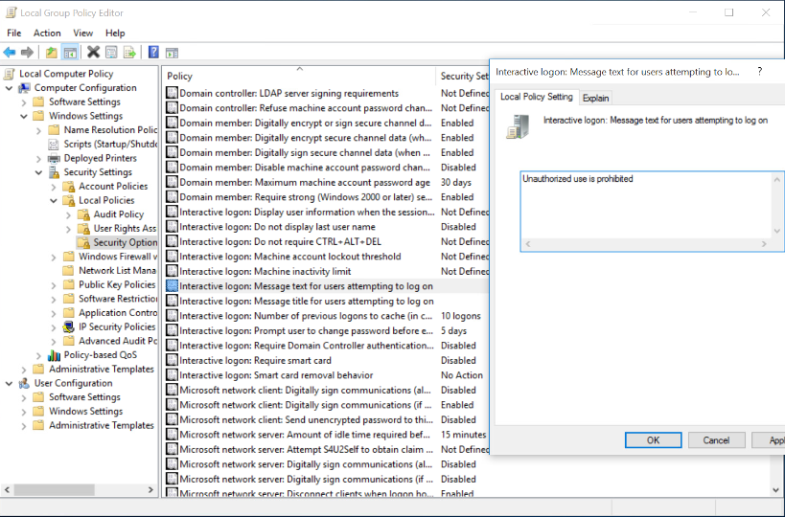

Active Directory Users and Computers
Using the Active Directory Users and Computers to add and edit users on a server
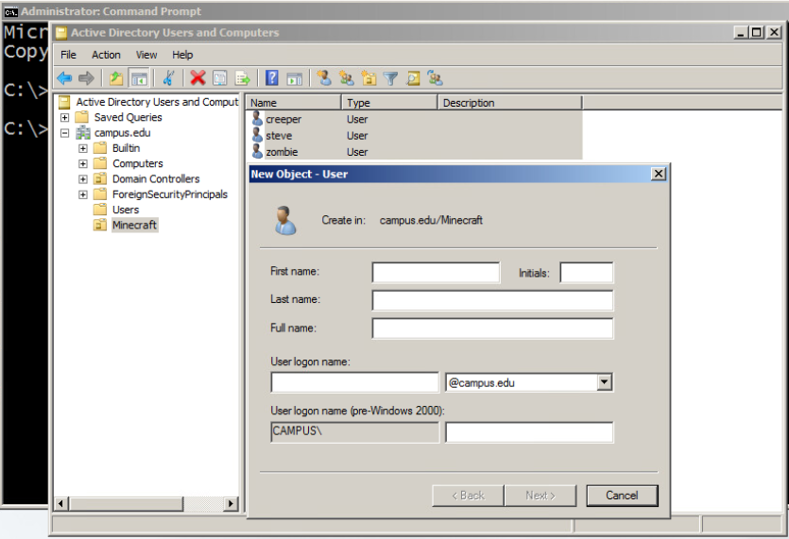

Database Design & Architecture
~CIS 310 (Database Design) & CIS 350 (Infrastructure Technology)~
ERD
An Entity Relationship Diagram between a supplier and a customer
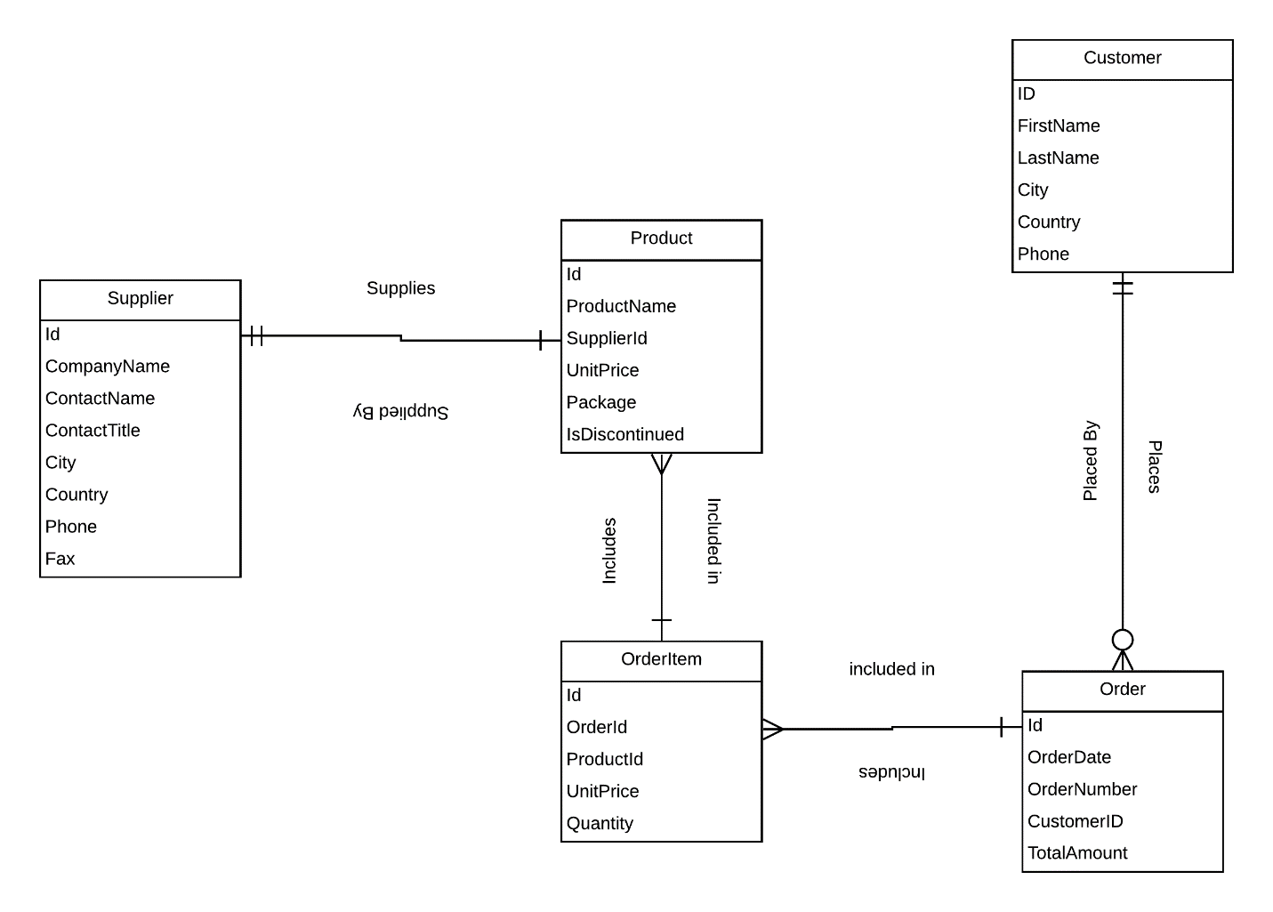

Windows Batch/Script Files
Creating a batch file that functions as a menu for opening notepad and calculator, the code follows
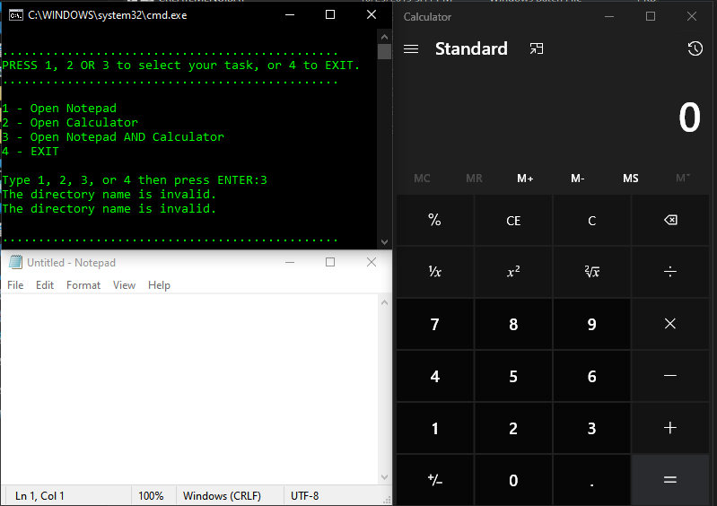
ECHO OFF
CLS
:MENU
ECHO.
ECHO ...............................................
ECHO PRESS 1, 2 OR 3 to select your task, or 4 to EXIT.
ECHO ...............................................
ECHO.
ECHO 1 - Open Notepad
ECHO 2 - Open Calculator
ECHO 3 - Open Notepad AND Calculator
ECHO 4 - EXIT
ECHO.
SET /P M=Type 1, 2, 3, or 4 then press ENTER:
IF %M%==1 GOTO NOTE
IF %M%==2 GOTO CALC
IF %M%==3 GOTO BOTH
IF %M%==4 GOTO EOF
:NOTE
cd %windir%\system32\notepad.exe
start notepad.exe
GOTO MENU
:CALC
cd %windir%\system32\calc.exe
start calc.exe
GOTO MENU
:BOTH
cd %windir%\system32\notepad.exe
start notepad.exe
cd %windir%\system32\calc.exe
start calc.exe
GOTO MENU
:EOF
UML (Unified Modeling Language) & OOP (Object-oriented Programming)
~CIS 320 (Systems Analysis & Design)~
ERD Prototype
The prototype Entity Relationship Diagram for the SRC renovation project showing the entities and relationships between the tables.
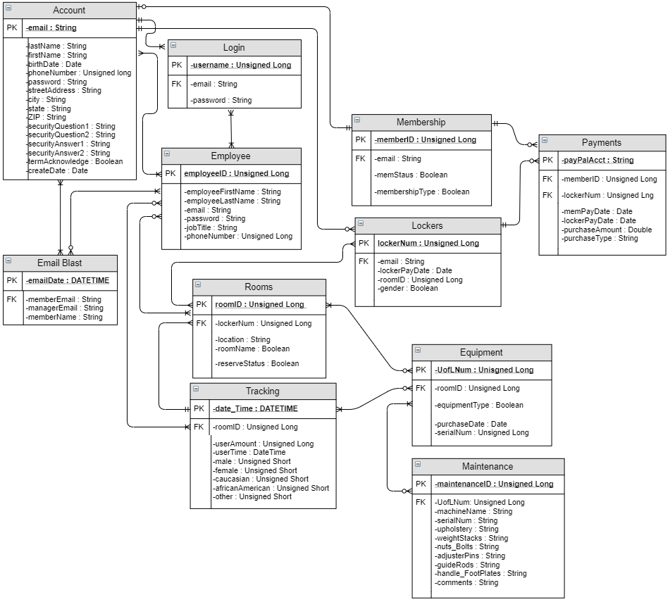

Sequence Diagrams
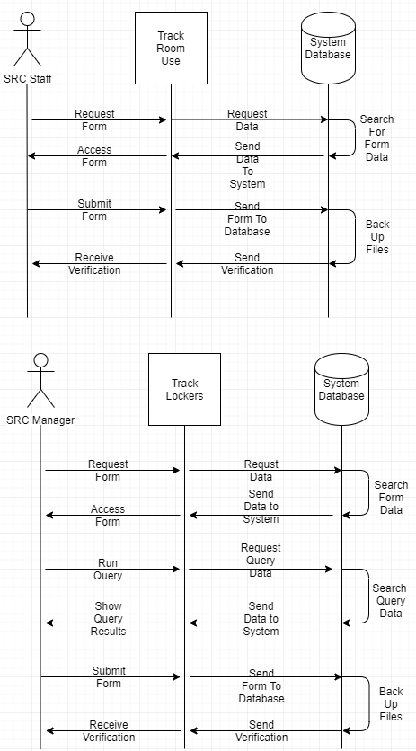
Use Case
A use case specification for the track lockers use case of the SRC revamp project.
SRC Revamp
Use Case Specification: Track Lockers

Version 1.3

Revision History
Date | Version | Description | Author
09/Oct/19 | 1.0 | Formatting | Marc Daniels
14/Oct/19 | 1.1 | Adding Information | Marc Daniels
20/Oct/19 | 1.2 | Final Formatting | Marc Daniels
23/Oct/19 | 1.3 | Revising | Marc Daniels

Table of Contents
1. Use-Case Name 4
1.1 Brief Description 4
2. Flow of Events 4
2.1 Basic Flow 4
2.2 Alternative Flows 4
2.2.1 Payment Due Soon 4
2.2.2 Payment Not Made 4
3. Special Requirements 4
3.1 Automatically Generated 4
4. Pre-conditions 5
4.1 Member Accounts Made 5
5. Post-conditions 5
5.1 Rented Lockers 5
5.2 Generated Spreadsheet 5
6. Extension Points 5
6.1 Manage Lockers 5
6.2 Change Lockers 5
Use Case Specification: Track Lockers

Track Lockers

Brief Description
This use case follows the procedure for tracking members lockers. Once a member pays for their locker, a spreadsheet will show the names, lockers, and payment due dates. The spreadsheet will be automatically generated whenever a new locker is paid for so that the information is always up to date. This way the SRC manager will be able to easily see who has paid for what lockers and when those payments will be due. The spreadsheet will be saved to the system database and backed up with all the other data used and created by the SRC.

Flow of Events

Basic Flow
- When an SRC member pays for a locker their information is added to a generated spreadsheet.
- The name of the member will be added first.
- The locker that the member paid for will be added next.
- Finally, the next payment due date will be added.
- The SRC manager will be able to access this spreadsheet whenever they need to track who has paid for what locker.
- The generated spreadsheet will be automatically saved to the system database.
- All the data will be backed up during the scheduled time.

Alternative Flows

Payment Due Soon
- If a member’s locker payment is due within the week, the due date in the spreadsheet will be highlighted so it can be easily seen by the SRC manager.
- This will be done with conditional formatting so that it is automatically generated without the need of a staff member manually inputting the highlights.

Payment Not Made
- If the member does not pay their dues, the due date will be highlighted in red to signify this missed payment.
- The highlight will notify the manager on what date the payment was not made.

Special Requirements

Automatically Generated Spreadsheet
A spreadsheet will need to be automatically generated to show what lockers have been rented and who has rented out each locker.

Pre-conditions

Member Accounts Made

SRC members will need to make accounts to rent out lockers.

Post-conditions

Rented Lockers

Lockers will need to be rented out and paid for by SRC members.

Generated Spreadsheet
A spreadsheet with all rented lockers will need to be generated and easy to access.

Extension Points

Manage Lockers
This use case comes before Track Lockers. The status of lockers, rented or not, are the basis of the use case and that data will need to be available before tracking lockers will be possible. Manage Lockers covers clients renting out lockers which will provide the information needed.

6.2 Change Lockers
All spreadsheets that involve locker rental information will be constantly changing. Dates will be important so that only current data is being focused on. All these changes will be recorded with the spreadsheets involved in tracking lockers. This makes sure the SRC manager will have accurate data when needed.

IS Management
~CIS 410 (Management of Information Systems)~
Business Case
Problem solving case write-ups based on readings that describe a business problem.
Agrico
Problem
“Business is neither moral, nor immoral. It is amoral. It exists in a world without morality.” (Political Loudmouth)¹
The problem Burdelle faces is one of ethics. They now have access to the source code that AMR has written for their software. The two companies could not come to an agreement to escrow the source code, allowing Agrico to have controlled access to AMR’s code. Now that the source code is accessible to Agrico, through means that technically break their contract with AMR, Burdelle must decide whether to copy the source code and possibly cause a lawsuit or continue working with AMR.
“The new contractual relationships create new personnel issues. A big one is job security and its flip side, employee loyalty to the firm.” (Cash)²
Industry Competitive Analysis & Mission Statement
Agrico Inc. provides cost-effective management services for farms and ranches. They acted as an agent, buying equity interests in ranches and farms for their clients, and managed them to provide operating cash flow and capital appreciation.
Five forces
Threat of New Entrants
The threat of new entrants to Agrico is low. They have a good hold on the market share with over 350 clients who use the software Agrico leases from a nearby commercial real estate concern.
Threat of Substitutes
The threat of substitutes to Agrico is low. They have a specialized service they offer to local farms and ranches in the region that would be difficult to duplicate and sufficiently execute.
Bargaining Power of Suppliers
The bargaining power of suppliers to Agrico is high. They rely on the real estate company to provide all the services that Agrico offers. Agrico has no control over the price of the services they lease.
Bargaining Power of Consumers
The bargaining power of consumers is low. Agrico’s clients rely on the specific management services that Agrico provides. Attempts to negotiate lower costs would be difficult for clients.
Competitive Rivalry
Competitive rivalry for Agrico is low. There aren’t any other organizations that offer the services Agrico does in the same region. This allowed the company the entire market share of the industry in that area.
Stakeholders
Henry Hockenberry: President and CEO of Agrico, Inc. As President and CEO Hockenberry is the face of the company. All actions and decisions made by him will affect all other stakeholders in the company. It is up to him to make decisions that will increase shareholder wealth and keep the company in business.
Joe Warburn: Chief Counsel for Agrico, Inc. As Chief Counsel of Agrico, Warburn is the “company’s main attorney and primary source of legal advice.” (Walters Article)³ It is up to him to make sure the organization stays within its legal boundaries when conducting business. His decisions and advise will affect all stakeholders in the company.
George Burdelle: Vice President of Information Systems for Agrico, Inc. As Vice President of Information Systems for Agrico, Burdelle is responsible for the company’s IS department including current systems and those in development. His decisions will affect those working in the department and the clients who benefit from the services.
Agrico’s Executive Staff: The executive staff of Agrico are responsible for maintaining, directing, and improving their respective departments. They work with the other executive’s as well as the employees in their departments. All decisions made by them will affect the employees and clients of Agrico.
Agrico’s Employees: The employees of Agrico are responsible for following the policies and standards of the company as well as the directions of their supervisors. The quality of service the clients receive is dependent upon them.
Agrico’s Clients: The clients of Agrico depend on the services provided to them and expect service levels to maintain or improve. Their businesses depend on the quality and effectiveness of Agrico’s managemental services.
Alternatives
Copy Source Code
“…a “business” is an entity that is purely defined by following a process, and the process has the stated goal of creating more value, it is neither moral nor immoral. It simply is, like a force of nature.” (Political Loudmouth)⁴
Due to the possible mistake that AMR’s programmer Jane Seymour made by leaving the source code on one of Agrico’s computers, they now have access to the source code that A.M. Rogers was increasingly protective over. Agrico has the option to now copy the source code and use it to provide improved services to their clients. This would break the contract between Agrico and AMR; however a case can be made that AMR broke the contract first by not agreeing to escrow the source code.
Henry Hockenberry: As President and CEO of Agrico, Inc., Hockenberry will need to take Burdelle’s decision into account, weight the options, and do whatever is best for the stakeholders of the company. Possible lawsuits could tarnish the image of Agrico, but constant issues in development hinder their ability to provide quality services to their clients.
Joe Warburn: As Chief Counsel for Agrico, Inc. Warburn will be responsible for making sure that Agrico faces little to no legal repercussions for copying the source code.
George Burdelle: As Vice President of Information Systems for Agrico, Inc., Burdelle will make the first decision to copy the source code. This will mean breaking ties with AMR and implementing the code themselves as well as updating it when needed.
Agrico’s Executive Staff: The executive staff of Agrico will need to be made aware of the decision and the departure with AMR. They will need to learn the new software system and get used to its differences from the services the real estate company provided.
Agrico’s Employees: The employees of Agrico will need to be made aware of the decision and the departure with AMR. They will need to learn the new software system and get used to its differences from the services the real estate company provided.
Agrico’s Clients: Possible lawsuits that will arise from the breaking of contract between Agrico and AMR may cause some clients to question the company’s practices. They will also expect at least the same level of service from the new software.
Continue Working With AMR
Agrico can decide to ignore and return the left behind source code to AMR. This would not break the contract between the two parties but the tensions between them will remain. Agrico will need to find a way to work with AMR’s persistent controlling of the programs source code for the remainder of the program’s use.
“…an organization is simultaneously a system of competition and a system of cooperation.” (Morgan)⁵
Henry Hockenberry: As President and CEO of Agrico, Inc., Hockenberry will need to step in and try to resolve the issues between Agrico’s IT department and AMR.
Joe Warburn: As Chief Counsel for Agrico, Inc., Warburn will continue with other matters as a lawsuit will not likely happen. However, he may be needed to help AMR adhere to the contract they signed.
George Burdelle: As Vice President of Information Systems for Agrico, Inc., Burdelle will need to try to work with AMR and Hockenberry to find some agreement that will allow the development to continue unfettered and give Agrico some control and access to the source code.
Agrico’s Executive Staff: It will be business as usual for the executives of Agrico until the program is fully developed and implementation begins. They will then need to be familiar with the system as well as any policies that may be created alongside it.
Agrico’s Employees: It will also be business as usual for the employees of Agrico until the program is fully developed and implementation begins. They will then need to be familiar with the system as well as any policies that may be created alongside it.
Agrico’s Clients: The clients of Agrico will expect the same level of service from the new software and will not need to worry about impacts of lawsuits.
Proposed Solution
Copy Source Code
I recommend that Agrico go ahead and copy the source code that was left on their computer to continue the programs development without hindrance from AMR. AMR has broken the agreement by not allowing an escrow on the source code that would allow Agrico some controlled access. Agrico’s Chief Counsel believes that a possible lawsuit would favor their side of the story due to A.M. Roberts unwillingness to cooperate and compromise throughout the development of this new software. While this action may be immoral it is the ethical thing for the business while keeping its stakeholders in mind. It is better for the company to continue development freely and improve the services they provide to their clients.
“A business is a machine for making money. It’s assembled out of people, equipment and resources, and its function is to operate in the world in such a way as to turn less value into more value.” (Political Loudmouth)⁶
I do not recommend that Agrico attempt to continue working with AMR. While this decision takes the moral high ground, it is not in the best interest of the company’s stakeholders. If AMR does not feel obligated to comply with the agreement and compromise with Agrico, they should not feel obligated to harm the company’s future in the name of morality.
Citations
( 1, 4, 6 ) - (2011, February 12). Why Publicly Traded Corporations Behave Like Sociopaths. Retrieved October 21, 2020, from https://politicalloudmouth.wordpress.com/why-publicly-traded-corporations-behave-like-sociopaths/
( 2 ) - Building the Information Age Organization by Cash, et. Al, Fried
( 3) - Walters, R. (n.d.). A day in the life of a general counsel. Retrieved October 21, 2020, from https://www.robertwalters.us/blog/a-day-in-the-life-of-a-general-counsel.html
( 5 ) - Morgan, Gareth. Images of Organization. Sage Publications, 2006.

SRC Project
~CIS 320 & CIS 420 (CIS Development Project)~
Final ERD
The finalized ERD for the SRC renovation project showing the entities with their attributes and data types.
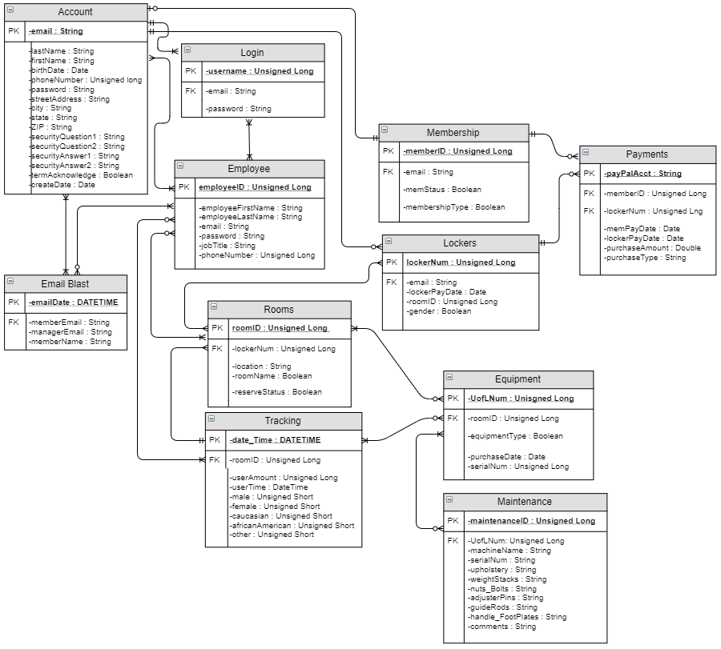

Demo Website
Demo version of the website we wanted to create early in the project.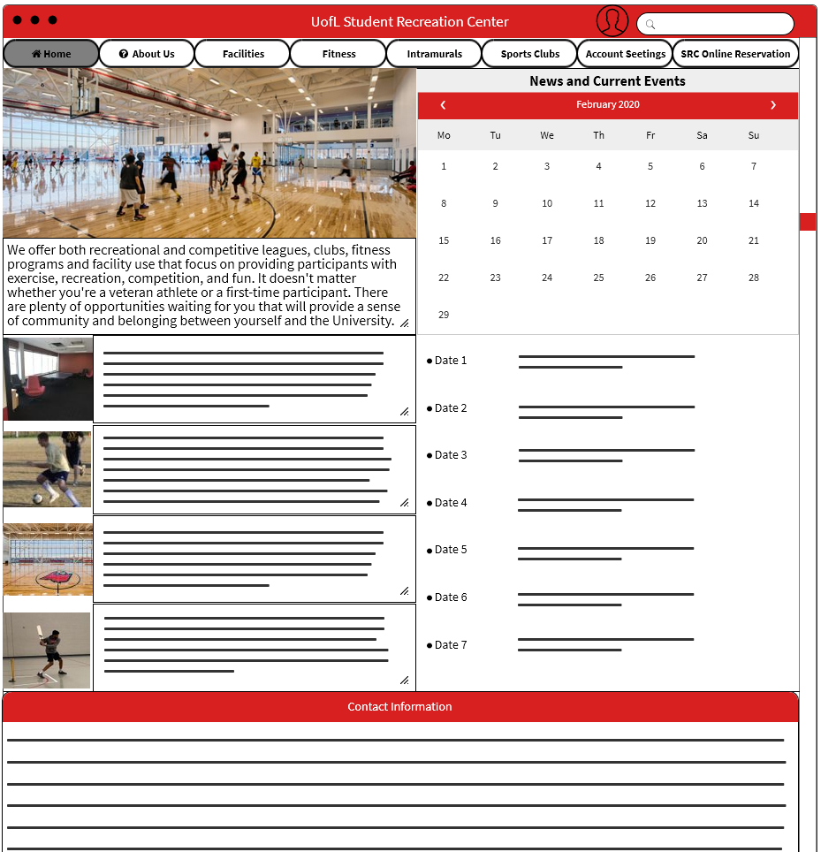
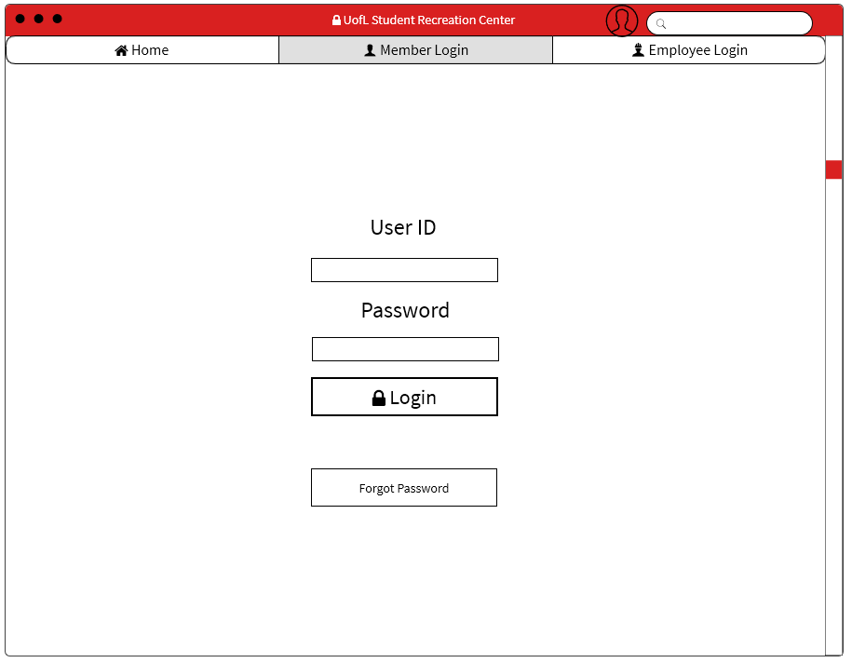
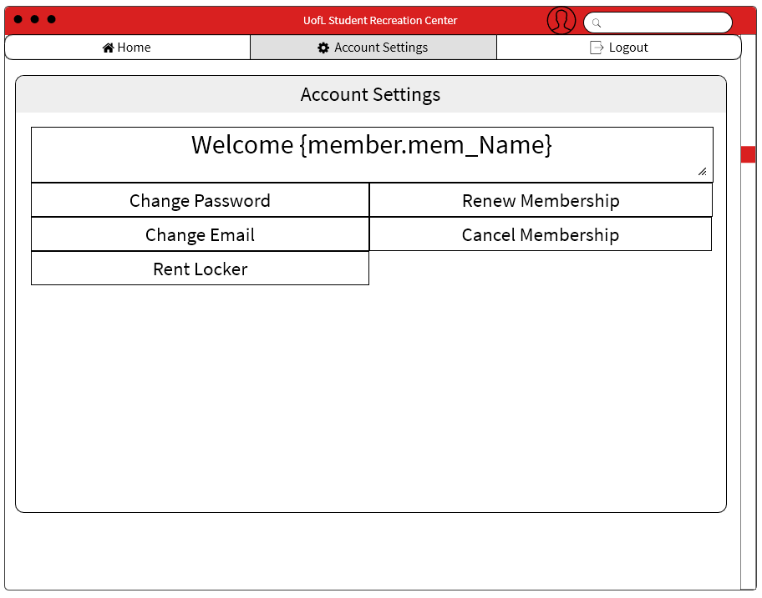

Excel & Access
~CIS 250 (Intro to Data/Information Management) & CIS 300 (Computer Information Systems)
Excel Pivot Tables
Pivot Table showing businesses and their average order amounts in a pie chart.
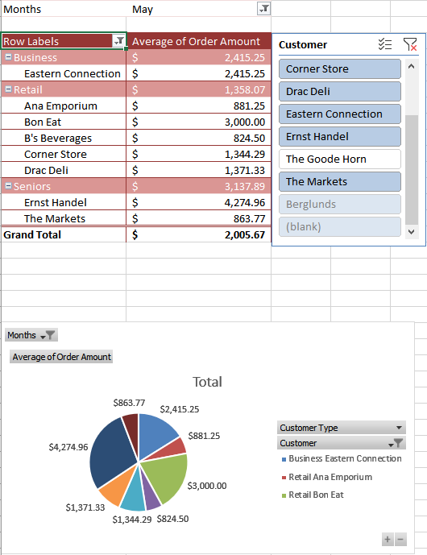
Access Queries, Forms, and Reports
Access query showing the service name and associated revenue, taking data from the service, orders, and location tables.
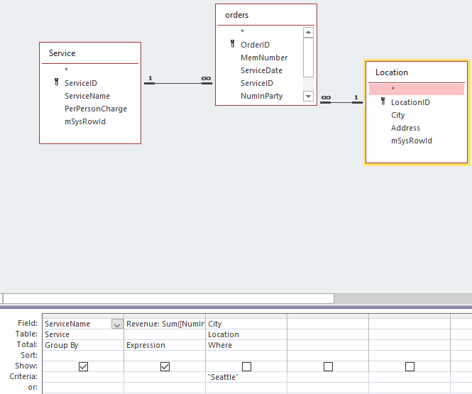

Access form displaying the records of members in a database
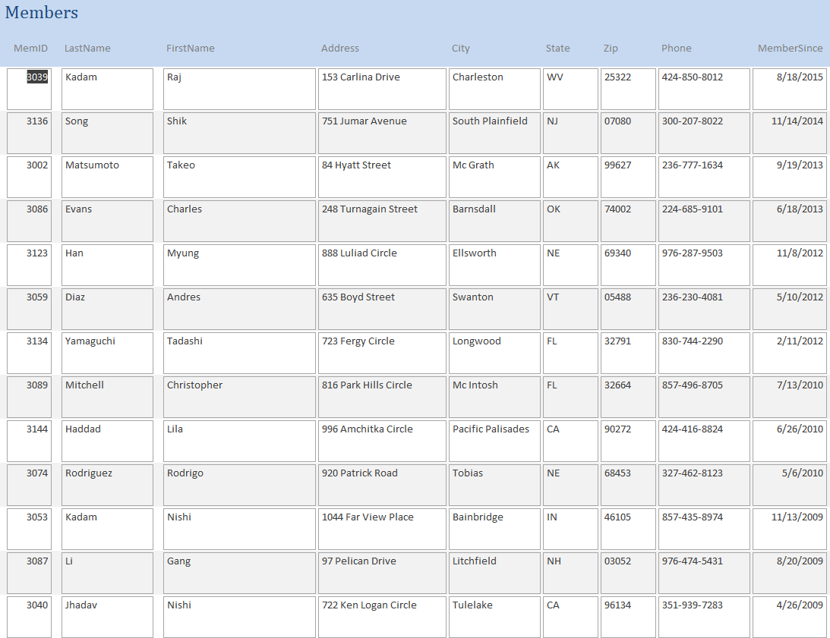

Access report displaying revenue values from varying cities and services.
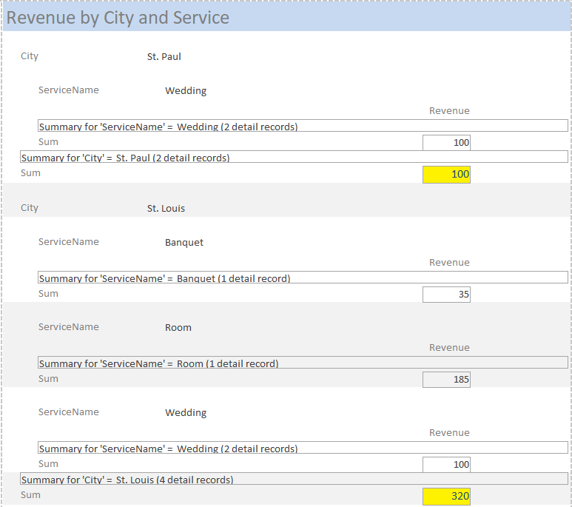

Professional Business Writing
~BUS 301 (Business Communication)~
Long Form Business Report
The report focusing on how West Louisville can be improved for the residents of the area through the introduction of beneficial businesses. This was done with a group of four collaborating through the entire process.


APRIL 5
,

2020

Team 3

Authored by:

Marc Daniels, Courtney Jackson,
Jacob Eibel, Faris Alkhathami

The
Renovation of
West Louisville

Lynn Manuel
Supervisor at Louisville Forward
444 S. 5th Street
Suite 600
Louisville, KY 40202

Dear Lynn Manuel,
Thank you for taking the time to read our report about the renovations that we see fit for West Louisville. We think that the community in this area has many opportunities to flourish with the help of Louisville Forwards, especially with the new addition of the Urban League Sports Complex. The following report addresses the needs that we see should be met in the West Louisville community while also presenting proposals for several businesses to be added to meet these needs. We strived to make our research and writing professional, clear, concise, and evidence driven.
We believe that this community needs some renovations to influence the lives of the residents. We provided several different businesses that would be good additions to the retail development that is located next to the sports complex. Thank you for giving us the opportunity to research the changes that should be made in this area. Please consider the businesses we have proposed so that the community can be benefited in a positive way. Thank you again for taking your time to read the report.

Best Regards,

Marc Daniels Courtney Jackson Jacob Eibel Faris Alkhathami


Table of Contents

Executive Summary 4
Introduction 5
Purpose of the Renovation 6
Needs of the Community 6
Education and Jobs 6
Economy 7
Health and Wellness 7
Safety 8
Business Proposals 8
Hibbett Sporting Goods 9
Heine Brothers Coffee 9
Southern Express 10
ValuMarket 10
Benefits of the Businesses 11
Potential Challenges 12
Flourishing in a Low-Income Area 12
“Proof of Concept” Challenge 13
The Concern of Safety 13
Integration into the Community 13
Hibbett Sporting Goods 14
Heine Brothers Coffee 14
Southern Express 15
ValuMarket 15
Conclusion 15

Executive Summary
The Urban League Sports and Learning Complex introduces many new opportunities for West Louisville to flourish. With the help of Louisville Forward, new businesses can be added to benefit the community.

Needs of the Community
The most apparent needs of the community that need attention are: a lacking of higher education which leads to lower paying jobs, economic isolation due to absence of growth, a high percentage of people without health insurance, and higher crime rates compared to other parts of Louisville.

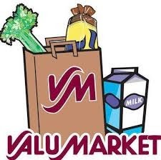
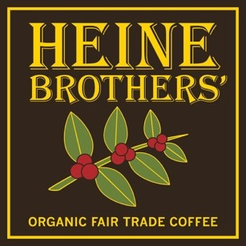
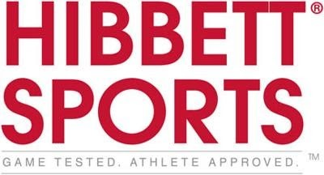

Business Proposals
Each new business addresses the needs of the community by providing new jobs, a boosted economy, healthier lifestyle and food options, and a safer environment.

Challenges and Integration
With the implementation of businesses to a new area there are always challenges. Flourishing in a low-income area can be difficult when people do not have a lot of discretionary income, however with the new additions and programs an influx of residents and job opportunities will bring more business to this area. With the proof of concept challenge not all the proposed businesses have a benchmark to compare to in terms of how their business will perform in the new region. Therefore, some trial and error may be needed for success. Lastly, with the concern of safety due to higher crime rates some businesses may not be comfortable conducting business in certain areas. Development of safety policies and collaboration with Louisville Metro Police can ease these concerns. Each business has their own way to try to integrate themselves into the community. Some of these include creating advertisements for the new products and job opportunities, decreasing overhead costs, creating a family friendly atmosphere, and creating rewards programs.
The Renovation of West Louisville

Introduction
West Louisville is a critical part of the Louisville Community. It is known for having a strong African American Heritage. It has a population of 62,923 people, which accounts for about 10 percent of the population of the city of Louisville. Although there are many people in this area, 81.6 percent are a part of the minority population with a median household income of $21,733. This helps show that there are many needs to be met in the community. There are many different things that could be improved and integrated to make a better and more stable community. (Louisvilleky.gov)

“West Louisville is a Critical part of the Louisville Community”

Purpose of the Renovation
Investments in West Louisville need to be made to help meet the needs and wants of the residents and families in the area. The goal is to revitalize the community to a place that is sustainable and attractive to new businesses. New additions can create a safer and healthier environment with new neighborhood amenities. They can also help bridge the gap of the racial divide in the city.

Needs of the Community
There are many needs that need to be met in West Louisville to make significant improvements.

Education and Jobs
Education is a major need. Only 38 percent of the population of West Louisville have some college experience. Out of that 38 percent, only 7 percent receive a bachelor's degree. The lack of education causes most of the population to not become career ready, resulting in a median household
income of only $21,733. Young people West Louisville's College Experience between the ages of 16 to 21 need real workplace experience. The unemployment rate of this area is twice as high as the Louisville Metro area, causing the poverty rate to be three times as high (Louisvilleky.gov). More jobs need to be present in this area to bring in more money into the economy and families of this area.
No College
Experience
62
%
College
Experience
38
%

Economy
The regional economy has been greatly isolated due to the absence of social capital, connections, and new businesses. The economy needs to be accelerated so that more business can be attracted to the area, a better workforce is built, and more money is put back into the area and the families in the community. A better economy would create a better lifestyle for all of those struggling in the community and open doorways for new businesses and opportunities.

Health and Wellness
West Louisville faces many health disparities. Health coverage in West Louisville lags behind the rest of the Louisville population. The uninsured rate of West Louisville is 21.9 percent whereas the Louisville Metro uninsured rate is only 12.7 percent. West
Louisville not only lacks the coverage but also lacks the information and care that they need to be healthy. Health and wellness locations need to be present in West Louisville to give the residents in this area an equal chance at receiving care and information about their current health situations. More healthier food options also need to be present in the area. Many people in the region live in food deserts, meaning that they cannot easily get healthy and affordable food. Adequate food needs to be provided to help prevent illness and other health risks (Ryan Combs, louisville.edu).

Safety
Figure 1 shows the crime rates in the city of Louisville. West Louisville is mostly covered with dark blue meaning that it is considered to be the most dangerous part of the city with the highest crime rates. People in the area need to feel safer in their community. Violence is a large issue that prevents West Louisville from flourishing. Safer neighborhoods would greatly influence the attraction of new businesses. Major steps have already been taken to help make the community be safer and cleaner by the addition of more parks and increased patrol, but more steps can always be taken to help the community.

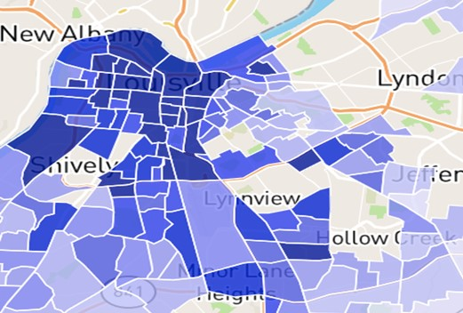

(Figure 1)

Business Proposals
The new Louisville Urban League Sports and Learning Complex is an upcoming addition to the West Louisville Community. Not only will this complex help grow the community, but also the economy by creating an attractive area for new businesses to move to. Each new business will create new jobs in the community resulting in a boost of the economy and the lives of the residents.

Hibbett Sporting Goods

Due to the focus on improving the healthcare and wellness of the West Louisville community, Hibbett Sporting Goods would be a great addition to the area. Hibbett Sporting Goods is a full line sporting goods retailer headquartered in Birmingham, Alabama. With more than 1,100 stores and sales of over $1 billion annually they would be a beneficial and competitive addition to the area due to their wide brand variety and affordable prices (hibbettsportsinc.com). With the growing focus on wellness, new healthcare opportunities, and the introduction of a new YMCA facility, interest in sports, physical fitness, and sporting gear will most likely rise.
Picture
from
“
https://freebiesupply.com/

logos/hibbett
-
sports
-
logo/
”

Heine Brothers Coffee
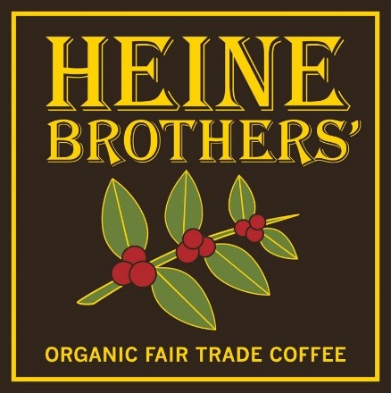
Heine Brothers is a local coffee roaster and coffee shop founded in Louisville in 1994. With 17 locations around the Louisville area, the company has found a great deal of success. In 2002 they became 100% fair-trade and organic, proving to be a health focused alternative to other coffee shop chains (heinebroscoffee.com). Not only are coffee shops quite popular on their own, but a mindful and local chain is sure to attract the attention of a community committing to better living and safety.
Picture from “https://heinebroscoffee.com/”

Southern Express

Southern Express currently has a location on West Oak Street. It is known for serving affordable and delicious soul food, which is traditional southern African American food. Dishes include fried chicken, pork, or fish with an abundant amount of sides including mashed potatoes, beans, corn, and macaroni and cheese. The service at Southern Express is greatly praised and offers a very family friendly atmosphere. The addition of this restaurant would not only impact the community by incorporating a new place to get good southern food, but it also encourages a more family friendly community which can result in a safer community.
Pic
ture from
“
https://www.facebook.com

TheSoulFoodExperienc/
”

ValuMarket
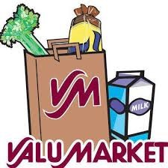
ValuMarket is a local grocery store with fresh produce and a focus on the community. ValuMarket boasts its truly local focus with a community page that describes what they have done to earn the title of being local. According to this page they have helped the neighborhood elementary school raise money for a new playground, acquire fresh produce from Henry County, and support little league teams, churches, scout troops, and community festivals. They also offer a Xtra Valu Rewards card for customers to earn points with each
Picture from “https://www.facebook.com/ValuMarket/“ purchase that can be redeemed for savings on your total
bill (valumarket.com). Having access to local, fresh, and affordable produce fits perfectly with the community’s new focus on health and wellness

Benefits of the Businesses
After addressing the needs of the area, we can see the demand for such businesses. Having a well-known and local coffee chain store in the area will help the economy by adding more jobs. The coffee store will also be a great place for students to come meet and study in a safe and quiet area. Sports are always needed in any healthy and safe community, having a sporting goods store is essential. In addition to the jobs added by opening the sporting goods store, we will be able to see more commitment to sports, and the addition of new sports that people can discover. Restaurants are essentials in any community, having a local restaurant that makes local southern food would add to the community. In addition to jobs and tasty food, the community would have a safe gathering place to unwind after work. Another essential would be a neighborhood market. This market would help by providing healthy food and goods for a low price.
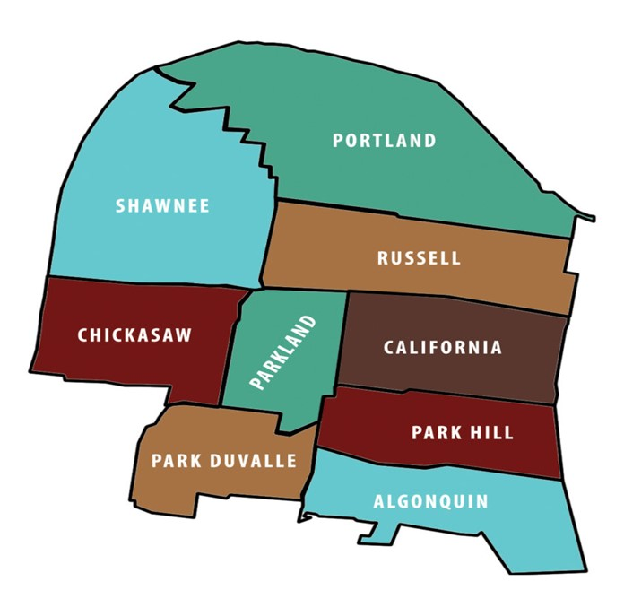

Potential Challenges
Challenges and risks involved in the implementation of these new businesses:

Flourishing in a Low-Income Area
Residents of West Louisville do not have the freedom to spend as much discretionary income as do other civilians from different areas of the city. The potential challenges that will arise from this will be how each business decides to allocate their capital, to suit the needs of this community. Though we believe this location is advantageous due to the close proximity and influx of travelers to the new Louisville Urban League Sports and Learning Complex, it is still crucial these businesses to adjust for the needs of the surrounding community. For these select businesses that also operate in more affluent parts of the city, such as Heine Brothers, most likely cannot simply “cut and paste” their exact model from other parts of the city into this area and expect it to operate in the same way. Discovering the nuances associated within each business to run more profitably in the area will be a challenge.

“Proof of Concept” Challenge
Though we have confidently and carefully identified these select businesses to put into this area of town, there isn’t much history of track records of similar businesses to refer to. Whereas we see this as an untapped opportunity, the risk of the unknown in implementing these businesses still resides. Decision-makers for these select businesses potentially will have to undergo several trial and error experiments to learn what is most profitable for this specific market.

The Concern of Safety
As stated previously, West Louisville has the highest crime rates in the city. For this development, safety must be paramount to ensure success. The challenge resides in how this development collectively enables safety policies and measures. With increased foot traffic and an influx of travelers coming from the new sports complex, we will work with Louisville Metro Police Department to carry out a plan to keep the area as safe as possible.

Integration into the Community
Each business would have their own way of integrating into the community to provide beneficial business for the residents in the area.

Hibbett Sporting Goods
We truly believe in the success Hibbett Sporting goods will have in this community. We think Hibbett is perfectly suited for this complex because of its great value for high quality sporting equipment at affordable prices. Hibbett is also a great fit for this development because they don’t require massive storefronts, as many of their competitors do. Once the new Louisville Urban League Sports and Learning Complex is completed, athletes from the area, as well as travelers participating in nation-wide tournaments will flock to this new location for all their sporting needs. Hibbett could reach out to this community and hire residents in the 16-21 age group to help give them work experience. Hibbett could also put advertisements in the new sporting complex to attract their new market.

Heine Brothers Coffee
We think the addition of a coffee shop will do great in this development, so why not choose an ethical, locally operated, and community-forward company like Heine Brothers? This coffee shop can be used as a safe and secure place to sit, relax, study, or to do some work. There aren’t any dedicated coffee shops in West Louisville at all, and we think it would excel in this location. Heine Brothers has seen success across Louisville. We know they will be perfect in this community, as well as for the travelers and families coming from the sporting complex. We suggest in the first few years to reduce any overhead costs as much as possible and to prioritize the quality of the drinks, food, and atmosphere. This could include reusing older yet effective equipment from other Heine Brothers locations. Until “proof of concept” is realized within a few years, we feel this will be the best plan of action.

Southern Express
Southern Express is a restaurant that will be perfectly integrated in this community because of the rich, soul food traditions they express through their food. It will quickly become a local favorite that will provide a safe, family-like atmosphere. The prices are very affordable, especially for the value and deliciousness each dish provides. The proximity to the Louisville Urban League Sports and Learning Complex will entice families and groups to indulge in the best southern cooking the area has to offer. Southern Express will have the ability to reach out and hire local chefs as well as filling positions for other restaurant staff.

ValuMarket
One of the bigger needs of the community is more access to healthy food options. Many neighborhoods in the area are food deserts. ValuMarket is a great fit for the community, as it offers fresh produce, an abundance of healthy choices, as well as general household needs. It also provides a rewards program that can help customers get products at a reduced price. The West Louisville community has very few grocery store options, and we believe a ValuMarket would perfectly fit in this development. This grocery store will have the ability to hire residents and give a boost to the immediate economy.

Conclusion
Each new business added would provide benefits to the West Louisville community in their own way. The needs of this community are important to focus on to influence the lives of the residents in this area. There have already been steps taken to help the area with the new YMCA complex and the Urban League Sports and Learning Complex, but more can be done. Adding the new business proposed can greatly influence the community in positive ways resulting in a healthier, safer, and cleaner West Louisville.

