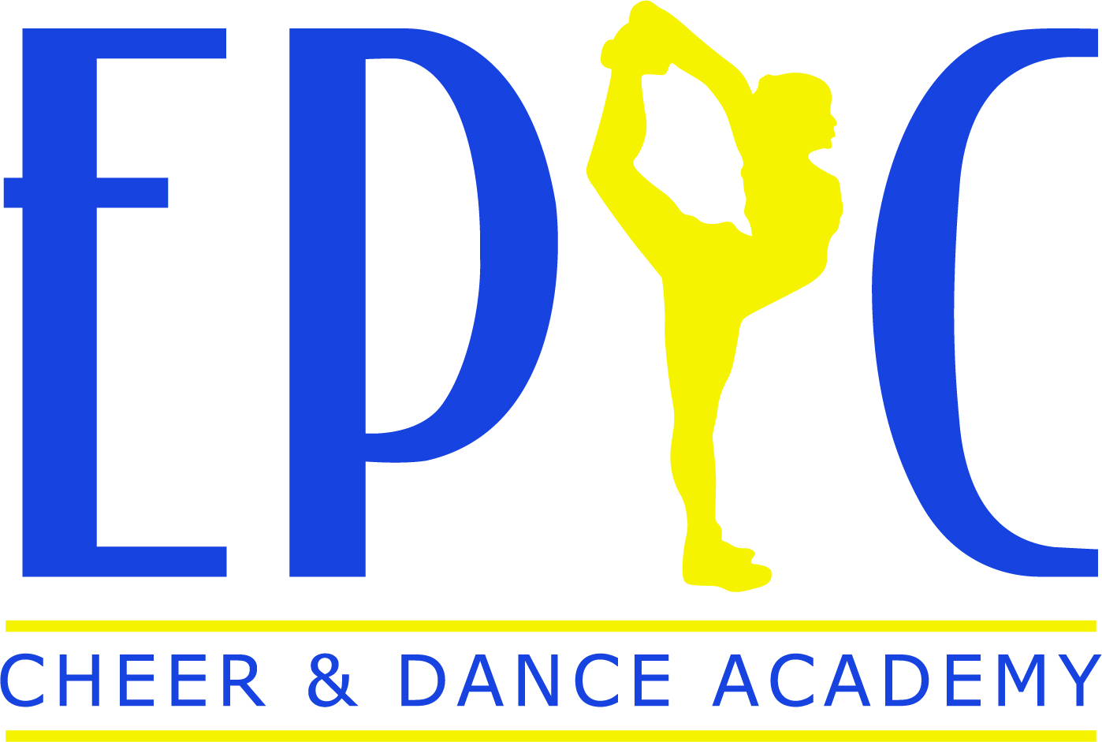

ALL-STAR/ TUMBLE WAIVER AND RELEASE OF LIABILITY

I hereby authorize the staff at EPIC Cheer & Dance Academy LLC to act for me according to their best judgment in any emergency requiring medical attention, and hereby waive any and all claims for personal injury, illness, and/or property damage against EPIC Cheer & Dance Academy LLC and its directors, officers, agents, employees, contractors, representatives and any volunteers in any way associated with EPIC Cheer & Dance Academy LLC. I agree and understand that participation in cheerleading, tumbling, or any other activity that involves motion, rotation, and/or height, carries with it the risk of injury. I agree and understand that all medical expenses incurred will be the responsibility of the parent or guardian. In lieu of a medical certification signed by a medical doctor, I state that I have no knowledge of any physical injuries or impairment that would be affected by the named child’s/children’s participation in any program at EPIC Cheer & Dance Academy LLC.

EPIC Cheer & Dance Academy LLC cannot assume responsibility for children left unattended in any facility operated by EPIC Cheer & Dance Academy LLC. Parent/Guardian(s) are responsible for the conduct of their children at all times in cheer/tumble gym premises. All children, attended or unattended, are expected to respect cheer/tumble gym property and other cheer/tumble gym patrons. Under no circumstances does EPIC Cheer & Dance Academy LLC assume any liability for injuries, accidents or any mishaps, whatsoever, which may occur when a child is left unattended, including, but not limited to intentional torts committed by or against the child. In the event that any liability results out of intentional torts committed by an unattended child, liability shall be borne by the parent/guardian(s) of such child.

I also expressly grant EPIC Cheer & Dance Academy LLC or any approved third party of EPIC Cheer & Dance Academy LLC, the right to film, videotape, photograph, or record my child/children. I give EPIC Cheer & Dance Academy LLC the irrevocable right to use, display, digitally enhance and/or alter in any manor the film, videotape, photograph or record of my child/children and use in any promotional activities to include, but not limited to, broadcast, television, cable, motion picture, videotape, DVD, CD, or any published articles.

I agree and understand that jewelry is not to be worn during any class or practice while at EPIC Cheer & Dance Academy LLC. I also understand and agree that if asked to remove jewelry, I or the said athlete(s) will be responsible for the security of that/those items. EPIC Cheer & Dance Academy LLC is not responsible for items that are lost, stolen or damaged.

1st Athlete’s Name:________________________________________

2nd Athlete’s Name:________________________________________

3rd Athlete’s Name:_________________________________________

Parent/Guardian Signature__________________________________ Date____________________

