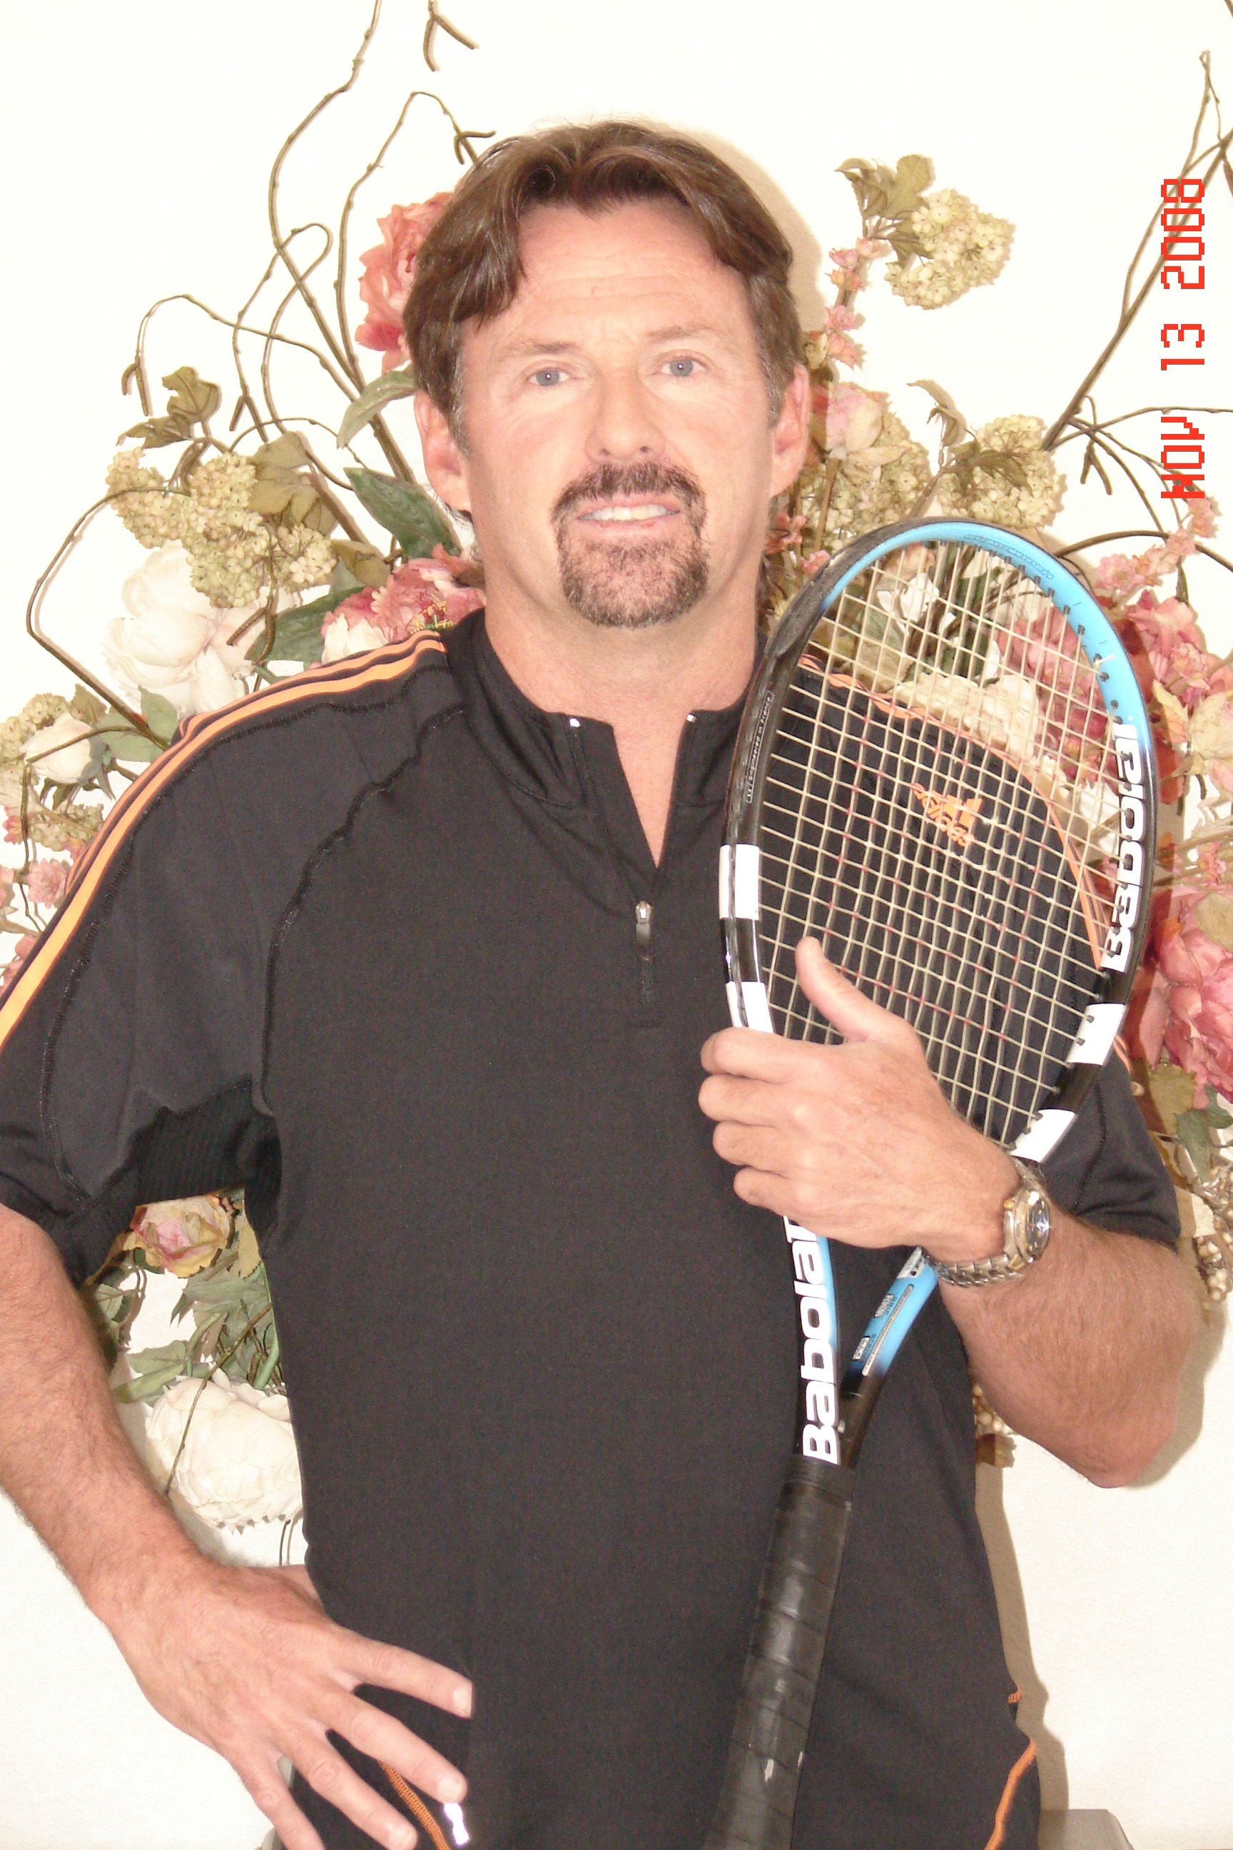 | Jeremy Berlin  (Jerry Berlin)  usprotennis@gmail.com  Business Cell  (970) 213-4580 | 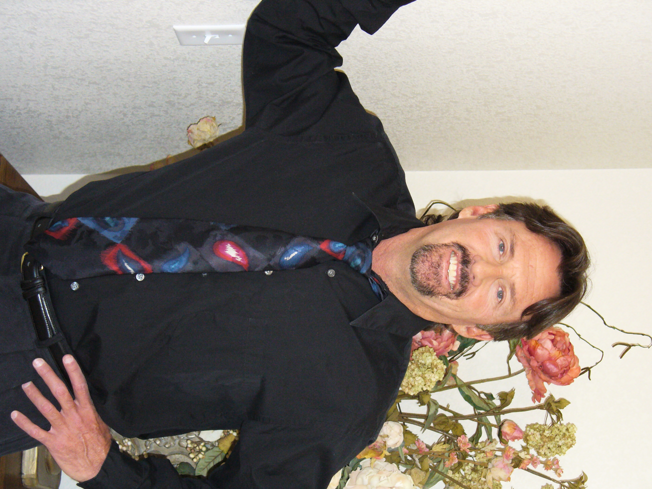

Objective

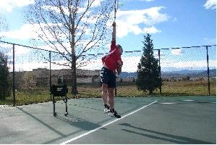 | The ability to use my talents as a tennis professional, as well as my marketing and public relations skills, to maximize tennis clubs assets. To build a positive, competitive, organized foundation at a tennis facility, focusing on professionalism, teamwork, character and sportsmanship. To implement innovative programs, increase membership, increase member satisfaction, retention, and club profits.

Affiliations
Current Men’s Gulf Coast Champion for Florida in Ultimate Tennis League
Currently ranked 5th in Men’s 55’s in Florida and tied for 11th in USPTA singles ranking
USPTA- Pro 1 Rating
Sponsored by: Adidas and Babolat
College: Played Varsity tennis at #1 and #3, won the #3 singles as a freshman, team set national record.
Member of the United States Racket Stringers Association

Highlights
John Gardiner’s Tennis Ranch- (Carmel and Scottsdale)
- Senators cup tournament with Master of Ceremonies, Merv Grifith, played doubles with Art Buchwald.
- Was chosen to work with Prince Mahdi- one of John Gardiner’s most important guests.
- Was the most requested Pro in the 30-year history of the ranch.
Cascade Club- Vail Colorado
- Increases membership in tennis and participation and retention of members.
Miramont Sports Center (Fort Collins, Colorado)
- Chosen by Cliff Buchholz to be Director of Tennis of new club.
- Hosted “Chet the Jet Marathon”
- Helped the club grow from a hundred members to over three hundred and fifty in one year.
Lewis Tennis School (Fort Collins, Colorado)
- Head Pro for the USTA “2001 Facility of the Year” – The tennis center at Rolland Moore.
- Managed this club for nine months out of the year including all staffing, lessons, and accounting functions.

Qualifications & Experience
J Berlin Tennis, Owner Fort Collins, Colorado Present
Offer private lessons, group lessons, quick start clinics, drill clinics and socials to Fort Collins Residents.

Self Employed- Private Tennis Coach Nationwide 2004- 2008
I have had clients from California, Colorado and Wyoming. I provide one on one, private, full time coaching for students who desired either to compete nationally in the WTA, or for students wanting full ride scholarships to colleges. I am responsible for all lessons, fitness programs, arranging matches, accompanying and coaching students at tournaments nationwide.

Tennis Professional, Cheyenne Country Club Cheyenne, Wyoming Spring – Fall 2008
Develop tennis in the Cheyenne community through private lessons and clinics, as well as organize and run tournaments and socials. Teach USTA drills and clinics to juniors and adults. Implement doubles strategy and positioning clinics for men's and women's teams. Work with advanced juniors who are seeking scholarships and advanced training. My students consistently have outstanding results in tournament play. My juniors consistently receive scholarships to the colleges of their choice.

Head Tennis Professional, Lewis Tennis Fort Collins, Colorado 2000-2004
Court training of staff and lesson planning, USTA coaching, planning and staffing for USTA teams, private and group lessons, operating all aspects of the club for nine months of the year, liaison with the City of Ft. Collins including maintenance, etc., The Tennis Center at Rolland Moore was chosen by the USTA as "Facility of the Year" For 2001.

Director of Tennis, Miramont Sports Center Fort Collins, Colorado 1995-1996
In charge of mixers and socials, training of employees, private and group lessons, operation of all tournaments as well as demo days with Wilson and Prince representatives and was successful in having the biggest showings in Northern Colorado, raised funds for the Junior Tennis of Ft. Collins by organizing and hosting Chet the Jet Marathon and other promotional activities.

Head Tennis Professional/Director of Tennis, Cascade Club Vail, Colorado 1993-1995
In charge of all aspects of tennis at the Westin/Cascade Club Southwest, ran a weekly pro am with local and area pros (Aspen) . Owned and operated the pro shop.

Director of Tennis/Head Tennis Pro, La Camarilla Tennis/Fitness Club Scottsdale, AZ 1990-1993
In charge of all tennis activities for over 2,000 members, taught private, semi-private, and group lessons, including special clinics of over 100 people, to juniors and adults, lessons given to beginners, intermediate and advanced tournament players, taught to groups of ladies and men, inter-club working on all aspects of the game including strategy for singles and doubles, incorporated programs in conjunction with management, ran club tournaments, socials, and provided for club ratings and public relations. Owned and managed Pro Shop.

Director of Tennis/Head Tennis Pro, Turtle Point Yacht & Country Club Killen, AL 1989 Season
Taught private, semi-private and group lessons, including special clinics, lessons for beginners, intermediate and advanced tournament players, provided for a variety of instruction ranging from basics of stroke production to more advanced strategies, organized all social events and tournaments (Round Robin Cook-outs/Mixers, Men's Night, Women's Morning Scramble), organized competitive events (Challenge Ladder, Dominoes Pizza League Play, Inner Club Tournament, and Club Championship), increased participation by 40% in all areas.

Tennis Professional, John Gardiner's Tennis Ranch, Carmel Valley, California April 1988-1990
Enjoyed teaching celebrities and financially successful guests in weekly clinics, taught adults and children in private lessons as well as in a group setting, responsible for all tournaments and social events, assisted in nine week clinic for over 300 juniors, and functioned as a Pro for one of the largest junior clinics. (This junior camp was renown as one of the best in the world) Used closed circuit television analysis for strokes and strategy video.

Tennis Professional, John Gardiner's Tennis Ranch, Scottsdale, Arizona 1986-1988/ 1990-1992
Instructional lessons given to guests of the ranch, including private, semi-private and groups, ran tournaments and social events, closed circuit television analysis for strokes and strategy video, involved in the prestigious Senators Cup Tournament, which raises funds for the Hospice of the Valley. This event involved 200 leading businessmen, 20 United States Senators and a variety of celebrities, and was arranged by Master of Ceremonies, Mr. Merv Griffin. I was fortunate to be able to play doubles with Mr. Art Buchwald, along with training employees of this event. At the end of the season, I was chosen to go to John Gardiner's in Carmel, California.

Director of Tennis, Bluefield Country Club, Bluefield, West Virginia 1986 Season
Taught group and private lessons, implemented programs for junior development, responsible for tournaments, mixers, Men*s and Ladies Day, Club Championships, organized challenge leagues and provided the "Stroke of the Week", increased participation in the Tennis Program by success in a variety of promotional activities.

Assistant Tennis Professional, Valley Tennis Club, Grand Junction, Colorado May 1984- April 1986
Arranged and played in matches with guests and members, stringing in the pro shop.

Head Professional, Elks Club, Grand Junction, Colorado March-October 1983
In charge of tennis functions and miscellaneous promotional opportunities, responsible for recruiting, hiring and training staff members.

 | Professional References
Mike Lowdermilk | Director of Tennis Val Vista Lakes, Mesa Arizona | 480-628-0851
Tom Lepisto | Director of Tennis at Westward Look Tucson Arizona | 520-260-0765
Julie Francis | President of Wyoming Tennis Association | 307-777-4740

Letters of recommendation are available from all of the clubs that I have worked for in a digital form.

My Philosophy
I am currently in the process of writing a couple of books, one on Full Body Tennis and one on Interactive Coaching. I consistently use a 8mm camera to film my students and use slow motion analysis to view strengths, and implement changes to improve my students’ game. I love tennis and I love teaching tennis. I believe tennis is a business, and should be run as a business. I believe that if people are having fun and improving, then they will return. I believe there should be something to draw everyone in, men, women, juniors and groups of all three. I don't believe there is a magic bullet, but I think people can tell when you really care about them and their tennis game. I believe it takes time and effort to build a great program, and to keep it evolving and growing. Fortunately for any club I work for, there is no place I'd rather be than on the tennis court! I believe I have the skills and the drive to implement programs that will keep members happy, keep me challenged and happy and will maximize profitability for the club.

