If you would like to host a mindfulness class for your business or organization, contact Heidi. We can work together to set up a time and venue for the course.  www.heidiodonghue.com  801-455-1727  yourpathyoga@gmail.com  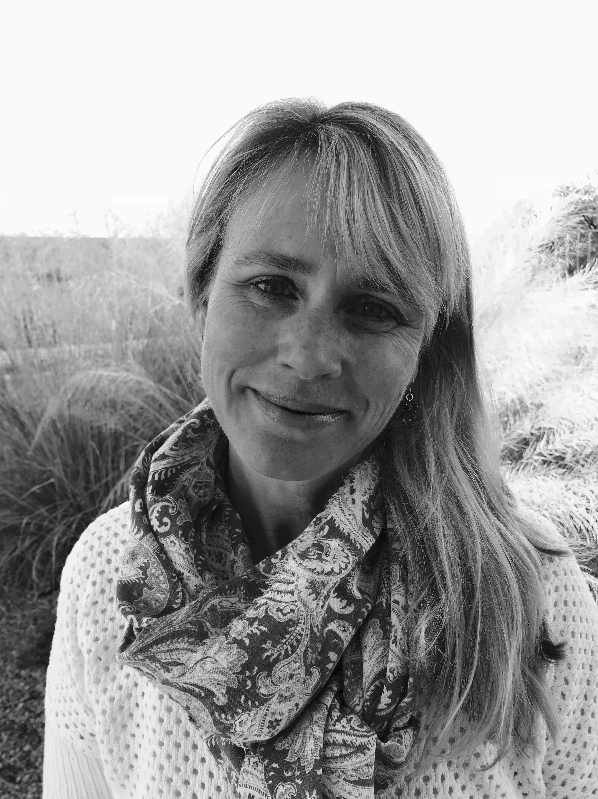  Heidi is a Qualified MBSR  Instructor and a certified  Yoga teacher. | Heidi O’Donoghue  Qualified MBSR Instructor  Registered Yoga Teacher |  | Mindfulness Courses  “Break the pitcher, become the ocean.” Rumi

Introduction to Mindfulness  What is mindfulness? There is a definition but ultimately it is something that we need to experience first-hand, it is not outside of ourselves. Introduction to Mindfulness is a short 30-45minute seminar where mindfulness is introduced through a couple of different experiential learning activities. Through a combination of presentation and guided mindfulness activities participants experience mindfulness for themselves.  Cost: This is a free offering intended to introduce groups, companies and organizations who are interested in having Heidi offer A Taste of Mindfulness or MBSR courses for them in the future. | “Mindfulness is a way of befriending ourselves and our experience.” – Jon Kabat-Zinn  A Taste of Mindfulness  A Taste of Mindfulness is a three-part workshop series that introduces students to some of the foundational formal practices of mindfulness. Groups meet 3 times for 2 hours sessions to practice sitting and walking meditation as well as gentle yoga and body scans. Although this is not an MBSR course the class is inspired by the MBSR curriculum and has some similar components. It is a wonderful way to begin to experience mindfulness and is appropriate for anyone interested in learning to incorporate mindfulness practices into their lives.  Cost: $75 per person  10 students minimum  Includes 6 hours in-person instruction + 3 recordings + handouts | MBSR  Mindfulness-Based Stress Reduction-MBSR-is an intensive 8-week, 9-session training in mindfulness. Groups meet weekly for 2-2 1/2 hours and for an all-day session between weeks six and seven. Guided instruction in various mindfulness practices is provided, including sitting and walking meditation, the body scan, gentle yoga, and other guided meditations. These practices are enhanced through inquiry exercises, group dialogue, daily home assignments, guided audio files, and practice materials. MBSR was developed by Jon Kabat-Zinn at the Center for Mindfulness, University of Massachusetts Medical School in 1979. Since that time hundreds of studies have been done proving the benefits to overall health and well-being of participants in MBSR courses.  Cost: $350 per person  10 students minimum  Includes 27 hours in-person instruction + weekly recordings + handouts.  https://www.umassmed.edu/cfm/

