1) Avoid transporting products across bumpy terrain at a speed that causes the product to bounce. Excessive travel bouncing of the product can cause damage. Also, avoid pushing or rolling a manhole product on the ground with on-site machinery.
2) Measure the diameter of the clear opening of the manhole to ensure that the diameter of the hole is not larger than the interior diameter of the manhole frame. Do not have frame bottom without ground underneath it (in other words, frame suspended over air). The frame must fully rest on the ground or riser rings for proper support. Select the proper
diameter frame and cover for the diameter of the manhole.
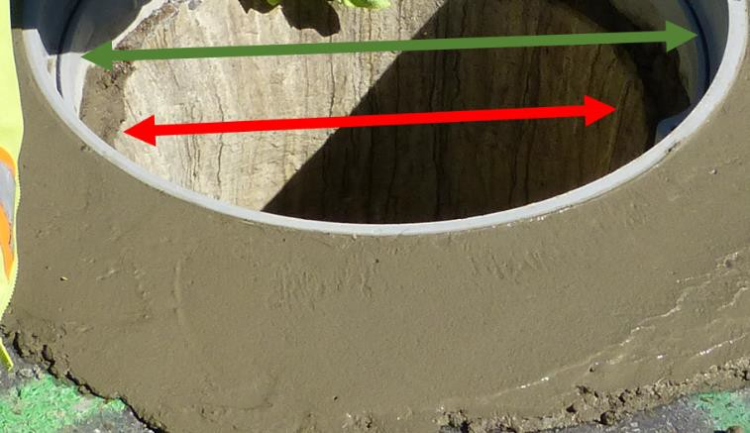
3) You may need to cut into the concrete or asphalt with a jackhammer, pick, or saw. Remove the current cover and frame. The old cover and frame may be very heavy depending on the
size. You may need some help or lifting tool to move it safely. Always bend knees when lifting.
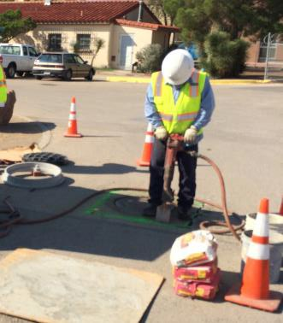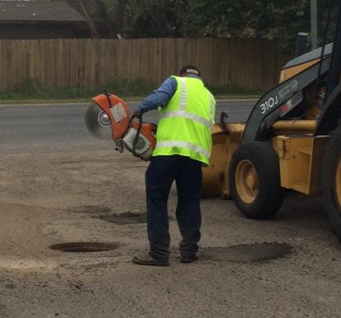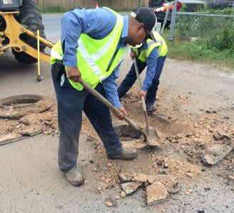
4) Inspect the manhole opening and remove any dirt, grease or other debris from the manhole opening and support.
5) Measure the depth of the hole top to the ground level. The depth should be deeper than the
height of the frame and cover.
6) Lay a layer of sealing product on the top of the manhole.
7) If riser rings are desired, use rings that are corrosion resistant like HDPE or other polymer based material. Concrete rings will corrode with Hydrogen Sulfide exposure.
8) Make sure each additional riser section is plumb as installed before installing the next riser, cone or cap. Follow instructions from riser ring manufacturer for proper adhesive, sealant, and concrete application around the chimney.
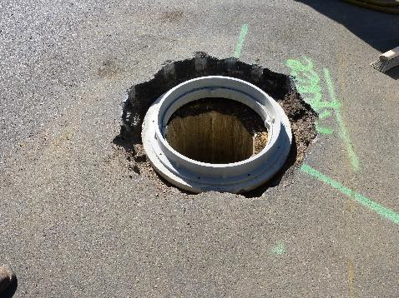
9) Mix concrete and water per instructions on the bag.

10) If riser rings are not used, lay a bed of concrete around the hole. The ring should be wide enough to fit under the flange bottom of the frame. Place the flange directly on the wet concrete ring. You can push the flange down by hand to set it into the concrete. If you use a tool to set the flange into the concrete, use a rubber mallet or blunt end, NOT a sharp metal hammer like the operator in the right of the photo below.
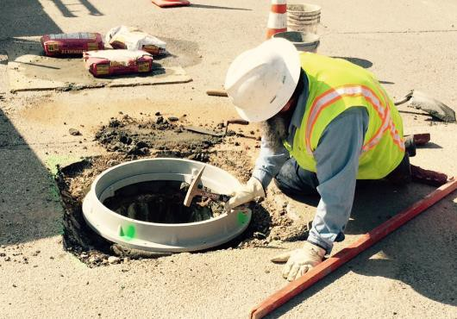
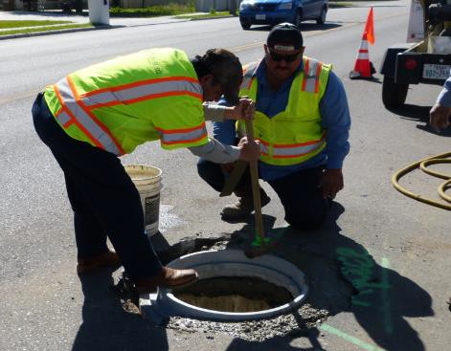
11) Holes in the frame can be used to anchor with bolts into the riser rings or concrete below. This is not mandatory, but the holes in the frames allow for this option.
12) Make sure the frame is level with the slope of your surrounding concrete or asphalt (concrete is preferred).
13) Fill in around the frame with more wet concrete until the concrete is level to the top of the
frame. You want at least 3-4 inches deep of concrete.
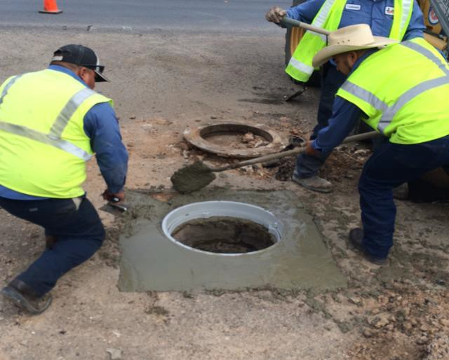
14) Spread and level the wet concrete with trowel.

15) Make sure to wipe all wet concrete off of the inside of the frame walls and seat. If this hardens with the cover on, it will be difficult to remove the cover, and the cover also will not sit flat.
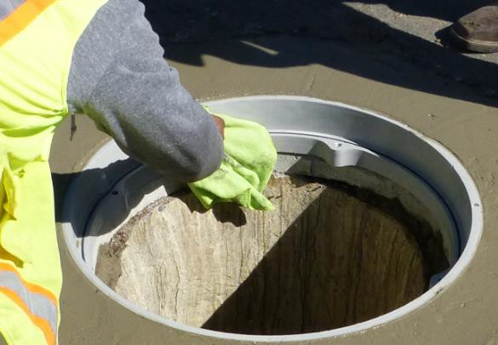
16) If the cover has bolt down or locking features, visually locate the receiving “notch” or bolt holes on the frame cover. Align the paddle locks or bolt holes on the cover with the receiving hole locations. Place the cover on the frame properly aligned. You may need to rotate the cover if the holes and hardware do not line up. In this case use the key tools or pick hooks to lift the cover evenly and level. Depending on the cover model, the frame may have shapes (triangles, stars) that indicate where the bolt holes should be aligned to have the cover and frame holes centered on each other.

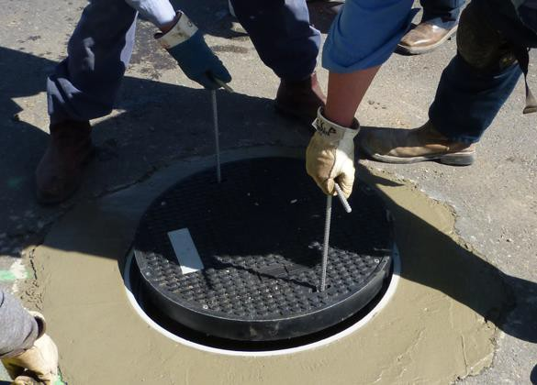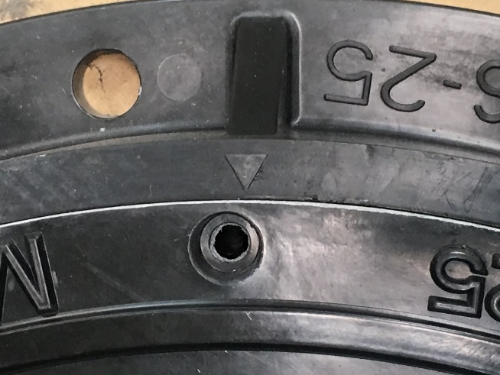
17) Be careful when inserting covers into frames. When possible, place the cover into the frame so that one edge rests on the frame top and push the cover in the remaining amount with a tool (or the base of your steel-toed footwear). Fingers and hands need to be kept clear of the cover when it falls into the frame seat to avoid injury.

18) Once in the hole, tighten all the bolts or paddle locks. Paddle locks may need to be pressed down and then rotated to engage the frame. A mark on the head of the paddle should be pointing toward the frame wall as this mark is in the same position as the paddle underneath.
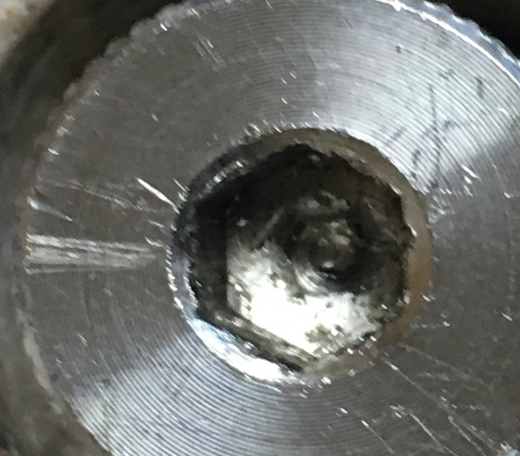

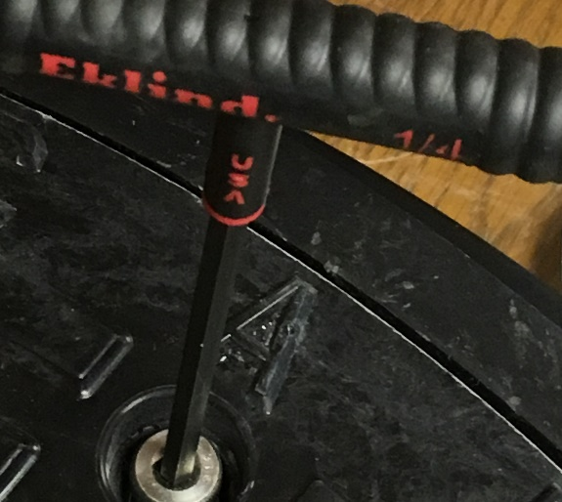
19) DO NOT OVERTIGHTEN stainless steel bolts for the threaded bolt option. Stainless steel is corrosion resistant, but overtightening will strip threads. Maximum torque is 29 ft.lb.

20) Allow the concrete to cure for at least 24 hours before driving a vehicle over it. Follow
instructions and warnings on your concrete product packaging.
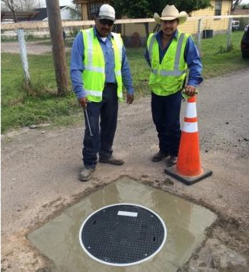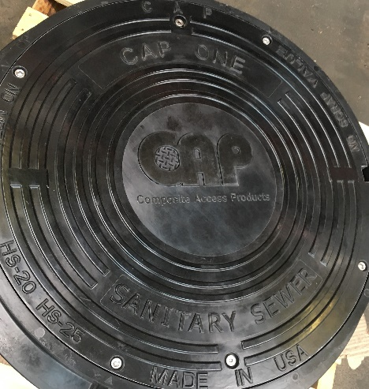
Note: There are many other products and methods that can be used to reduce infiltration and provide other benefits. This guideline is very basic and not intended to represent the optimum method for installing manhole covers. The life and performance of any manhole cover depends on proper installation. Review recommendations and other training guides available online.

