
2026 CALF OFFERING
The Sanzenbacher Ranch, a Texas historical ranch, has produced high quality calves since 1873. Baldwin Agriland is proud to carry on that tradition since 1978.
FOR SALE:
Three loads of steers and two loads of heifers. Buyer chooses from approximately 218 steer & 200 heifer calves. Gross weight average estimated at 725 & 675. Buyer has the option to purchase remaining merchantable calves. Delivery on or about June 22, 2026.
DETAILS:
Located 90 miles northwest of Fort Worth, Texas.
Calving began around September 1 and lasted 90 days with most born in the first 60 days.
Calves are out of black and black baldy cows bred to reputation ranch Charolais & Angus bulls. Bull EPDs for weaning weight, yearling weight and ribeye are consistently in the top 10% of the breed.
Approximately 10% of the calves are black hided.
Over the last 10 years, steers have an average daily gain of 2.6 pounds and heifers 2.2 pounds on native pasture. The average weight of steers sold over the last 10 years is 714 pounds and heifers are 665 pounds.
Cattle will be gathered early, sorted then weighed on ranch scales. 3% shrink with $.12 slide.
HEALTH PROGRAM:
November 2025: Vision 7, Vista Once SQ, Multimin 90
April 2026: Vision 7, Vista Once SQ, Dectomax, Multimin 90, Ralgro
Steers are knife cut. All calves are polled/dehorned.
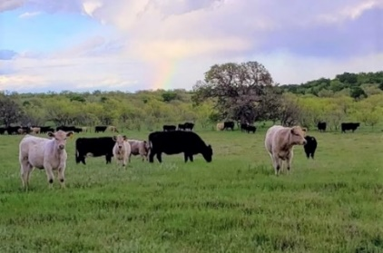
CONTACT:
Forrest Baldwin
214-763-1079
Forrest@Baldwinagriland.com

