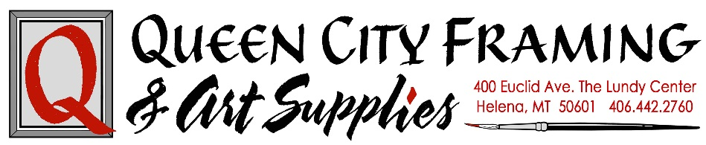

Artist Submissions 2026
Queen City Framing & Art Supplies is committed to finding and presenting a stimulating range of contemporary Montana artists. We are ever on the lookout for original art in both established artists and fresh, emerging talent. Our Featured Artists have been diverse and eclectic. We promote a variety of works.
We are seeking submissions from Montana artists proposing solo and group exhibitions of 2D work, for month long time periods. We will consider proposals at any time. Quality of work, evidence of ability to produce proposed exhibit, balance of mediums submitted for season, and quality of the framing will all be considered. Notification of acceptance will be made along with contracts and guidelines for framing. IF YOU ARE A RETURNING ARTIST: Work must not feature work shown at Queen City prior, and reflect your newest created work, preferably in the last calendar year.
There are some size restrictions and a recommended price range on the accepted pieces. Please note that art pieces within Queen City Framing & Art Supplies exhibitions tend to sell better if they are priced less than $400 and we limit the number of pieces we accept that are more. We have limited space for displaying over-sized pieces of art. We promote our Featured Artists via our mailing list, social media and print ad. Commission is 30% to Queen City Framing & Art Supplies and we also offer a discount on framing of pieces for the show.

How to Apply
Artists may submit entries in JPEG format via email to qcity.framing.art@gmail.com. Image files must be labeled artist’s last name followed by 01, 02, etc, and artwork titles. All CDs/ images must be readable by PC platforms. Files sizes cannot exceed 2MB with DPI of at least 72. Images should be oriented correctly. DO NOT submit power point presentations, automated slide presentations, or work on a DVD.
Guideline for digital images
- Must only submit original art (no AI generated work, please)
- File size: 1MB or less
- File type: JPG file
- File dimensions: at least 900 pixels wide
- File resolution: 72 dpi
- File name: Images should be titled with your last name and number; Monet1, Monet2, etc.
Supporting Material to Include
- Please provide a statement about the work you would like to exhibit (philosophy of your art, inspiration…)
- What materials and/or process do you use to create your art?
- What specifically promoted you to apply for an exhibit at our store?
- Art education, Awards or honors
- Where have you recently shown your work
- Tell us something unique about your life story
- Are you interested in teaching a workshop?
Deliver Application Packet to: Queen City Framing & Art Supplies | 400 Euclid Ave | Helena, MT 59601
Email Application Packet to: qcity.framing.art@gmail.com

