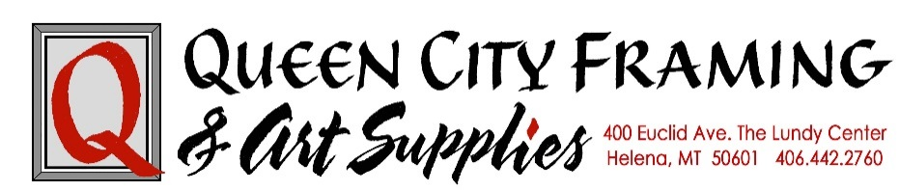

Featured Artist – Art Consignment Agreement
Queen City Framing & Art Supplies agrees to accept artwork on consignment, listed on Attached Inventory, by ______________________________________ (artist name) for sale for a CONTRACT TERM beginning ____________ (date)
and ending _____________ (date).
The following commission payment terms will apply to each consigned artwork sold by Queen City Framing & Art Supplies 30 % commission to QCF&AS, and 70% payment to artist. By signing and initialing this document, both parties agree to each stipulation listed in this Agreement:
- The Artist hereby warrant that he/she created all the works of art listed on Attached Inventory. Artist retains ownership of all work consigned and retains copyright, as governed by law. QCF&AS may, for promotional purposes, photograph them for inclusion in online notices, and other materials as long as the Artist is credited. Initial here: ________

- Retail prices for each work will be established by Artist set forth on Attached Inventory, in consultation with QCF&AS. Factors influencing retail sales price include history of prior sales by Artist, market demand and QCF&AS knowledge of its inventory, buyers and price-points. Initial here: ________

- Payment to Artist will be provided within 30 days after receipt of payment from Buyer to QCF&AS. Artwork will not be released to Buyer without full payment to . Buyer may be requested to leave purchased artwork on display for duration of Contract Term. Initial here: _________

- Artist agrees to consign artwork listed on Attached Inventory with understanding QCF&AS does NOT provide insurance for said art and Artist consigns artwork at own risk. Reasonable efforts will be made to protect consigned artwork from accidental damage, fire/theft/vandalism. Initial here: _________

- Art MUST be framed in a professional manner, ready to hang. Custom Framing done by QCF&AS for consigned artwork on Attached Inventory, would receive a 25% discount off regular price of work only to be framed in their show, to be paid by the Artist. Initial here: _________

- QCF&AS shall promote Artist/artwork through their online mailing list. They will also submit information to The Independent Record (published at IR discretion), and host an Artist’s Reception the month of the Contract Term. Artist shall be responsible to pay for and/or distribute any printed promotional materials. Initial here: _________

- Should consigned artwork remain unsold at the end of Contract Term, Artist must retrieve their work within a week of the end of their show. All/any packing/shipping expenses are the responsibility of the artist. Initial here: _________

Queen City Framing & Art Supplies owner - printed name: _____________________________________________________ date: _________________
signature: _________________________________________________________
ARTIST – printed name: _____________________________ phone: _______________________________________ date:________________
signature: _______________________________________ address: ________________________________________________________
email: ___________________________________________ city: __________________________________ state: __________ zip: ______________

