**Behaviour Policy**



**Date: 2nd February 2021**

**Review Date: 1st February 2022**

**Responsible Person: Karen Holmes**

*“Thinking of a child as behaving badly disposes you to think of punishment. Thinking of a child as struggling to handle something difficult encourages you to help them through their distress.”*

**The Gottman Institute**

Behaviour is a means of communication, and all behaviour has a functional element. 'Challenging' behaviour is often described as communicating unmet needs. Children are communicating something through their behaviour during every moment in every day, even if they are not aware of it. A child's problematic or inappropriate behaviour is a sign that he is upset and that something is not right. Children with complex needs have many unmet needs and often find it difficult to express them. Unexpressed needs can result in a child being perceived as having challenging behaviour, and being labelled as aggressive, antisocial, or offensive

When children behave in a way that challenges us, we need to question why they're behaving in this way, consider the origins of the behaviour and wonder what the message behind the behaviour might be. This will help us to understand the meaning behind the actions, and avoid us attaching labels to the child.

**Statement and vision**

More Than Ed Independent Special School (MTEISS) has a holistic approach to education valuing all learning both inside and outside of the classroom. We recognise that understanding our emotions is a key aspect of understanding and managing behaviour, enabling everyone to work together with the common purpose and aim to help all children to be the best that they can be. In order for students to feel safe, their environment needs to be rich with both nurture and structure. Our ethos is already grounded with nurture principles and being attachment and trauma aware, we use Emotion Coaching to structure our Behaviour Regulation strategy.

Our school is committed to the emotional mental health and well-being of its staff, pupils and parents/carers. We wish to work towards this in all aspects of school life, and to provide an ethos, environment and curriculum that supports the social, emotional and mental health of the whole school community. To facilitate this, we provide a safe and nurturing environment where students can be themselves and be empowered to engage and be ambitious in their learning. Furthermore, adult and child relationships are integral for this to occur. Through the development of trust and co-regulation of feelings, children learn to become more independent and develop self-regulation.

The school expects every member of the school community to behave in a considerate, cooperative and respectful way towards others. Pupils should be treated impartially and with the Behaviour Regulation Policy being applied in a consistent and attuned way.

This policy is to ensure we have a clam and consistent whole school approach for all staff, students, parents/carers, governors, visitors and partners working within the school and provides guidelines and procedures how our school supports and responds to behaviour.

The development of positive social, emotional and learning behaviours is at the heart of our Behaviour Policy.

1. **Aims:**

Our aim is for all students to:

* feel safe and happy
* build positive trusting relationships with staff and peers
* develop self-worth and self-esteem
* develop self-regulation and resilience skills by creating emotionally positive and calm environments modelling empathy, respect and self-regulation.

We aim to enable pupils to experience challenges, succeed in their learning, and have a sense that learning can be fun and relevant to their lives. To become independent and enthusiastic learners with a willingness to take risks. From the earliest opportunity, pupils will be encouraged to build tolerance, resilience, self-esteem, and take responsibility in readiness for them taking their place in society.

As a Trauma-Informed school, we are guided by the overarching principles of Dan Hughes’ PACE model - Attachment aware guidance which MTEISS uses for all relationships, and Eva Holmes' and Eve Boyd's Six Principles of Nurture. Jones and Bouffard (2012) and Banerjee, Weare and Farr (2014) suggest that interventions for pupils’ social and emotional learning should be integrated into the daily life of the classroom rather than provided through discrete programs

1. **Strategies:**

**2.1 Zones of Regulation and Linked Emotions**

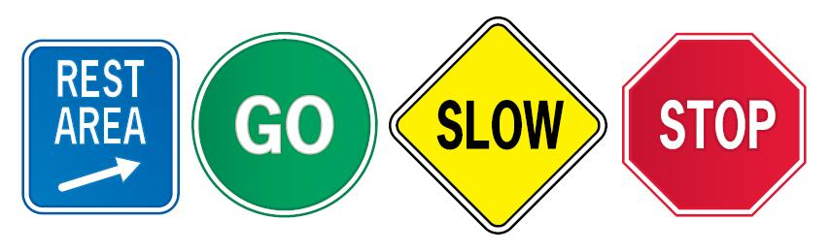

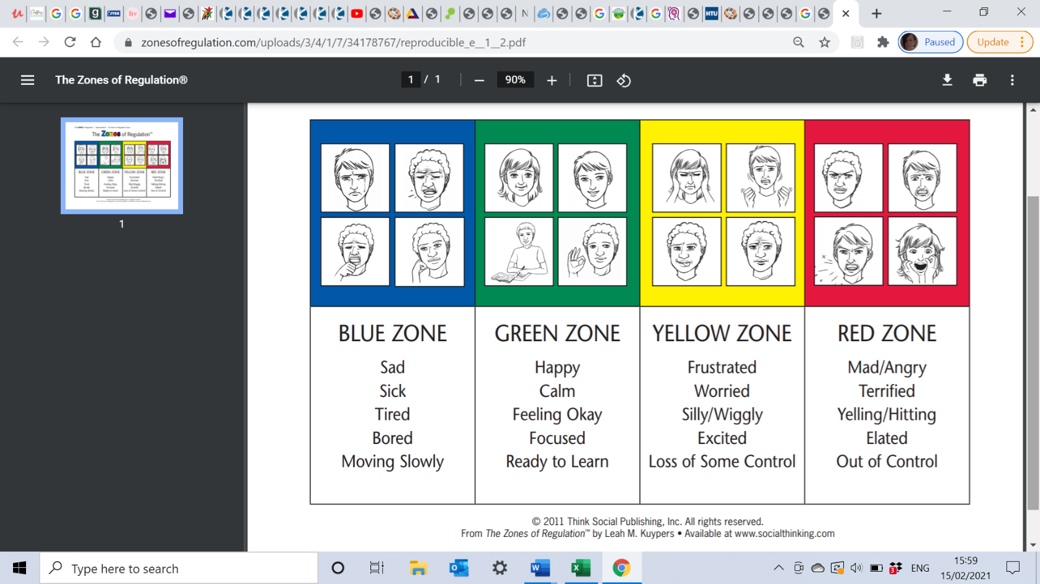

**2.2 PACE/PLACE**

PLAYFULNESS: creating an atmosphere of lightness and interest when you communicate. An open, ready, calm, relaxed and engaged attitude.

ACCEPTANCE: actively communicating to the child that you accept the wishes, feelings, thoughts, urges, motives and perceptions that are underneath the outward behaviour. Unconditionally accepting a child makes them feel secure, safe and loved.

CURIOSITY: wondering about the meaning behind the behaviour for the child.

Curiosity lets the child know that the adults understand. Without judgement, children become aware of their inner life.

EMPATHY: the adult demonstrating that he or she knows how difficult an experience is for the child. The adult is telling the child that she will not have to deal with the distress alone. Empathy gives a sense of compassion for the child and their feelings

**2.3 The Six Principles of Nurture**

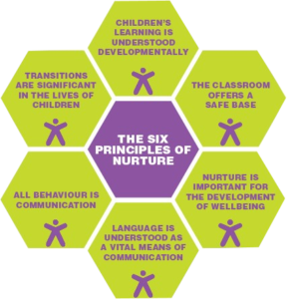

**2.4 Emotion Coaching**

At MTEISS, we use Emotion Coaching, an evidence-based strategy based on the work of John Gottman and colleagues 1996-97. Emotion coaching can contribute to the promotion of sustainable, holistic improvement in wellbeing for pupils, school staff, and families’ (Gus et al 2017). This approach helps young people to understand the different emotions they experience, why they occur and how to manage them. We want to support children to understand, regulate and reflect on their behaviour and feelings. We recognise the power of a relational approach and understand for Emotion Coaching to have impact, the adult involved, would need to have an existing relationship with the young person.

We do recognise that staff would need to react very differently to stop a behaviour that was dangerous. For any dangerous behaviours, the Emotion Coaching technique would not be appropriate and not immediate enough to protect a child from harm.

We use a 3 steps approach to emotion coach and manage behaviour:

|  |  |
| --- | --- |
| Step 1 | Recognise the child’s feelings and empathise with these feelings and not the behaviour. |
| Step 2 | Verbalise and label the feeling with the child, validating to the child why they might be feeling that way and that it is ok to feel that way.  Use zones of regulation that all feelings link to. This supports the children to identify how their feeling links to an emotion. |
| Step 3 | Set limits on the behaviour, discussing that although it is ok to feel a particular way it is not ok to then…… |
| Step 4 | Problem solve with the child supporting them to identify how to make the situation better, identifying what needs to happen as a result.  This aims to empower the child to do something positive about their behaviour and supports them to self-regulate if faced with a similar situation in the future. The more exploration and modelling of emotional problem solving a child receives, the more empowered they become in identifying their own feelings and emotional regulation. |

* 1. **Intensive Support**

Life events can introduce episodes which become interruptions to some children’s development and learning, and sometimes a student’s timetable may need to be collapsed in order for them to receive more intensive therapeutic intervention or therapy. The student will spend an extended period of time in the …………….. Centre, where they can receive targeted support from any one of our in-house therapists.

1. **Behaviour Practices and Procedures**

*“When little people are overwhelmed by big emotions, it is our job to share our calm, not join their chaos”*

**3.1 Classroom Code of Conduct**

* we respect people and spaces with kind actions
* we respect with kind words
* we listen with care
* we follow instructions
* we dress appropriately

**3.2 Classroom rules and Procedures**

Rules and procedures should be designed to make clear to the children how they can achieve acceptable standards of behaviour, and should be kept to a necessary minimum. They should:

* be positively stated, telling the children what to do rather than what not to do
* actively encourage everyone involved to take part in their development;
* have a clear rationale, made explicit to all;
* be consistently applied and enforced;
* promote the idea that every member of the school has responsibilities towards the whole.

The revisiting of our expectations and agreements regularly is vital for them to remain important and relevant.

**3.3 Rewards**

Our emphasis is to focus on rewards to reinforce good behaviour. We believe that rewards have a motivational role, helping children to see that good behaviour is valued. The commonest reward is praise, informal and formal, public and private, to individuals and groups. It is earned by the maintenance of good standards as well as by particularly noteworthy achievements. Rates of praise for behaviour should be as high as they are for work. Our rewards will be as bespoke and diverse as our curriculum but may include, amongst others:

* external visits and treats;
* postcards home;
* stickers and certificates
* ‘Always’ awards

These aim to promote confidence, competency, motivation, help pupils to develop growth mind-sets and promote prosocial behaviour.

**3.4 Behaviour Interventions**

When a child is displaying inappropriate behaviours we recognise that each situation will be absolutely unique to the child and, therefore, the response needed will also be unique. The situation and the factors involved will be considered carefully and responses will be made following a Professional’s discussion including some/all members of the team around the child.

In most situations we will be able to implement the correct interventions and therapies required to modify the child’s behaviour and reduce their anxieties, however, there are some situations that will provoke a more severe response from school, and could result in a fixed term or permanent exclusion. These incidents would include:

* Physical assault against a pupil
* Physical assault against an adult
* Verbal abuse / threatening behaviour against a pupil
* Verbal abuse / threatening behaviour against an adult
* Bullying
* Racist abuse
* Damage
* Sexual misconduct
* Theft
* Persistent disruptive behaviour
* Any illegal activities; e.g., incidents involving drugs, alcohol or sharps.

In the case of an exclusion, parents and Commissioners will be informed. Following exclusion, the pupils and parents will be called to a ‘return to school’ meeting and a behaviour support plan will be initiated where appropriate.

Throughout all our responses to behaviour, we recognise that our partnership with parents/carers, external agencies and Commissioners plays a vital role in ensuring good outcomes for students. We will work, wherever possible, in agreement and consult fully on actions and next steps.

A behaviour review will take place at least annually to scrutinise the effectiveness of the school’s approaches.