Date: February 2021
Review Date: January 2022
Responsible Person: Michelle Needham
Complaints Policy

Contents

1. Principles 2

2. Aims 2
3. The difference between a concern, complaint and appeal 2

4. The Complaints procedure 2

5. Stage 1 3

6. Stage 2 3

7. Stage 3 3

8. Timeliness 4
8.1 Stage 1 – informal 4
8.2 How to escalate a complaint. 5
8.3 Stage 3: submit the complaint to the review panel. 5
8.3i Convening the panel 5
8.3ii At the meeting 6
8.3iii The outcome 6
8.4 Maintaining Confidentiality. 6

9. Complaints not in scope of the procedure 7

10. Further information useful resources and External Organisation procedures 8

1. Principles

It is the aim of More Than Ed Independent School (MTEIS) to provide an outstanding education for all student.

Senior Leaders, Learning Managers, teaching staff and therapeutic staff work hard to build positive relationships with all students, parents/carers, employers and commissioners. We are nonetheless obliged to have procedures in place in case where there may be complaints by learners, parents, commissioners, employers or other members of the public. The following policy sets out the procedures that we follow in such cases.

If there are any complaints regarding the education any learner is receiving, or have any
concerns relating to the school, or employer we encourage, in the first instance to talk with their
learning manager, immediately either face to face or over the phone.
2. Aims

We aim to be fair, open and honest when dealing with any complaint. We give careful consideration to all complaints and deal with them as swiftly as possible. We aim to resolve any complaint through dialogue, mutual understanding and in some cases investigations. In all cases we put the interests of the student above all else. We provide sufficient opportunity for any complaint to be fully discussed and then resolved. All written complaints (stage 2) will be followed with a report outlining all actions undertaken and any recommendations to be made.

3. The difference between a concern, complaint and appeal

A ‘concern’ may be defined as ‘an expression of worry or doubt over an issue considered to be
important for which reassurances are sought’. A complaint may be generally defined as ‘an
expression of dissatisfaction however made, about actions taken or a lack of action’. An appeal is
defined as a ‘application to a higher court for a decision to be reversed’.

It is in everyone’s interest that concerns and complaints are resolved at the earliest possible
stage. Many issues can be resolved informally, without the need to invoke formal procedures.
We will take all informal concerns seriously and will make every effort to resolve the matter as quickly as possible. There are occasions when complainants would like to raise their concerns as a formal complaint, or make an appeal for a reversal of a decision e.g. where there is a disagreement regarding an internal or external grading for an individuals’ work. In those cases, the following procedure should be invoked.

4. The complaints procedure

If a parent/carer or student is concerned about anything to do with the education we provide they should, in the first instance, discuss the matter with the student’s tutor or Learning Manager. In our experience most matters of concern can be resolved positively in this way. Our tutors and Learning Managers ensure that each learner is happy and is making good progress. They naturally want to know if there is a problem so that they can take action before it seriously affects their progress.
Where the complainant feels that a situation has not been resolved through contact with the tutor, or Learning Manager, or that their concern is of a sufficiently serious nature, they should make an appointment to discuss it with the appropriate senior leader. This is known as a stage 1 complaint. These complaints can be made either face to face, over the telephone, or in writing (e.g. via an email). It is important to ask the complainant at this stage what they think might resolve the issue.
An appeal can also be made using the staged processes outlined below.
5. Stage 1

A meeting with the appropriate senior leader to talk through and take consideration of any complaint. The senior leader will take all complaints very seriously and most complaints can be resolved at this stage. All resolutions will be agreed and made in writing, along with any further recommendations or agreed actions.

If after stage 1 the parent/carer or student are not satisfied, the complaint can be made in writing, stating the nature of the complaint and how we have handled it so far. The complaint would now be processed through formal protocols known as stage 2.

6. Stage 2

Further information will need to be gathered at stage 2 and this may include investigations and interviews with members of staff, or any other individuals who may be involved. This stage may also invoke other procedures such as disciplinary procedures, or the whistleblowing procedure. It may also be that the relevant Local Authority are informed and may/may not participate in the procedures from this point.

Following any investigation, a full report will be available to all involved outlining any findings and further recommendations. Where a multi-agency network surrounds the child and the family, this report will be shared with the relevant professionals (with consent).

If the complainant remains unsatisfied with the way the complaint has been handled at this point, a stage 3 process will be invoked.

7. Stage 3

The stage 3 process involves conducting a panel to finally resolve issues. The panel will consist of individuals from MTEIS, the commissioning LA, and external agencies as appropriate. Members of the panel must not have any connection to the complaint in any way.

All information, and particulars in relation to the actions thus far, including any paperwork or notes recorded will be made available to the panel no later than 5 working days prior to the panel meeting.

The complainant may be accompanied to the hearing by one other person. This may be a relative, teacher or friend. Legal representation will not normally be appropriate. If possible, the panel will resolve the complaint immediately without the need for any further investigation.

Where further investigation is required, the panel will decide how this will be carried out. After due consideration of all facts, the panel will reach a decision and may make recommendations, which it shall complete within 5 working days of the panel meeting. The panel will write to the complainant informing them of the decision and the reasons for it. The panel’s findings and, if any, recommendations will be made in writing.

The decision of the panel will be final but if the complainant is still not satisfied, they can complain directly to the Secretary of State, who will look into whether the school handled the complaint properly.

In the case of serious misconduct complaints will be referred immediately to the police.
Should any parents/carers have a complaint about a member of the Leadership Team, they should first request an informal meeting with him/her if appropriate, or with one of the Directors if not. However, if the complaint is very serious, a formal complaint, as outlined above should be made.

Written records of complaints are kept and a log indicates whether they were resolved at the preliminary stage or proceed to a panel hearing.

All correspondence, statements and records relating to individual complaints are kept confidential except where the Secretary of State or a body conducting an inspection under section 162A of the 2002 Act, as amended, requests access to them.

8. Timeliness

Complaints need to be considered and resolved as quickly, and efficiently as possible:

- Reasonable time limits for each action within each stage will be set (where further investigations are necessary, new time limits will be agreed, the complainant will be sent the details of any new deadlines and will be given an explanation any delay)
- We do not consider excessive time limits to be reasonable or acceptable, except in extenuating circumstances
- Complaints tend to be made as soon as possible after an incident arises (although three months is generally considered to be an acceptable time frame in which to lodge a complaint)

The school will take informal concerns seriously and make every effort to resolve the matter quickly. It may be the case that the provision or clarification of information will resolve the issue.
The complainant should raise the complaint as soon as possible with the relevant member of staff or the headteacher as appropriate, either in person or by letter, telephone or email. If the complainant is unclear who to contact or how to contact them, they should contact the school office on 01302 ******, or at enquiries@morethaned.co.uk.
8.1 Stage 1 - Informal
The school will acknowledge informal complaints within 5 school days, and investigate and provide a response within 15 school days.
The informal stage will involve a meeting between the complainant and the Headteacher and/or the subject of the complaint], as appropriate.
If the complaint is not resolved informally, it will be escalated to a formal complaint.
Stage 2: formal
Formal complaints can be raised:
By letter or email
Over the phone
In person
By a third party acting on behalf of the complainant
The complainant should provide details such as relevant dates, times, and the names of witnesses of events, alongside copies of any relevant documents, and what they feel would resolve the complaint.
If complainants need assistance raising a formal complaint, they can contact the school office on 01302 ******, or at enquiries@morethaned.co.uk. The headteacher (or designated member of the senior leadership team) will call a meeting to clarify concerns, and seek a resolution. The complainant may be accompanied to this meeting, and should inform the school of the identity of their companion in advance.
In certain circumstances, the school may need to refuse a request for a particular individual to attend any such meeting – for example, if there is a conflict of interest. If this is the case, the school will notify the complainant as soon as they are aware, so that the complainant has the opportunity to arrange alternative accompaniment.
The headteacher (or other person appointed by the headteacher for this purpose) will then conduct their own investigation. The written conclusion of this investigation will be sent to the complainant within school days.
If the complainant wishes to proceed to the next stage of the procedure, they should inform the clerk to the governing board within 5 school days.
8.2 How to escalate a complaint
Complaints can be escalated by contacting the clerk to the governing board:
By letter or email
Over the phone
In person
Through a third party acting on behalf of the complainant
The clerk will need the details of the complaint as set out above, as well as details from the complainant on how they feel the previous stage of the procedure has not addressed their complaint sufficiently, and what they feel would resolve the complaint.
The written conclusion of this investigation will be sent to the complainant within 20 school days.
If the complainant wishes to proceed to the next stage of the procedure, they should inform the clerk to the governing board in writing within 5 school days. Requests received outside of this time frame will be considered in exceptional circumstances.
The clerk will acknowledge receipt of the request within 5 school days.
8.3 Stage 3: submit the complaint to the review panel
8.3i Convening the panel
The complainant must have reasonable notice of the date of the review panel; however, the review panel reserves the right to convene at their convenience rather than that of the complainant. The clerk will aim to find a date within 10 school days of the request, where possible. The Panel will be attended by 3 people unrelated to the complaint.
If the complainant rejects the offer of 3 proposed dates without good reason, the clerk will set a date. The hearing will go ahead using written submissions from both parties.
Any written material will be circulated to all parties at least 3 school days before the date of the meeting.
8.3ii At the meeting
At the review panel meeting, the complainant and representatives from the school, as appropriate, will be present. Each will have an opportunity to set out written or oral submissions prior to the meeting.
The complainant must be allowed to attend the panel hearing and be accompanied by a suitable companion if they wish.
At the meeting, each individual will have the opportunity to give statements and present their evidence, and witnesses will be called as appropriate to present their evidence.
The panel, the complainant and the school representative will be given the chance to ask and reply to questions. Once the complainant and school representatives have completed presenting their cases, they will be asked to leave and evidence will then be considered.
The panel will then put together its findings and recommendations from the case. The panel will also provide copies of the minutes of the hearing and the findings and recommendations to the complainant and, where relevant, the subject of the complaint, and make a copy of the findings and recommendations available for inspection by the headteacher.
8.3iii The outcome
The committee can:
Uphold the complaint, in whole or in part
Dismiss the complaint, in whole or in part
If the complaint is upheld, the committee will:
Decide the appropriate action to resolve the complaint
Where appropriate, recommend changes to the school’s systems or procedures to prevent similar issues in the future
The school will inform those involved of the decision in writing within 5 school days.
8.4 Maintaining confidentiality.
The following documents related to individual complaints are kept confidential in a central location:
- Correspondence
- Statements
- Records
However, these will if be shared with the Secretary of State or someone acting on their behalf or conducting an inspection under Section 109 of the 2008 Act

9. Complaints not in scope of the procedure

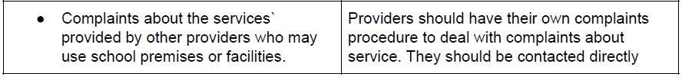
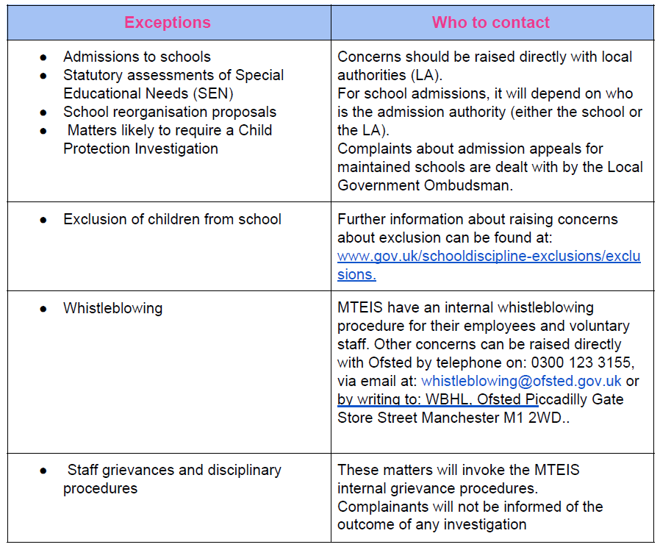
A complaints procedure should cover all complaints about any provision of facilities or services that a school provides with the exceptions listed below, for which there are separate (statutory) p Monitoring and review
MTEIS monitors the complaints procedure in order to ensure that all complaints are handled properly. Complaints are recorded via a log and shared with the Headteacher and the Directors of MTEIS, the log also records how complaints have been resolved. The log is reviewed on an annual basis and helps to inform CPD and training needs of staff.

This policy is made available to all students, parents/carers so that they can be properly informed about the complaints process. Students also receive a child-friendly version of the process in their Induction Pack.

10. Further information Useful Resources and External Organisations procedures

• National Governors Association
• Information Commissioner’s Office Other Relevant Departmental Advice and Statutory Guidance
- Section 29 of the Education Act 2002
• Governors Handbook
• Understanding and Dealing with Issues Relating to Parental Responsibility

This policy has been written in conjunction with:

● DfE Best Practice Advice for School Complaints Procedures 2016
● Section 29, Education Act 2002

