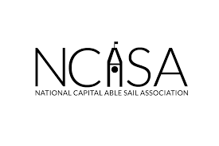

**GEORGE SIMPSON LEGACY FUND (GSLF)**

NCASA is dedicated to ensuring the accessibility of sailing for individuals with disabilities, irrespective of their financial circumstances. To this end, the George Simpson Legacy Fund was established to provide financial assistance, specifically through bursaries, enabling individuals with disabilities to participate in both recreational sailing and competitive regattas. Considering the limited financial resources available, NCASA aims to prioritize supporting sailors for whom the cost could be a barrier to participating in Able Sail's recreational and/or racing activities. Furthermore, the Fund partially covers travel expenses, reducing the financial barriers to participating in regattas outside Ottawa.

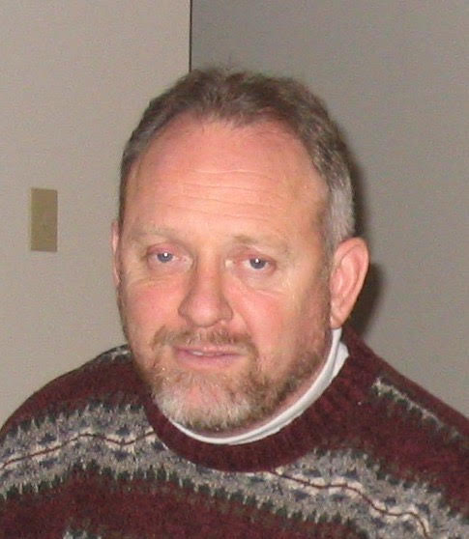

George Simpson, a pivotal figure in the able sail community for over three decades, is being remembered for his unwavering dedication to making sailing accessible to everyone. As the founding member and inaugural President of the National Capital Able Sail Association (NCASA) in 1998, Simpson's passion and tireless efforts left an indelible mark on adaptive sports.

Despite a life-altering accident in his twenties that confined him to a wheelchair, George Simpson refused to be sidelined. He discovered a passion for sailing and became a dedicated able sailor. In recognition of his profound impact, following his passing in October 2021, the George Simpson Legacy Fund was established. This fund aims to provide financial support to individuals wishing to participate in able sail programs, carrying forward his mission of inclusivity.

In a testament to his foundational role, the Able Sail Dock at the NSC was officially dedicated as the "George Simpson Landing." George Simpson's enduring legacy is one of resilience, passion, and a profound commitment to breaking down barriers, ensuring that the joy of sailing is a shared experience for all.

**GEORGE SIMPSON LEGACY FUND (GSLF)**

**APPLICATION FORM**

**Full Name:________________________________________**

**Email Address: __________________________________**

**Civic Address: ___________________________________**

**_______________________________________________**

**_______________________________________________**

**Phone #: _______________________________________**

**Please provide a short outline of your request to the GSLF.**

|  |
| --- |

**Please email your application to NCASA Treasurer John Brooks** [**jdbrooks.kv@gmail.com**](mailto:jdbrooks.kv@gmail.com)**, noting GSLF Application in the subject line. A Committee will review the request and contact you directly with a response. Thank you.**