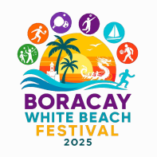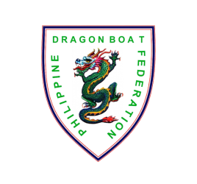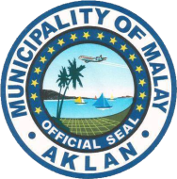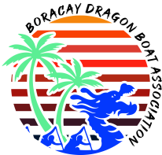

**OARTOBERFEST DRAGON BOAT FESTIVAL 2025**

*White Beach Boracay Island, Malay, Aklan , Philippines*

November 7 to 9, 2025

**Team Name: _____________________________________________**

**TEAM GALLERY**

***NOTE: SEPARATE TEAM GALLERIES MUST BE ACCOMPLISHED FOR TEAMS WITH MULTIPLE ENTRIES. Put the full name of crew member inside the box below their photo.***

1. **Photos 1-5 for Stroke Side Paddlers; b. Photos 6-10 for Bow Side Paddlers;**
2. **11-12 for Reserve Paddlers; d. 13-16 for Drummer/Steersman/Team Manager/Coach (as labeled)**

**Premier WOMEN Small Boat (DB12)**

**RACE DISTANCE: 200m**

|  |  |  |  |  |
| --- | --- | --- | --- | --- |
| **1** | **2** | **3** | **4** | **5** |
| Paddler | Paddler | Paddler | Paddler | Paddler |

|  |  |  |  |  |
| --- | --- | --- | --- | --- |
| **6** | **7** | **8** | **9** | **10** |
| Paddler | Paddler | Paddler | Paddler | Paddler |

|  |  |  |
| --- | --- | --- |
| **11** | **12** |  |
| Paddler | Paddler |

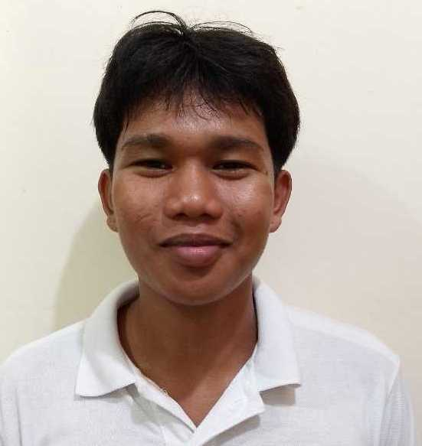

|  |  |  |  |
| --- | --- | --- | --- |
| **13** | **14** | **15** | **16** |
| DRUMMER | HELM | TEAM COACH | TEAM MANAGER |

Checked and certified true and correct by:

__________________________________________ Date: ____________________________

Signature over printed name of

Team Manager / Team Representative