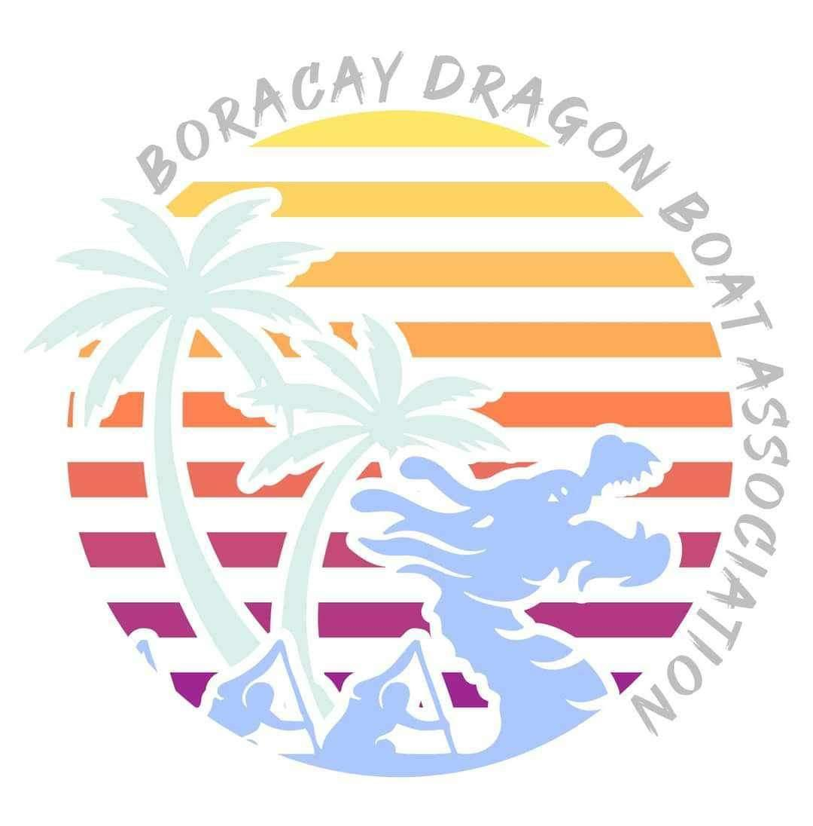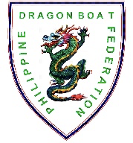
L️VEBoracay International
Dragon Boat Festival 2024
April 27 to 28, 2024
Station 1, White Beach, Boracay Island, Malay, Aklan

REQUEST FOR SUBSIDY

For a limited number of slots, local teams may avail themselves of subsidized race fees from our partners and sponsors. Subsidized race fee is P1,500/ participant or racer. If you are a Philippine-based team and would like to apply for a subsidized race fee, please fill out the form below and wait for the confirmation from the organizers if your team could still be accommodated in the subsidy program.

Team Name

Contact Person

Position

Mobile No.

e-mail address

No. of team members

Team’s location in the Philippines
Boracay-based team? | ____ YES _____ NO
PDBF member club? | ____ YES _____ NO
Signature

INSTRUCTIONS:
- E-mail this form along with other race forms to phidbfed@gmail.com on or before January 31, 2024.

