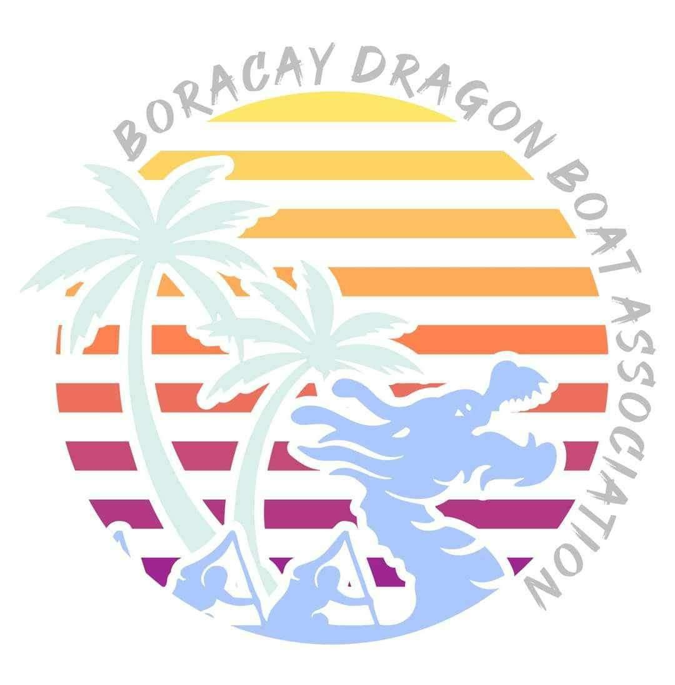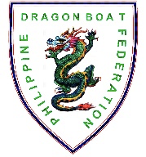
L️VEBoracay International
Dragon Boat Festival 2024
April 27 to 28, 2024
Station 1, White Beach, Boracay Island, Malay, Aklan

CONFIRMATION OF ENTRY

Team Name

Contact Person

Position

Mobile No.

e-mail address

Signature

Check race distance of entry that you would like to join.

Category | Competition Class | 200m | 500m
Standard Boat (22 racers) | Premier Open
 | Premier Mixed
Small Boat (12 racers) | Premier Women
 | Premier Open
 | Senior-A Mixed

Need assistance in booking hotel?
YES NO

Need assistance in local transportation?
YES NO

With food restrictions? If yes, specify: _____________________________________
YES NO

INSTRUCTIONS:
- E-mail this form and soft copy of all other race forms to phidbfed@gmail.com on or before January 31, 2024.

