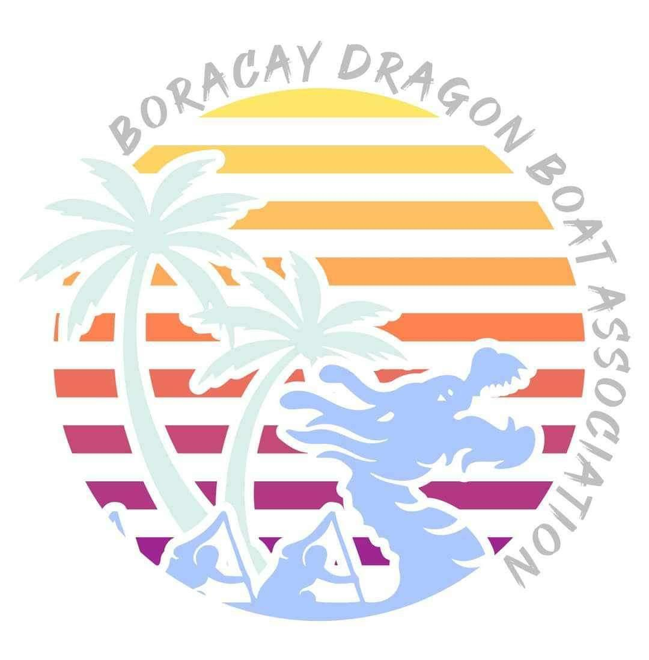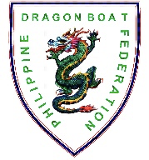
L️VEBoracay International
Dragon Boat Festival 2024
April 27 to 28, 2024
Station 1, White Beach, Boracay Island, Malay, Aklan

Team Name: _____________________________________________

TEAM GALLERY

NOTE: SEPARATE TEAM GALLERIES MUST BE ACCOMPLISHED FOR TEAMS WITH MULTIPLE ENTRIES
- Photos 1-10 for Stroke Side Paddlers; b. Photos 11-20 for Bow Side Paddlers;
- 21-24 for Reserve Paddlers; d. 25-28 for Drummer/Steersman/Team Manager/Coach (as labeled)

Premier MIXED Standard Boat (22)
RACE DISTANCE: 200m 500m

1 | 2 | 3 | 4 | 5
PADDLER | PADDLER | PADDLER | PADDLER | PADDLER

6 | 7 | 8 | 9 | 10
PADDLER | PADDLER | PADDLER | PADDLER | PADDLER

11 | 12 |  | 13 | 14 | 15
PADDLER |  | PADDLER | PADDLER | PADDLER | PADDLER

16 | 17 | 18 | 19 | 20
PADDLER | PADDLER | PADDLER | PADDLER | PADDLER
21 | 22 | 23 | 24
PADDLER | PADDLER | PADDLER | PADDLER

25 | 26 | 27 | 28
DRUMMER | STEERSMAN | TEAM COACH | TEAM MANAGER

