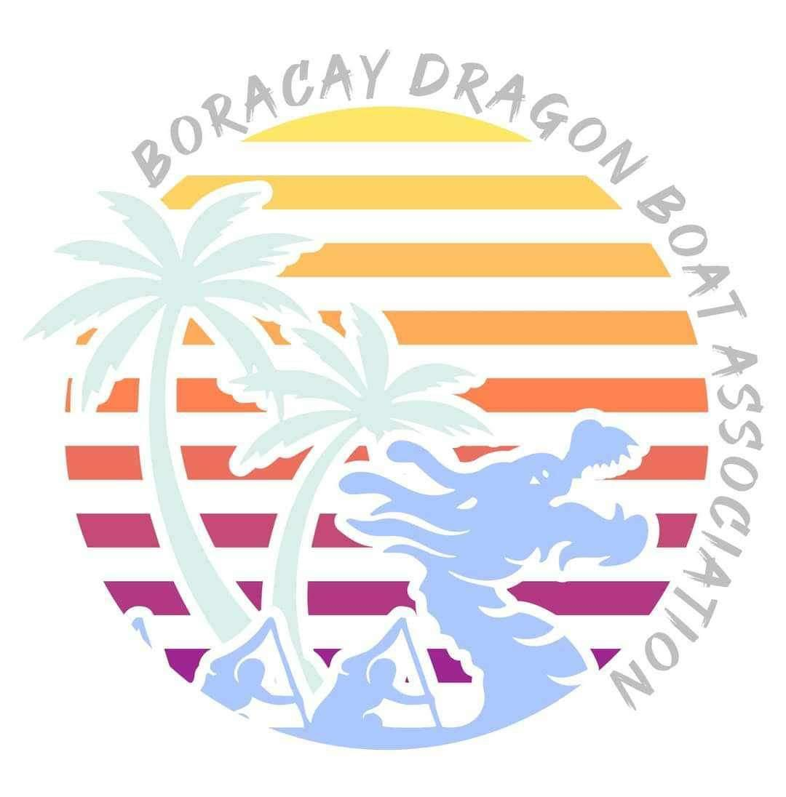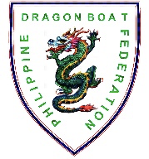
L️VEBoracay International
Dragon Boat Festival 2024
April 27 to 28, 2024
Station 1, White Beach, Boracay Island, Malay, Aklan

TEAM WAIVER

I, ___________________________________, the undersigned team manager, on behalf of the ____________________________________________________ hereby notify the organizers of L️VEBoracay International Dragon Boat Festival 2024 that the individuals whose signatures appear below on the attached list are, through their signature, confirming that they are physically fit and trained for competitive dragon boat racing, have been vaccinated against COVID-19, do not exhibit COVID-19 symptoms on the day of the race, and that they can swim at least 100 meters wearing light clothing.

By their signatures, each individual also confirms that they have undergone a medical check and that there is no known medical or other reason why they should not take part in the race program of the L️VEBoracay International Dragon Boat Festival 2024 for which they have entered.

The signatories hereby expressly agree to abide by all rules and regulations of the PDBF and the event organizers, and hereby discharge the organizing committee, the PDBF and other individuals or organizations connected directly or indirectly with the race and festival, from any responsibility in the event of injury, death or loss of property incurred during or as a direct consequence of or while travelling to or from the event.

I further declare that all fees due as notified by the organizing committee with respect to my team will be paid in full before the competition and that in the event of any debt incurred by any of the signatories during the event, that the organizing committee will be reimbursed in full before the end of the event or by a written guarantee payable within 30 days from the end of the event.

_____________________________________________________ ____________________________
Signature over printed name of team manager Date

_____________________________________________________ ____________________________
Signature over printed name of team captain Date

NOTE: One Team Waiver per Crew. For example, a team has entry in Mixed Standard, Open Small Boat and Women Small Boat. The team will need to submit a total of THREE (3) Team Waivers, with one Team Waiver per crew.
L️VEBoracay International
Dragon Boat Festival 2024
April 27 to 28, 2023
Station 1, White Beach, Boracay Island, Malay, Aklan

CREW LIST FORM

500m Premier Open Standard 500m Premier Mixed Standard

No | NAME | SIGNATURE | No | NAME | SIGNATURE
25 | [Drummer] |  | 26 | [Steersman]
PADDLER’S NAME |  |  | PADDLER’S NAME
1 |  |  | 11
2 |  |  | 12
3 |  |  | 13
4 |  |  | 14
5 |  |  | 15
6 |  |  | 16
7 |  |  | 17
8 |  |  | 18
9 |  |  | 19
10 |  |  | 20
21 | [Reserve] |  | 23 | [Reserve]
22 | [Reserve] |  | 24 | [Reserve]

Crew Officials' Declaration

In accordance with IDBF Competition Regulation 3, we certify that those competitors listed above are shown on our Team/Club Entry Form or crew gallery, that they are fit to race and are the only ones who will take part in the Competition Class shown. We understand that a false declaration may result in the disqualification from the Competition Class and from the race.

_____________________________________________________ ____________________________
Signature over printed name of team manager Date

_____________________________________________________ ____________________________
Signature over printed name of team captain Date

NOTE: This form may be reproduced as many copies as may be needed.
L️VEBoracay International
Dragon Boat Festival 2024
April 27 to 28, 2023
Station 1, White Beach, Boracay Island, Malay, Aklan

CREW LIST FORM

500m Premier Women Small Boat 500m Premier Open Small Boat

500m Senior-A Mixed Small Boat

No | NAME | SIGNATURE | No | NAME | SIGNATURE
13 | [Drummer] |  | 14 | [Steersman]
PADDLER’S NAME |  |  | PADDLER’S NAME
1 |  |  | 6
2 |  |  | 7
3 |  |  | 8
4 |  |  | 9
5 |  |  | 10
11 | [Reserve] |  | 12 | [Reserve]

Crew Officials' Declaration

In accordance with IDBF Competition Regulation 3, we certify that those competitors listed above are shown on our Team/Club Entry Form or crew gallery, that they are fit to race and are the only ones who will take part in the Competition Class shown. We understand that a false declaration may result in the disqualification from the Competition Class and from the race.

_____________________________________________________ ____________________________
Signature over printed name of team manager Date

_____________________________________________________ ____________________________
Signature over printed name of team captain Date

NOTE: This form may be reproduced as many copies as may be needed.
L️VEBoracay International
Dragon Boat Festival 2024
April 27 to 28, 2023
Station 1, White Beach, Boracay Island, Malay, Aklan

CREW LIST FORM

200m Premier Open Standard 200m Premier Mixed Standard

No | NAME | SIGNATURE | No | NAME | SIGNATURE
25 | [Drummer] |  | 26 | [Steersman]
PADDLER’S NAME |  |  | PADDLER’S NAME
1 |  |  | 11
2 |  |  | 12
3 |  |  | 13
4 |  |  | 14
5 |  |  | 15
6 |  |  | 16
7 |  |  | 17
8 |  |  | 18
9 |  |  | 19
10 |  |  | 20
21 | [Reserve] |  | 23 | [Reserve]
22 | [Reserve] |  | 24 | [Reserve]

Crew Officials' Declaration

In accordance with IDBF Competition Regulation 3, we certify that those competitors listed above are shown on our Team/Club Entry Form or crew gallery, that they are fit to race and are the only ones who will take part in the Competition Class shown. We understand that a false declaration may result in the disqualification from the Competition Class and from the race.

_____________________________________________________ ____________________________
Signature over printed name of team manager Date

_____________________________________________________ ____________________________
Signature over printed name of team captain Date

NOTE: This form may be reproduced as many copies as may be needed.
L️VEBoracay International
Dragon Boat Festival 2024
April 27 to 28, 2023
Station 1, White Beach, Boracay Island, Malay, Aklan

CREW LIST FORM

200m Premier Women Small Boat 200m Premier Open Small Boat

200m Senior-A Mixed Small Boat

No | NAME | SIGNATURE | No | NAME | SIGNATURE
13 | [Drummer] |  | 14 | [Steersman]
PADDLER’S NAME |  |  | PADDLER’S NAME
1 |  |  | 6
2 |  |  | 7
3 |  |  | 8
4 |  |  | 9
5 |  |  | 10
11 | [Reserve] |  | 12 | [Reserve]

Crew Officials' Declaration

In accordance with IDBF Competition Regulation 3, we certify that those competitors listed above are shown on our Team/Club Entry Form or crew gallery, that they are fit to race and are the only ones who will take part in the Competition Class shown. We understand that a false declaration may result in the disqualification from the Competition Class and from the race.

_____________________________________________________ ____________________________
Signature over printed name of team manager Date

_____________________________________________________ ____________________________
Signature over printed name of team captain Date

NOTE: This form may be reproduced as many copies as may be needed.

