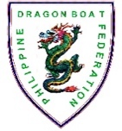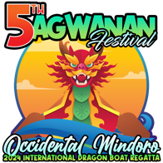

**5TH SAGWANAN FESTIVAL:**

**2024 OCCIDENTAL MINDORO INTERNATIONAL DRAGON BOAT RACE**

***November 16, 2024***

***Isla de Oro Ecopark, Mamburao, Occidental Mindoro***

**Team Name: __________________________________**

**TEAM GALLERY**

***NOTE: SEPARATE TEAM GALLERIES MUST BE ACCOMPLISHED FOR TEAMS WITH MULTIPLE ENTRIES. INDICATE NAMES OF CREW MEMBERS BELOW THEIR PICTURES***

1. **Photos 1-5 for Stroke Side Paddlers; b. Photos 6-10 for Bow Side Paddlers;**
2. **11-12 for Reserve Paddlers; d. 13-16 for Drummer/Steersman/Team Manager/Coach (as labeled)**

**Small Boat WOMEN (12)**

|  |  |  |  |  |
| --- | --- | --- | --- | --- |
| **1** | **2** | **3** | **4** | **5** |
| PADDLER | PADDLER | PADDLER | PADDLER | PADDLER |

|  |  |  |  |  |
| --- | --- | --- | --- | --- |
| **6** | **7** | **8** | **9** | **10** |
| PADDLER | PADDLER | PADDLER | PADDLER | PADDLER |

|  |  |
| --- | --- |
| **11** | **12** |
| PADDLER | PADDLER |

|  |  |  |  |
| --- | --- | --- | --- |
| **13** | **14** | **15** | **16** |
| DRUMMER | STEERSMAN | TEAM COACH | TEAM MANAGER |