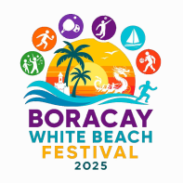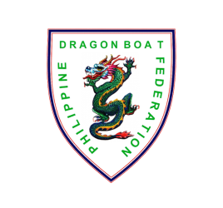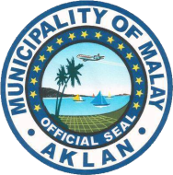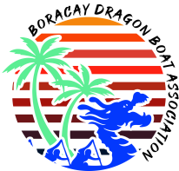

**OARTOBERFEST DRAGON BOAT FESTIVAL 2025**

*White Beach Boracay Island, Malay, Aklan , Philippines*

November 7 to 9, 2025

**CONFIRMATION OF ENTRY**

|  |  |
| --- | --- |
| Team Name |  |
| Contact Person |  |
| Position |  |
| Mobile Number |  |
| E-mail Address |  |
| Signature |  |

Check race distance of entry that you would like to join.

|  |  |  |
| --- | --- | --- |
| **CATEGORY** | **COMPETITION CLASS** | **200 Meters** |
| Standard Boat (22 racers) | Premier Mixed |  |
| Small Boat (12 racers) | Premier Open |  |
|  | Premier Womens |  |
|  | Under 24 Mixed |  |

Need assistance in booking hotel?

YES NO

Need assistance in Local transportation?

YES NO

*INSTRUCTIONS:*

1. E-mail this form and soft copy of all other race forms to [boracaydragonboatassociation@gmail.com](mailto:boracaydragonboatassociation@gmail.com)
2. Contact no. +63 9664503101