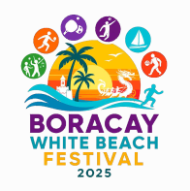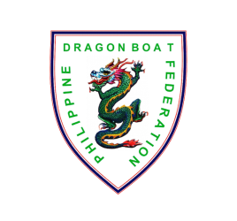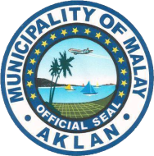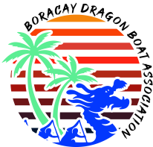

**OARTOBERFEST DRAGON BOAT FESTIVAL 2025**

*White Beach Boracay Island, Malay, Aklan , Philippines*

November 7 to 9, 2025

**Team Name: __________________________________**

**CREW SUMMARY**

|  |  |  |
| --- | --- | --- |
| **NO.** | **NAME (IN ALPHABETICAL ORDER)** | **COMPETITION CLASS** |

|  |  |  |  |  |  |  |
| --- | --- | --- | --- | --- | --- | --- |
|  |  | **Shirt Size** | **Premier Mixed**  **(DB22)** | **Premier Open**  **(DB12)** | **Premier Women**  **(DB12)** | **U24 Mixed**  **(DB12)** |
| 1 |  |  |  |  |  |  |
| 2 |  |  |  |  |  |  |
| 3 |  |  |  |  |  |  |
| 4 |  |  |  |  |  |  |
| 5 |  |  |  |  |  |  |
| 6 |  |  |  |  |  |  |
| 7 |  |  |  |  |  |  |
| 8 |  |  |  |  |  |  |
| 9 |  |  |  |  |  |  |
| 10 |  |  |  |  |  |  |
| 11 |  |  |  |  |  |  |
| 12 |  |  |  |  |  |  |
| 13 |  |  |  |  |  |  |
| 14 |  |  |  |  |  |  |
| 15 |  |  |  |  |  |  |
| 16 |  |  |  |  |  |  |
| 17 |  |  |  |  |  |  |
| 18 |  |  |  |  |  |  |
| 19 |  |  |  |  |  |  |
| 20 |  |  |  |  |  |  |
| 21 |  |  |  |  |  |  |
| 22 |  |  |  |  |  |  |
| 23 |  |  |  |  |  |  |
| 24 |  |  |  |  |  |  |
| 25 |  |  |  |  |  |  |
| 26 |  |  |  |  |  |  |
| 27 |  |  |  |  |  |  |
| 28 |  |  |  |  |  |  |
| 29 |  |  |  |  |  |  |
| 30 |  |  |  |  |  |  |
| **TOTAL** | |  |  |  |  |  |

NOTES: for each name entry -

1. Tick ONE option only for TEAM 3. Add more page/s as may be necessary

2. Tick one or more CATEGORY 4. No double rostering. Team A must remain in Team A