Case Studies
Peter J Fadde Instructional Design & Technology
Associate Professor Study Southern Illinois University
Differences in Batting Statistics: Cooperating Team vs. Conference
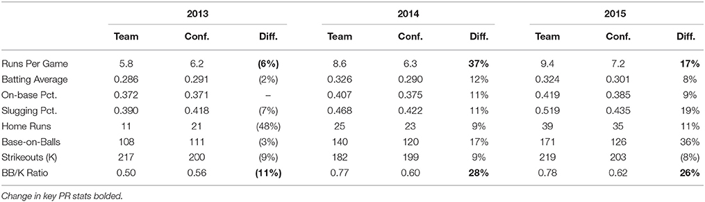
Changes in Batting Statistics: Cooperating Team vs. Comparison Team
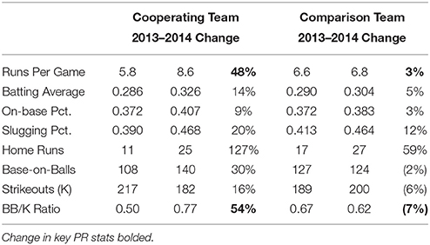
Ranking of Training and No Training Teams in Conference(11 = best; 1 = worst).

