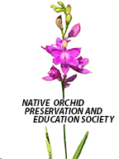
NATIVE ORCHID PRESERVATION AND EDUCATION SOCIETY
NEWSLETTER
nativeorchidpreservationeducationsociety.com

January 2019

We had a very successful first meeting of NOPES on October 16th, 2018. Thirteen people attended, and many stepped up to volunteer for activities and discussed the direction NOPES plans to take in the future.

Officers are Teresa Huesman, President; Pat O’Connor, Treasurer; Ann Tsui, Secretary; Jeanne Rhinehart, IT; Angela Carter, Educational Activities and Facebook.

Dues will be $20 a year.

Another meeting is planned for January 28 at Joseph Beth at Rookwood at 6:30 for dinner.

We have our first hike at East Fork State Park February 9. We will meet at Krogers in Mt. Carmel at 1:30. Contact Teresa if attending.

Hello,
Native orchid enthusiast,

Even though it is cold outside there are still orchids to be found. As you take your winter hikes, remember to keep your eyes out for two orchids which put out a single leaf in the fall. Look closely at the leaves on the ground and you may see a leaf poking through.

Aplectrum hyemale , also known as Putty Root and Adam and Eve, puts out a single leaf that’s ovate in shape, light green in color with pronounced white stripes. (Photo Jeanne Rhinehart)
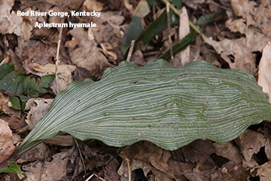

Tipularia discolor, also known as the cranefly orchid, puts out one dark green leaf that has pronounced veining and can have different shades of green. The one defining characteristic that helps in knowing for sure that it is a Tipularia, is the dark maroon color on the underside of the leaf. (Photo Flower White)

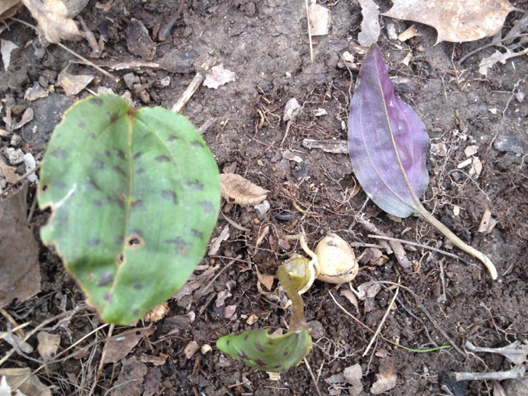

Once you have found these orchids you need to remember where you saw them. In May you will need to go back to where you saw the Aplectrum hyemale leaf and you may find it in bloom. Sometimes the leaf is still present and other times it’s not. For the Tipularia discolor you will need to wait until the end of July to find this one blooming. The leaf will not be present and you will need to look carefully for it will blend into the back ground.

Remember to look but not remove. Orchids need special fungi to live. If you remove it from its environment, you have killed it.

Sincerely,
Teresa Huesman
President

ACTIVITIES THIS FALL

We have had a display on Native Orchid Habitats at shows with the Kentucky Orchid Society, Cincinnati Orchid Society, Mid America Orchid Conference in Kansas City, and Saginaw Valley Orchid Society. The display has received 2 trophies, 4 blue ribbons, and an AOS Educational Exhibit award of 87 points. The display will be at the Miami Valley Orchid Society and Lansing Orchid Society shows. Talks on “Experiencing Native Orchids” were given at the Miami Valley Orchid Society in November and will be given at the Cincinnati Orchid Society and Saginaw Valley Orchid Society in March.

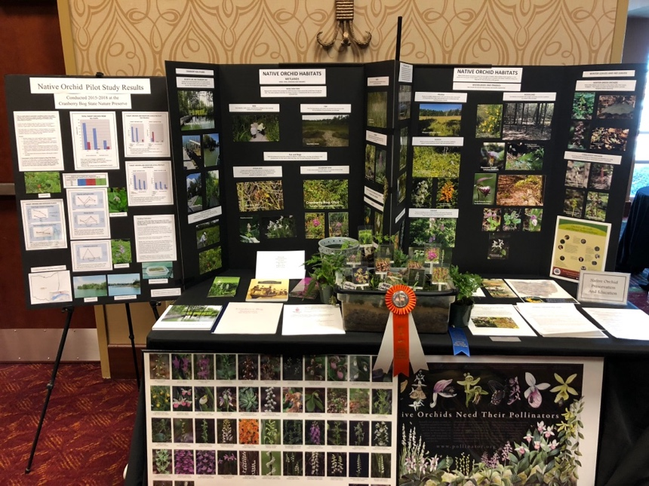

Native Orchid Protection and Education Society (NOPES)
Meeting Minutes of October 16, 2018
Attendees: Teresa Huesman, Michelle Little, Flower White, Angela Carter, Lois Shadix, Ann Tsui, Barry Rhinehart, Jun Lao, Jeanne Rhinehart, Pat O’Connor, William O’Connor, Cheryl Jaworski, John Jaworski.

The meeting of NOPES was begun by President Teresa Huesman at 7:15 pm at the home of Pat O’Connor.
Each attendee introduced him/herself by briefly providing their background and goals regarding native orchid conservation.
The agenda was handed out and discussed:
Society Goals and objectives: A copy of the page on the NOPES website was passed out. This has been a handout at orchid shows. The scope of region was discussed and the decision made to strike “from the tristate region” as this might limit the extent of our activities. The “objectives for our group” was accepted as an excellent beginning document able to change as new challenges may be considered.
Other activity goals were mentioned: Propagation with intent to disperse into other habitats when current native growing areas become unsuitable; clearing invasive plants from a bed of coral root at Cincinnati Nature Center; growing Cyp kentuckiense from seed pods (we have permission to harvest seed pods from plants growing at CGC), and the very long term goal of obtaining our own property to grow native orchids for dispersal.
Organization and officers: For now, Teresa will head the group as president, Jeanne as technical support, Ann as secretary, Pat as treasurer, Angela to schedule educational activities to view native plants in situ and to check into liability; Angela to set us up on Facebook which Teresa and Jeanne will monitor. Officer positions should be limited to a 2 year term.
The membership application from the Washington Native Orchid Society will be used to remind us of issues we would like to include in our form. We want NOPES to be open to all who respect native orchids.
Dues were suggested to be $20 to cover expenses such as the website.
Registered nonprofit status will not be pursued at this time.
Meetings will be held as needed and often tied to an activity, as opposed to a regular meeting schedule.
NOPES members volunteered their time and effort to clear Cranberry Bog’s invasive species on October 13. A large area was efficiently cleared especially about the board walk. Previous studies performed at Cranberry Bog have been loaned to us for review. We plan to return in June to view blooming Grass pinks and continue the Native orchid Study of 2015-2018.
The problem with potential poachers was reviewed. We will not publish GPS orchid sites on our website but may list public places such as the CZBG, state nature preserves… At private sites attendees will meet at a location and someone will escort them to the site to avoid publishing the orchid site location.
The meeting was concluded at 8:58 pm. Much was discussed, volunteers elicited for duties, and the direction NOPES intends to take was set at this meeting.
Respectfully submitted,
Ann Tsui

