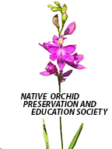**NATIVE ORCHID PRESERVATION AND EDUCATION SOCIETY**

**NEWSLETTER**

**nativeorchidpreservationeducationsociety.com**

**February 2019**

Hello Everyone,

We are half way through winter and quickly heading towards spring. Spring brings with it a very busy time as we start setting up trips to see as many native orchids as we can!

As we wait for spring, some very brave souls braved the cold and went looking for *Tipularia discolor*, *Aplectrum hyemale* and *Goodyera pubescens* this past weekend.

We bundled up and headed out on a trail and after a couple of wrong turns we were finally on our way. We weren’t on the frozen trail long before we started seeing *Tipularia* leaves poking through the brown leaf matter. Small ones, big ones, some with warts and some without. We kept looking for the elusive *Aplectrum*, but it remained hidden. After the trail turned and we saw that the sun was quickly turning the frozen ground into mud we decide to try our next site to see if we could find the *Goodyera*.

After a 15-mile ride we bundled up again and headed down the road to the trail head. Unfortunately, we were disappointed to see that the trail was underwater. Being orchid lovers, we all declared the trip a success! One orchid was better than none.

Our Website continues to grow. We now have an email address that is linked to google calendar: [natorchidspe@gmail.com](mailto:natorchidspe@gmail.com), so make sure you check the calendar for upcoming events.

We are planning our next meeting, which will be in the beginning of May. More information to come. We’re planning on this meeting being held on a weekend and in Adams County so we can have a meeting and see native orchids.

Some of us will be joining the Wild Flower Society for a trip to Kelly’s Island the weekend of 17-19. If interested, let me know.

Sincerely,

Teresa Huesman

**Cranberry Bog Update**

We met with Rick Gardner, Chief Botanist, Ohio State Nature Preserves to discuss our work at Cranberry Bog on January 12. Minutes of our meeting follows.

Native Orchid Preservation and Education Society

January 12, 2019 12:30 PM

Carsonie’s, Westerville, OH

Members Present: Jeanne and Barry Rhinehart, Ken Mettler, Angela Carter and Ann Tsui

Guests: Rick Gardner, Chief Botanist, Ohio State Nature Preserves

Rick was encouraging and actively participated in our discussion regarding our involvement at the bog and future direction for the society.

Areas of focus at Cranberry Bog: Continue to remove woody invasive species such as poison sumac, buckthorn and maple from the meadows and expand out as possible. Brush should be put at the edges of the bog. J-me remains the primary contact for work at the bog. ODNR could help with certified wetland herbicide use at the bog that has had some negative impacts with past herbicide attempts.

Fundraising: Consult or partner with the Friends of the Bog and The Buckeye Lake Historical Society; Go Fund Me is a possible option for money for bog cleanup and improvements such as a possible boardwalk extension for boat but additional boardwalk trails through the bog are not encouraged.

Additional invasive removal sites and networking: ONAPA assists with invasive removal at the Medway Eastern prairie fringed orchid site and has expressed interest in invasive removal at Cranberry Bog. Angela will reach out to ONAPA for potential volunteer partnership.

Flasking and reintroducing native orchids: There are historical records of Pogonia ophioglossoides, Rose Pogonia and Calopogon tuberosus, Grass Pink from McCracken Fen that may be a site for reintroduction in the future.

Miscellaneous topics: Recording and submitting counts of plants and locations. Recover the conservation camera for checking on geese issues and warbler houses. Identify and implement methods to vet membership to protect natural areas.

**Cincinnati Nature Center**

On February 6 Teresa Huesman, Lois Shadix, Ann Tsui, Jeanne and Barry Rinehart met with Cory Christopher and Jake Sberna to discuss our possible work with them. It was a profitable meeting. After showing us around their new greenhouse, they discussed what CNC has been doing with native plant conservation and what native orchids are presently found there. Concerns were also expressed on the need to protect native orchid populations around the center. We agreed to work on clearing an area around *Corallorhiza wisteriana* commonly called Wister’s Coral-root or Spring Coral-root. It is on Ohio’s Endangered List as being probably threatened. We also discussed ways to display native orchids at CNC.

Cory would check with Marjie Becus about what native orchids have been there. We could possibly help with reintroduction.

**Orchid of the Month – February**

***Tipularia discolor* (Purah) Nutt The Crane fly Orchid**

Jeanne Rhinehart

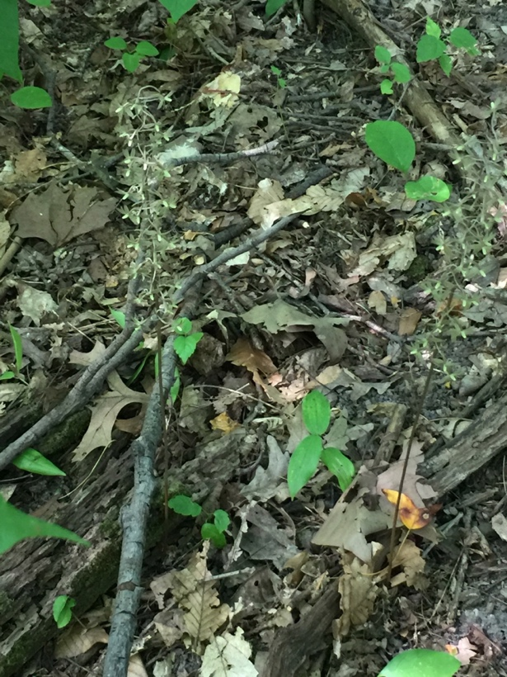

Because of its growth habits *Tipularia discolor* is considered one of the Naked Lady orchids along with *Aplectrum hyemale* or Putty Root because its leaves appear first, then die back and then the flower spike appears later in the summer. It is also considered one of the Wintergreen orchids which keep their foliage visible and green all winter long. *Aplectrum hyemale* is also a member of this group along with *Goodyera pubescens*, the Downy Rattlesnake Plantain. But unlike *Tipularia* and *Aplectrum* it is not deciduous.

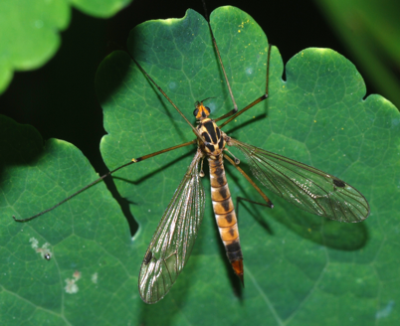

*Tipularia discolor* is called the Crane fly Orchid because its flowers are asymmetric with one petal overlapping the dorsal sepal which some think resembles a crane fly in midair. Crane fly is a *Tipula* species of insects resembling a mosquito (superfamily of insects  *[Tipuloidea](https://en.wikipedia.org/wiki/Tipuloidea" \o "Tipuloidea)*).

The roots of *Tipularia* are a chain of irregular corms. In midsummer a new corm is formed from which a new ovate leaf appears above ground in the autumn. This leaf survives the winter and then dies. Then in midsummer the corm sends up an inflorescence. Rodents love the corms and slugs love the leaves and corms. Note the Kentucky Forager says they are edible and taste like potatoes.1

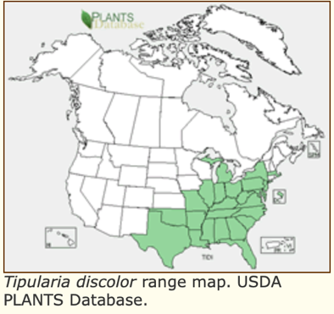Three species of *Tipularia* exist. Two are found in Asia. *Tipularia discolor* is the only one found in North America. 2 It blooms from mid-July to late August. In North America its range has been expanding.

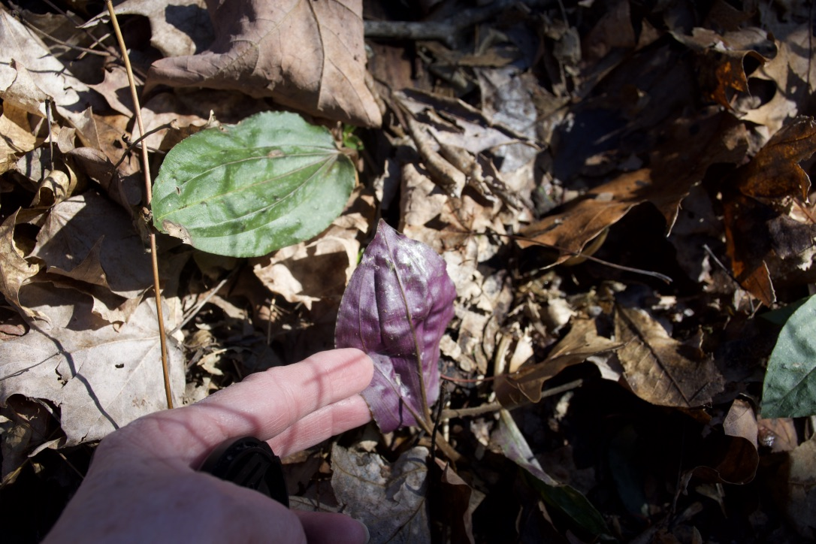

The plant is 35-45 cm tall. Leaves are solitary and ovate, 6-7 cm in length and 4-6 cm wide. Leaves are dark green above and purple below. Black spots may appear as raised spots surface of some leaves. No fungus or rust has been found to cause this. Some theories are that they are caused by insect damage others that they may be a concentration of pigment without a cause from the 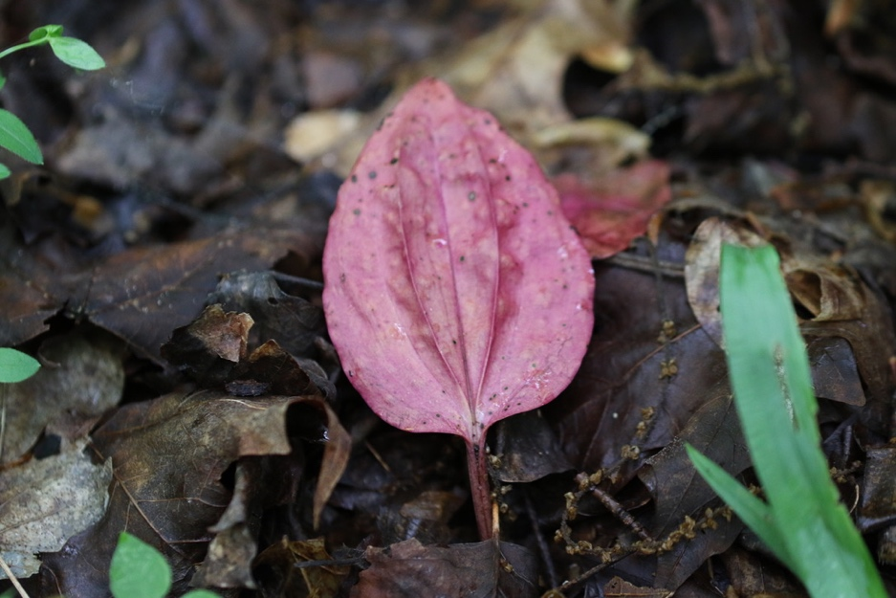environment.

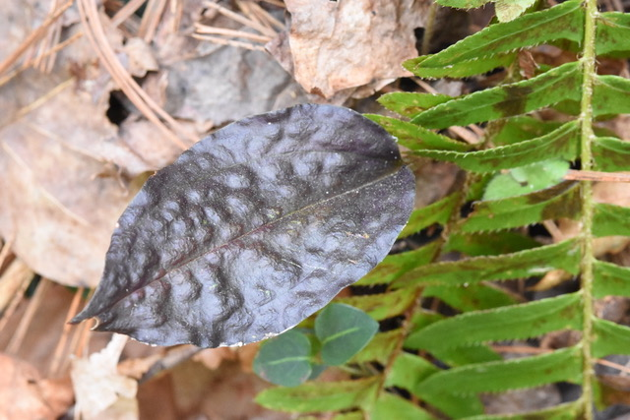

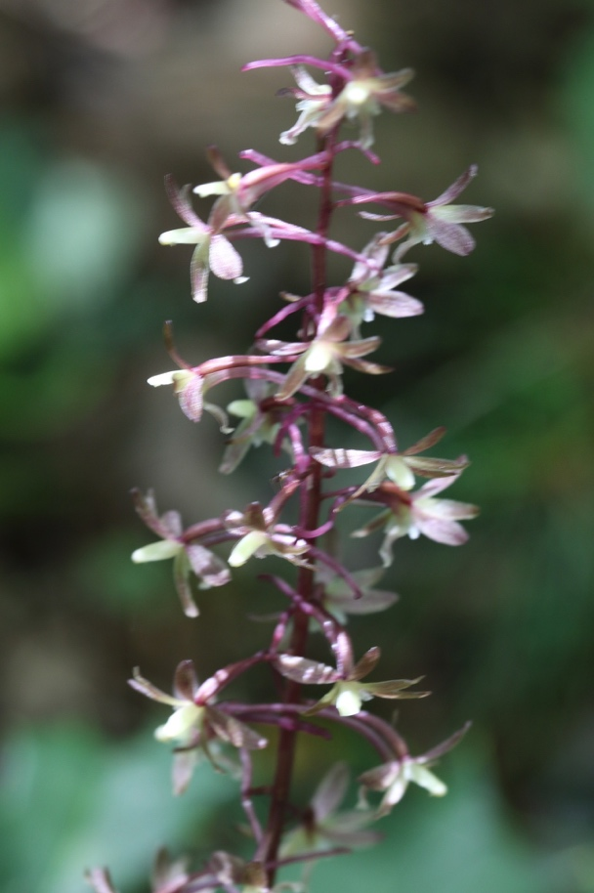“Inflorescence a raceme of 30-40 flowers on a purplish-brown scape, each flower subtended by a minute, almost imperceptible bract. Lip 4-5 cm long x 1-2 cm wide, translucent, pale purple, 3-lobed, the lateral lobes short, acute, the middle lobe long and narrow, lanceolate and dilated apically with a basal spur 13-18 mm long x 0.5-1 mm wide. Petals oblong-elliptic, pale purple 4-5 mm long x 1 mm wide. Sepals similar to petals, 4-5 mm long x 1.5-2 mm wide.” 3

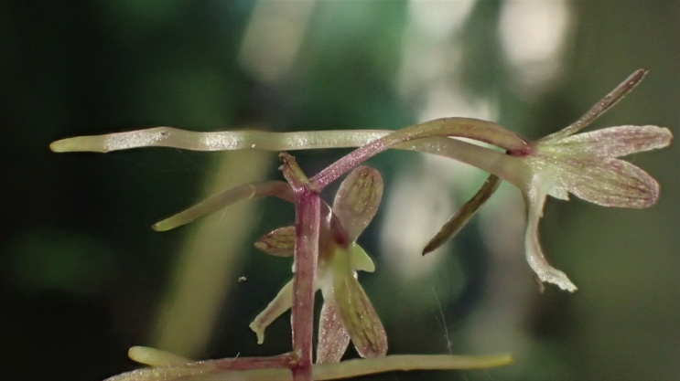

*Tipularia* flowers are unique in North America in that they do not have bilateral symmetry. They have uneven numbers of petals and sepals on either side of the column making them appear lopsided. They are also angled to the right or left side of the main stem.

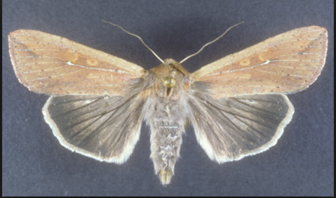Pollinators observed visiting *Tipularia* have pollinaria attached to their right eye when visiting right angled flowers and left eye for left angled. Flowers. Anther cap retention promotes outcrossing in *Tipularia*. Pollinators of *Tipilaria* are nocturnal moths called millers - *Pseudaletia unipuncta.*4

While seed production is from self-pollination and insect pollination, the main method of reproduction is by the asexual method of underground production of corms. Studies are being done on the fungal effect on reproduction of *Tipularia* along with Goodyera.5

Habitats for *Tipularia* are quite varied ranging with moderate and well balanced moist to dry woodland regions with neutral to acid soils. They are found among beech, maple, oak, hickory and dogwood. They are found in regions with *Aplectrum* and *Goodyera*.

1. The Kentucky Forager, Signs of Life After a Long Winter, <https://kentuckyforager.com/2013/03/24/signs-of-life-after-a-long-winter/>
2. *Native Orchids of North America, North of Mexico*, Donovan Stewart Correll, Standford University Press, 1978, pp.277-279.
3. *Orchids of Indiana*, Michael A. Homoya, Indiana Academy of Science, 1993, pp228-233.
4. Studies on the Pollination Ecology of Tipularia discolor (Orchidaceae), Dennis F. Whigham and Margaret McWhethy, *Botany*, 1980, <https://www.jstor.org/stable/2442295?seq=1#page_scan_tab_contents>
5. “Limitations on orchid recruitment: not a simple picture,” Melissa K. McCormick ,D. Lee Taylor, Katarina Juhaszova, Robert K. Burnett Jr, Dennis F. Whigham And John P. O'Neill,, *Molecular Biology*, <https://www.fs.fed.us/pnw/pubs/journals/pnw_2012_mccormick001.pdf>

Photos Jeanne Rhinehart, Jan Yates, Angela Carter, Wikipedia

NATIVE ORCHID PROTECTION AND EDUCATION – NOPES January 28th, 2019 Meeting

ATTENDEES: Angela Carter, Diana Dwight, Teresa Huesman, John Jaworski, Jun Lao, Barry Rhinehart, Jeanne Rhinehart, Lois Shadix, Flower White, Alan Wolfson, Connie Peebles Wolfson, and Jan Yates.

Approval of our last meetings Minutes. = Approved by Jeanne Rhinehart, second by John Jaworski, approved by all present.

Old Business: Website: Jeanne – Still working on it - adding photos, links from lectures, pictures, newsletters

New Business:  
Membership application: Jeanne, Ann. Teresa, and Pat worked on Objectives and Goals and application similar to WA. Native Orchid Society.

Cranberry Bog Meeting with ODNR: Angela – Rick (ODNR) was encouraging to the group and offered help for work on Bog this spring. He thought some chemical control could be used on site.

Field trips and Education: Angela & Jeanne – Discussed 47 different native orchids in Ohio. Passed out information on Arc of Appalachia Preserve and the Edge of Appalachia Preserve, etc.

Tentative date of May 17th for field trip to Kelly’s Island, OH. See Angela. Trip in June to Bruce Peninsula. See Jeanne.

CNC Wister’s coralroot: Teresa - Need to talk to Cory Christopher and Jake Sberna.

February 9th East Fork Park: Teresa – Field trip to check location of leaves of *Aplectrum hyemale* and *Tipularia discolor*. Also, check Stone Lick Lake to see *Goodyera pubescens*.

Camera – Teresa – Need to set up again.  
MAOC Grant: Teresa- Educational Talks given by members. Jeanne. Look into this for Grants  
Next work Day at the Bog Teresa – sometime in April – weather permitting. Plan to take photos to see where Poison Sumac is present. Need new research site. Bog will not be open to public in 2019. Boat will not be running for public.

Upcoming events – May 10th NOPES Meeting – Shawnee State Park – Dinner at Lodge.

Orchid a month for our newsletter. – A native orchid of the month will be put on our website. Let Angela know your favorite Ohio orchid or one you would like to find blooming for suggestions for future field trips.

Goggle Calendar – Teresa

Check with historical societies about ways to acquire some cash for Cranberry Bog.

 Someone to look at requirements for Land Grant- John J. will look into this.

Bank Account- Pat O’Conner– will be Treasurer. - Dues will be collected after acquiring a checking account and other duties are completed.

Look into getting NOPES registered nonprofit status in Ohio.

Respectfully submitted, Lois Shadix