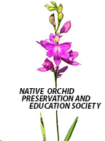
The Fringe
Newsletter of the Native Orchid Preservation and Education Society
nativeorchidpreservationeducationsociety.com
April

WE ARE OFFICIAL!

We are officially a nonprofit corporation in Ohio and have our IRS EIN number and a bank account. We can now accept memberships. Membership forms are attached to this email.

Letter From The President

Hello everyone,
Spring has finally arrived, and the native wildflowers are proving once again that they know what to do with our confused weather. One of the first spring orchids is the Corallorhiza wisteriana also known as Wister’s Coral-root or Spring Coral- root. On April 27th a group will be taken to the area at CNC where you can see and take pictures of them in bloom. Details to follow once we see that it’s going to bloom at the same time as last year. If the weather warms up it may show up earlier. I’ll be sending out updates.

I was speaking to Jeanne and she reminded me to make sure that everyone remembers to wear hiking appropriate foot wear and bring a hiking stick if needed for safety. The one thing we sometimes forget is ticks! Please remember bug spray, protective clothing that you bought with bug repellent on them or that you’ve treated yourself. It’s too early to see what the tick population will be like this year, but I remember last year’s!

Other great news, we are officially recognized as a nonprofit corporation and have our IRS EIN number and a bank account. We are no longer an idea! We’re a real society!

Membership forms are included in this newsletter. Please fill them out and send them with your dues, so we have an idea of our membership.

I look forward to meeting some of you for the first time and seeing the rest of you this spring on one or all of our field trips.

Sincerely,
Teresa Huesman
President

Orchid Viewing Weekend Shawnee State Park, May 10-12, 2019

Consider joining us for a weekend of hiking, driving tour and social time to learn about natives in the southern Ohio region. Depending on the weather, we should be viewing Cypripedium acaule (pink and white varieties), Cypripedium parviflorum var. pubescence, Galearis spectabilis, Isotria verticillate, Cypripedium kentuckiense, Spiranthes lucida and other beautiful wildflowers. The weekend is planned around the Davis Memorial Orchid Hike which starts at 10:00AM until 12 at the Davis Memorial State Nature Preserve. ODNR Preserver Manager Josh Deemer will lead a guided hike to see the orchids in bloom at Davis Memorial SNP. It is suggested you bring your mom and camera on this casual trail hike through Cedar Fork Gorge. Meet at the preserve’s main entrance, located south of Peebles Ohio, take St Rt 32 approximately 2 miles east of Peebles, Ohio, turn right onto Steam Furnace Rd 1/4 mi then turn left onto Davis Memorial Rd. Travel 2 1/4 mile and main parking lot is on your right. Boots and bug spray are encouraged.
For those who are staying at the lodge or cabins either Friday night or Saturday night or both we are staying at the Shawnee Lodge and Conference Center, 4404B State Route 125, West Portsmouth, OH 45663, 740-858-6621. Call early if you want a room. We have reserved one cabin and some of us have rooms at the lodge.

Friday afternoon (2:00 PM) and Sunday morning (10:00 AM) will repeat driving tours of the region to accommodate those who cannot make one or the other. Saturday afternoon will be a hike to other areas in the region. A packed lunch for Saturday and water is recommended so we can cover planned trips. Dinner at the lodge is planned for both evenings. There will be a PowerPoint presentation on Spiranthes for Friday night and a business meeting for Saturday night.

Planned hikes and work days.
Orchids present on these dates are dependent on the seasonal weather variation. If you wish to attend, let Teresa know.
Cranberry Bog Work Day - May 5
Cincinnati Nature Center – April 27- Corallorhiza wisteriana
Lawrence Woods and Cedar Bog - June 1 - Platanthera flava v. herbiola, Cypripedium reginae
Spangler Prairie and Cedar Bog – June 22 - Platanthera leucophaea, Calopogon tuberosus

We will be doing preview hikes to see what is available throughout the year. If you would like to be put on an email list to be notified, please let Teresa know.

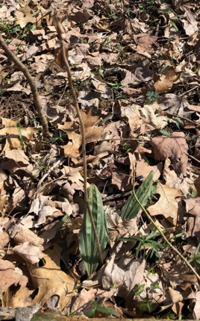
Other Activities
We are doing a plot study of Aplectrum hyemale or Putty Root at Winton Woods. We counted 116 plants and 3 plants with seed pods. We plan on checking on them for flowers early summer and seed pods in the fall. We plan to study this plot for the next several years and check on its progress.

We are also putting in displays at Central Indiana Orchid Society and West Shore Orchid Society shows.

Orchid of the Month – March
Corallorhiza wisteriana Conrad - Wister’s Coral-root or
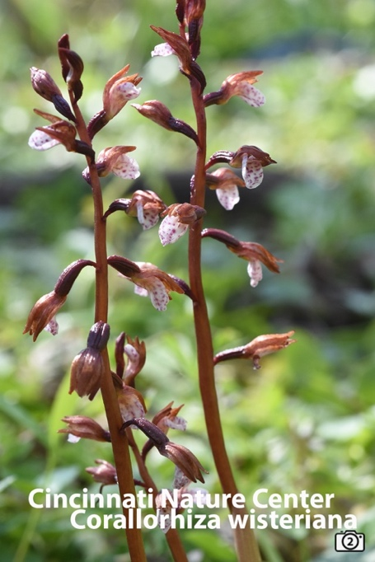
Spring Coral-root
Jeanne Rhinehart

Corallorhiza wisteriana is named after its discoverer Charles Wister. He was an American botanist living from 1782 to 1865. He first found it in Pennsylvania within today’s city limits of Philadelphia.
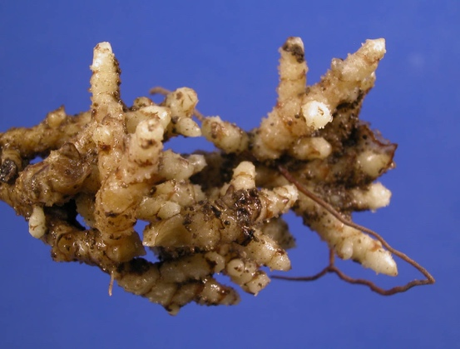
¹

The Coral-root name refers to the underground stems, rhizomes, appearing like an ocean coral.

Corallorhiza wisteriana do not flower every year and vary in the number of bloom inflorescences from year to year. During the non-flowering years, the rhizomes are semi-dormant. After a severe flood over a population of wisteriana in Virginia, the population was not seen for over a decade.
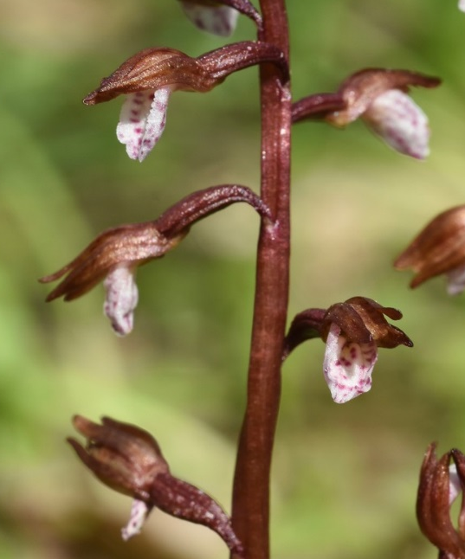
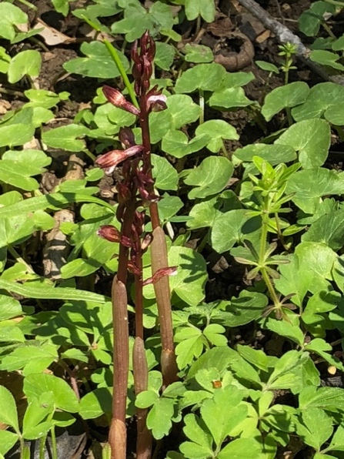
The plant description is as follows: “Plant glabrous, leafless, with reddish to yellowish, fleshy stem 20 – 30 cm tall. Roots absent. Rhizome multi-branched, coralloid. Inflorescence a loose raceme of 8 – 14 flowers, each subtended by a minute floral bract. Lip 5 – 6 mm long x 3 – 4 mm wide. Sepals similar to petals, 5 – 6 mm long x 1 – 1.3 mm wide, ovate, entire, white with purple spots. Petals lanceolate, yellowish to purplish-brown, 4 – 5 mm long x 1 mm wide. Sepals similar to petals, 5 – 6 mm long x 1 – 1.3 mm wide. Petals and sepals converge to form a hood over the lip. Flowers normally chasmogamous.” ²

Corallorhiza wisteriana grows in upland forest communities of conifers, sugar maple, white oak, red oak, American beech white ash, and shagbark hickory. Soil pH is apparently not important as they grow in both sandstone and limestone regions. Soil is rich in humus and while Corallorhiza wisteriana grows in well drained regions, leaf mulch helps keep it moist.

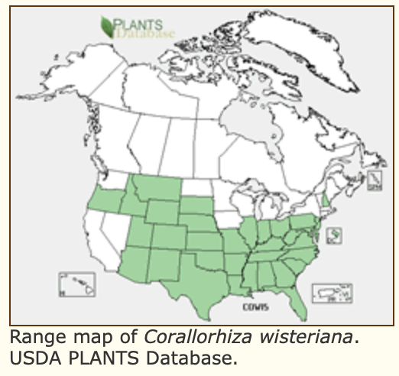
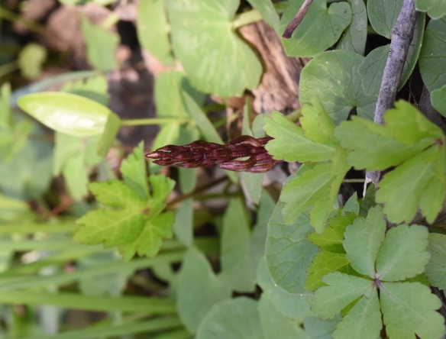
As late as 1924 it was thought to be an orchid found only in southeastern United States and once was called the Early Southern Coral-root. It can now be found over much of the continental United States.
Its bloom times vary based on location from early spring in Florida to midsummer in its northern regions. ³

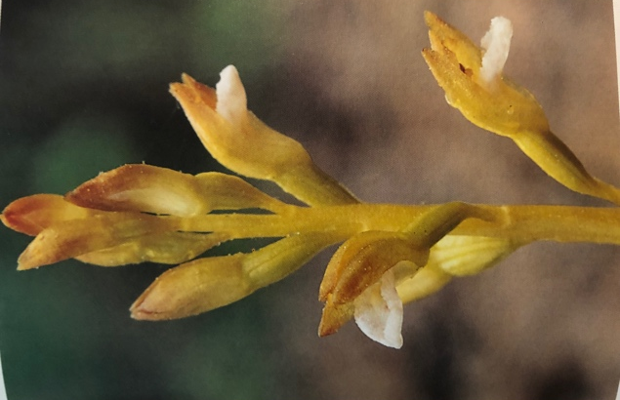
Stanley L. Bently in his book names a yellow variety that he found in Virginia in 1995. He names it Toler’s Coralroot Orchid, Corallorhiza wisteriana forma toleri S. Bently. He found 4 of the forma toleri in a population of 150 of wisteriana. He describes it as “yellow throughout, except for a bright white lip.” Pictures of it along with a rare double-lipped example follows. ⁴
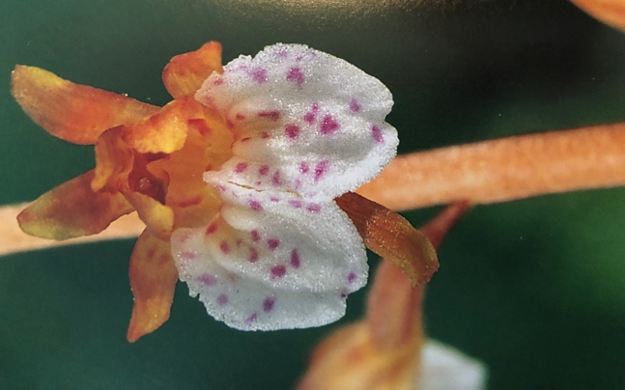
He collected a specimen and it is in the herbarium at Virginia Tech. Plants have not reappeared as of 2001. ⁵

There are 11 species of terrestrial orchids in the Corallorhiza genus in temperate regions of North America, Central America and Eurasia. They are myco-heterotrophic plants.

Heterotrophs are plants that are not green having no chlorophyll and thus cannot make their own food. Mycotrophic (fungus feeding) plants are a type of heterotrophs. There is a symbiotic relationship between trees and mycorrhizal fungi. These fungi allow the trees to absorb larger quantities of water and nutrients and the trees in turn supplies the fungi with carbohydrates and other nutrients. Corallorhiza and other mycotrophic wildflowers utilize these fungi (often from the Russulaceae family of ectomycorrhizal fungi)⁶ to meet their food needs.

¹ Nickrent, D.L,( 2007), PhytoImages. Available from: http://www.phytoimages.siu.edu].
² Orchids of Indiana, Michael A. Homoya, Indiana Academy of Science, 1993, p. 88.
³ USDA Forestry Service,
https://www.fs.fed.us/wildflowers/plant-of-the-week/corallorhiza_wisteriana.shtml
⁴ Native Orchids of the Southern Appalachian Mountains, Stanley L. Bentley, University of North
Carolina Press, 2000, pp. 88 - 89.
⁵ http://members.tripod.com/blueridge_wildflower/id42.htm
⁶ http://goorchids.northamericanorchidcenter.org/genus/corallorhiza/
Photos by Jan Yates, Jeanne Rhinehart, D.L. Nickrent, Stanley L. Bentley.

Native Orchid Protection and Education Society (NOPES)
Meeting Minutes of March 9, 2019
Attendees: Teresa Huesman, Angela Carter, Ann Tsui, Barry Rhinehart, Shirley Holt, Mary Anne Foss, Ken Mettler and Jeanne Rhinehart.

President Teresa Huesman started the Membership Meeting of NOPES at 2:35 pm at Joseph-Beth Booksellers in Hyde Park. Ken Metter provided a History of Cranberry Bog. The agenda was handed out and discussed as follows:

Regulations: Regulations for NOPES need to be established. A committee of 3 volunteers will meet to draft the regulations which will then be reviewed by all. Teresa Huesman, Ann Tsui and Jeanne Rhinehart volunteered and will meet sometime during the week of March 21-25.

Bank Account: The bank account will be set up soon, probably without waiting for NOPES incorporation. Teresa is investigating how different banks handle accounts like ours. Until then, Teresa will be entrusted with any money collected.

Membership: $20 single, $30 family. A lifetime membership level will be explored.
Camera: GCOS has offered to let us to buy the camera (purchased with MAOC money for the Cranberry Bog Study) for $25. The offer was rejected, and Angela will draft a letter explaining this to GCOS.

Cranberry Bog: J-Me, the Director of the Buckeye Lake Museum, is willing to help us get onto Cranberry Bog and provide assistance whenever we desire. The ONAPA Stewardship Project is scheduled to work at Cranberry Bog on September 25. Perhaps NOPES could become affiliated with and/or help ONAPA? Possible Boardwalk expansion methods and placement were proposed. April 22 is a probable Cranberry Bog Workday.

Calendar: The Calendar is or soon will be available on the NOPES website. Scheduled events are: April 22 Cranberry Bog Workday; May 11 NOPES General Meeting, hike and dinner at Shawnee Lodge; May 17 Kelly’s Island with another society and May 27 trip to Red River Gorge to see the spreading pogonia.
MAOC Grant: MAOC granted NOPES $400 for continued study and assistance at Cranberry Bog. To avoid poison sumac reactions Ken Mettler will use part of the grant to select hazmat suits and provide instruction.
NAOCC: Dennis Whigham of CERC/Smithsonian sent a letter to Jeanne after the MAOC conference in Michigan. He named other orchid enthusiasts in our area and sent “kits” with instructions for NOPES to assist in collecting mycorrhizae samples.

New Newsletter Name: “The Fringe”
The meeting adjourned at about 4 pm.

Respectfully submitted, Ann Tsui

Native Orchid Preservation and Education Society
Membership Application

Objectives for our group:
- Preserve native orchid habitat and in situ native orchids
- Work with other groups to preserve habitat and orchids
3. Educate people who are interested in native orchids through presentations, displays, observation, and demonstration of in situ orchid habitats about how to:
  - Grow native orchids according to their growth habits
  - Assist in orchid conservation
  - Preserve endangered species
  - Prevent removal of native orchids from the wild
  - Remove invasive species from known orchid habitats
  - Study the results of our efforts
  - Grow seedlings for distribution to orchid habitats
  - Perform research and field studies
- Prepare resources about native orchid vendors, books, internet sites, native orchid conservation groups

Name:

Address:

Phone Number:

Email:

Occupation:

Other Interests:

Other Orchid Societies You Belong To:

Other Plant Societies You Belong To:

Are you involved in the sale of native orchids?
How did you learn of NOPES?

Why do you want to join NOPES?

IN CONSIDERATION of being given the opportunity to participate in any NOPES activity, including scheduled, supervised club activities, and during my membership, I, for myself, my personal representatives, assigns, heirs, and next of kin:
- ACKNOWLEDGE, agree and represent that I understand the nature of NOPES Activities, both in meetings and hiking based, and that I am qualified, in good health, and in proper physical condition to participate in such Activity.
- FULLY UNDERSTAND that:
- some NOPES ACTIVITIES such as Orchid Hikes INVOLVE RISKS AND DANGERS of serious bodily injury, including permanent disability, paralysis and death ("Risks");
- these Risks and dangers may be caused by my own actions, or inactions, the actions or inactions of others participating in the Activity, the condition in which the Activity takes place, or the negligence of the Releasee named below;
- there may be other risks and social and economic losses either not known to me or not readily foreseeable at this time; and I FULLY ACCEPT AND ASSUME ALL SUCH RISKS AND ALL RESPONSIBILITY FOR LOSSES, COSTS, AND DAMAGES I incur as a result of my participation in the Activity.
- FULLY UNDERSTAND that: NOPES is a society dedicated to the appreciation of native orchids through education and preservation. Individuals found poaching orchids will have their membership immediately revoked and will be reported to local and state authorities. A member may not act on behalf of nor invoke the name of NOPES without the express written permission of the board of NOPES. Members agree to hold harmless NOPES, the board, its officers and other members for any activities conducted by said member.
- AGREE AND WARRANT that I will examine and inspect each Activity Which I take part as a member of NOPES and that, if I observe any Condition which I consider to be unacceptably hazardous or dangerous, I will notify the proper authority in charge of the Activity and will refuse to take part in the Activity until the condition has been corrected to my satisfaction.
- HEREBY RELEASE, discharge, and covenant not to sue NOPES, their administrators, directors, agents, officers, volunteers and employees, other participating organizers, any sponsors, advertisers, and if applicable, owners and lessors of premises, on which the Activity takes place, (each considered one of the Releasees herein) from all liability, claims, demands, losses or damages on my account caused or alleged to be caused in whole or in part by the negligence of the Releasee or otherwise, including negligent rescue operations; and I further agree that if, despite this release and waiver of liability, assumption of risk, and indemnity agreement, I, or anyone on my behalf, makes a claim against any of the Releasees, I WILL INDEMNIFY, SAVE AND HOLD HARMLESS each of the Releasees from any litigation expenses, attorney fees, loss, liability, damage, or cost which any may incur as a result of such claim, to the fullest extent permitted by law.
I have read this agreement, fully understand its terms, understand that I have given up substantial rights by signing it and have signed it freely and without any inducement or assurance of any nature and intend it to be a complete and unconditional release of all liability to the greatest extent allowed by law and agree that if any portion of this agreement is held to be invalid, the balance, notwithstanding, shall continue in full force and effect.
Printed Name of Participant:
Address:
CITY STATE ZIP
Phone:
Cell Phone:
Participant's Signature: Date:
Membership dues are $20.00 for an individual or $30 for a family. They can be mailed to Teresa Huesman, 5044 Goal Post Lane, Cincinnati, Ohio 45244

PARENTAL CONSENT (if participant is under the age of 18).
AND I, the minor's parent and/or legal guardian, understand the nature of NOPES activities and the minor's experience and capabilities and believe the minor to be qualified to participate in such activity. I hereby release, discharge, covenant not to sue, and AGREE TO INDEMNIFY AND SAVE AND HOLD HARMLESS each of the Releasees from all liability, claims, demands, losses, or damages on the minor's account caused or alleged to be caused in whole or part by the negligence of the Releasees or otherwise, including negligent rescue operations, and further agree that if, despite this release, I, the minor, or anyone on the minor's behalf makes a claim against any of the above Releasee,
I WILL INDEMNIFY, SAVE, AND HOLD HARMLESS each of the Releasees from any litigation expenses, attorney fees, loss liability, damage, or cost any may incur as the result of any such claim, to the fullest extent permitted by law.
Printed Name of Parent/Guardian: _________________________________________________
Address: _________________________________________ _________________________________________________ _________________________________________________
City State Zip__________
Phone: ___________________________
Cell Phone: ___________________________Date: __________ Parent/Guardian Signature (only if participant is under the age of 18): _________________________________________________

