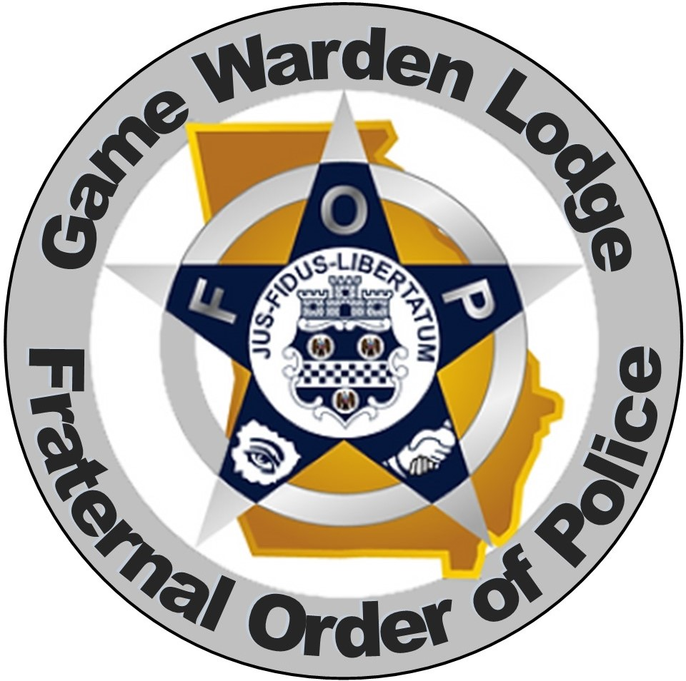
Georgia Fraternal Order of Police

Game Warden Lodge #104
PO Box 796 Ellabell, GA 31308. Email : gamewardenlodge104@gmail.com. 770-877-2079

Member Contact & Beneficiary Form
Updated forms can be mailed or emailed to the address above.

Name (Last, First, Middle Initial)

Address

Home/ Cell # Personal Email (DO NOT USE GOVERNEMENT EMAIL ADDRESS)

BENEFICIARY INFORMATION:

Last Name, First Name (1st Beneficiary) Relationship to Member Date of Birth

Complete Mailing Address (if different from member) Contact #

Last Name, First Name (2nd Beneficiary) Relationship to Member Date of Birth

Complete Mailing Address (if different from member) Contact #

Signature of Applicant Date

It is the responsibility of the member to keep their personal information up to date and correct. The State Lodge must pay the benefits as noted in the most recent document submitted by the member. Please use this form to update any of the personal information.

