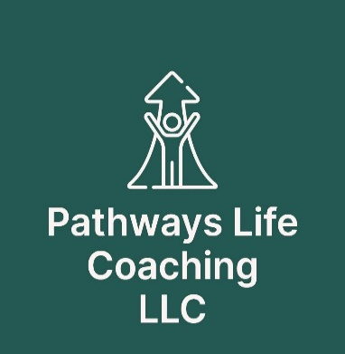

**STATEMENT OF INTENT**

All coaching services delivered by Michal Ravid Vrabel through Pathways Life Coaching LLC are meant to challenge, uplift, empower and support you through the process of reaching your goals.

However, coaching is not psychotherapy and is not a replacement for mental health treatments.

If you feel psychologically stressed to the point that it is interfering with your ability to function, please have the courage to seek the help you need in the form of a professional counselor.

The work of coaching is meant to be done when major emotional and psychological wounds are already healing or healed.

Please read the following and sign below should you agree and wish to proceed:

* I understand that the life coaching services I will be receiving from Michal Ravid Vrabel through Pathways Life Coaching LLC are not offered as a substitute for mental health care. I also understand that my coach, Michal Ravid Vrabel, through Pathways Life Coaching LLC, is not acting as a psychotherapist, and does not purport to offer mental health care.
* I understand that my coach, Michal Ravid Vrabel through Pathways Life Coaching LLC, will maintain the confidentiality of our communications only to the extent defined by the laws of the state in which each of us resides.
* I understand and agree that I am fully responsible for my own well-being and mental health during my coaching sessions, and subsequently, I understand and agree that I am fully responsible for my choices, decisions and actions.
* I understand that all comments and ideas offered by my coach are solely for the purpose of aiding me in achieving my set desired goals. I understand that I have the ability to give my informed consent, and hereby give such consent to my coach to assist me in achieving such goals.

I hereby release, waive, acquit and forever discharge Michal Ravid Vrabel through Pathways Life Coaching LLC from any claim, suit action, demand or right to compensation for damages I may claim to have or that I may have arising out of actions, or commissions taken by myself or by Michal Ravid Vrabel through Pathways Life Coaching LLC as a result of the advice given by Michal Ravid Vrabel or otherwise resulting from the coaching relationship contemplated hereunder.

I further declare and represent that no promise, inducement or agreement not herein expressed has been made to me to enter into this release.

The release made pursuant to this paragraph shall bind my heirs, executers, personal representatives, successors, assigns and agents.

I have read the statements above and I understand and agree with the points contained therein:

Michal Ravid Vrabel

___________________ __________________

Client’s name (please print) Coach’s name

___________________ __________________

Client’s signature Coach’s signature

___________________ ___________________

Date Date