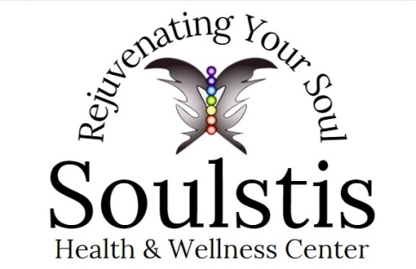

**NAD+**

**Overview**

NAD and NAD+ occur naturally in the body. They play a major role in the chemical process of generating energy. NAD+ is probably the most important co-factor for improving mitochondrial function. Mitochondria are intracellular organelles (AKA “energy powerhouses”) where micronutrients are converted to energy-rich ATP molecules for the cell. As we age, our body’s NAD levels gradually drop due to lower intrinsic production and inflammation/oxidative stress caused by environmental factors. This drop in NAD+ can cause fatigue, mental fog, dull and tired skin, and poor sleep quality. Boosting NAD+ may help manage a wide spectrum of diseases, ranging from diabetes to cancer.

**Other Uses**

NAD+ is administered via IV (intravenous) route. When administered by IV, some research has demonstrated its ability to improve mental clarity, memory, concentration and alertness. Moreover, NAD+ infusions may improve athletic endurance and reverse the symptoms of chronic fatigue. Research has shown that NAD+ may have potential for fighting the effects of addiction. Excessive alcohol and drug use diminishes the amount of NAD naturally found in the body; by reintroducing it through NAD therapy, cravings and withdrawal effects may be reduced as a result. Additionally, NAD+ has been shown to boost serotonin, aiding with symptoms brought on by depression and anxiety

**Concentration:** 250mg in 500mL Normal Saline for first dose. (Dose titrated thereafter depending on client tolerance and goals)

**Route of Administration:** IV

**Side Effects**

It’s important to note that there is currently no research to support that NAD IV therapy has any long-lasting side effects. However, during the infusion process, some people indicate that they feel temporarily nauseous or experience some stomach discomfort for a short period of time. This subsides quickly, and there are no other issues in the days or weeks following the treatment.