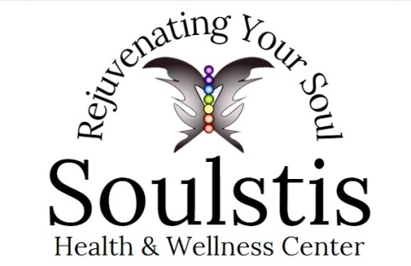

**Pepcid**

Although Pepcid is available in over-the-counter tablet form, IV therapy delivers the famotidine directly into your bloodstream. This allows the H2 blocker to have nearly instantaneous effects, treating your heartburn or indigestion almost immediately.

**Treats Stomach and Intestinal Ulcers**

Stomach acid can damage the lining of your stomach, small intestine or even esophagus. This damage is called an ulcer. To heal an ulcer, you must reduce stomach acid production. That's where Pepcid comes in. Famotidine is extremely useful in promoting the healing of both stomach and intestinal ulcers as well as preventing future ulcers.

**Fights Acid Reflux**

Acid reflux occurs when your stomach acid begins to back up into your esophagus, irritating the sensitive tissue. If you experience acid reflux two times a week or more, you may have a chronic form of acid reflux known as gastroesophageal reflux disease (GERD). By decreasing the amount of acid your stomach makes, Pepcid can prevent many of the symptoms associated with acid reflux, including:

Upset stomach.

Nausea after eating.

Belching.

Regurgitation.

Feeling full.

Bloating.

A bitter taste in the mouth.

Tightness in the throat.

Dry cough or wheezing.

Hoarseness.

Vomiting.