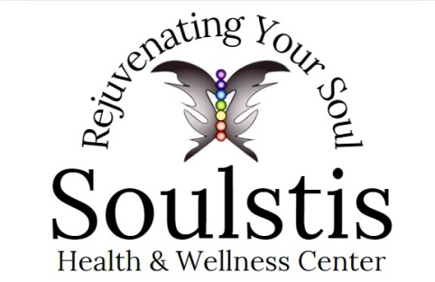

## **Vitamin C**

Ascorbic acid (vitamin C) is used to prevent or treat vitamin C deficiency. Extremely low levels of vitamin C can cause a condition referred to as scurvy. Symptoms of scurvy include rash or brown spots on the skin, muscle weakness, pale skin, joint pain, tiredness, depression, or tooth loss. Ascorbic acid is important as it is needed to maintain the health of skin, teeth, cartilage, bone and blood vessels.

**Overview**

Ascorbic acid, also known as vitamin C, is a water-soluble vitamin that plays a crucial role in various physiological functions within the human body, including maintaining the health of skin, teeth, bone, cartilage and blood vessels. It is an essential nutrient, meaning that it cannot be synthesized by the body and must be obtained through diet or supplements.

Ascorbic acid is found naturally in many fruits and vegetables, especially citrus fruits, kiwi, broccoli, tomatoes, leafy vegetables, potatoes, brussels sprouts, raw bell peppers and strawberries. It is also commonly added to various foods and beverages as a nutritional supplement. Most people get sufficient ascorbic acid through their diet. Others may not be able to absorb enough through diet or ingestible supplements and may suffer from vitamin C deficiency as a result. In these cases, ascorbic injections may be prescribed.

What is Ascorbic Acid (Vitamin C)?

Ascorbic acid is a powerful antioxidant, meaning it helps protect cells from damage caused by free radicals. Free radicals are unstable molecules that can lead to oxidative stress and contribute to various chronic diseases, such as heart disease, cancer, and certain neurological disorders. It also plays a vital role in the synthesis of collagen, a protein found in connective tissues, skin, blood vessels and bones. Collagen is essential for wound healing, maintaining healthy skin, and supporting the structure and integrity of various body tissues. Ascorbic acid aids in the absorption of dietary iron, particularly non-heme iron found in plant-based foods, by converting it into a more absorbable form and increasing its bioavailability. This makes it especially important for individuals following vegetarian or vegan diets to ensure adequate vitamin C intake, as they may have a higher risk of iron deficiency.

Vitamin C is well-known for its role in supporting the immune system. It enhances the production and function of white blood cells, which are crucial for fighting off infections and pathogens. Ascorbic acid also helps boost the activity of other antioxidants in the body, further supporting immune function. It has been associated with several other potential health benefits, including reducing the risk of chronic diseases, such as cardiovascular disease, age-related macular degeneration and certain types of cancer, and may also have anti-inflammatory properties that play a role in supporting brain health.

Concentration: 500mg/ml

Route of Administration: IV

**Precautions/Side Effects**

Before taking ascorbic acid, make sure to tell your doctor or pharmacist if you have any allergies, kidney disease (such as kidney stones), diabetes, are on anticoagulation therapy, are on a sodium-restricted diet, or have a certain enzyme deficiency called G6PD deficiency. It is said to be safe to use during pregnancy in recommended doses. If clearly needed, higher doses can be used in pregnancy. Risks and benefits should be discussed with your healthcare provider. Ascorbic acid does pass through in breast milk safely when used in recommended doses. This vitamin may interfere with certain lab tests (including certain glucose tests), possibly causing false test results.

Stop using Ascorbic Acid and call your doctor right away if you experience any:

– Painful urination

– Pink/bloody urine

– Allergic reaction, including rash, itching/swelling (especially of the face/tongue/throat), severe dizziness and trouble breathing.

Some common side effects include:

– Nausea

– Heartburn

– Abdominal pain

– Vomiting

– Diarrhea

## 