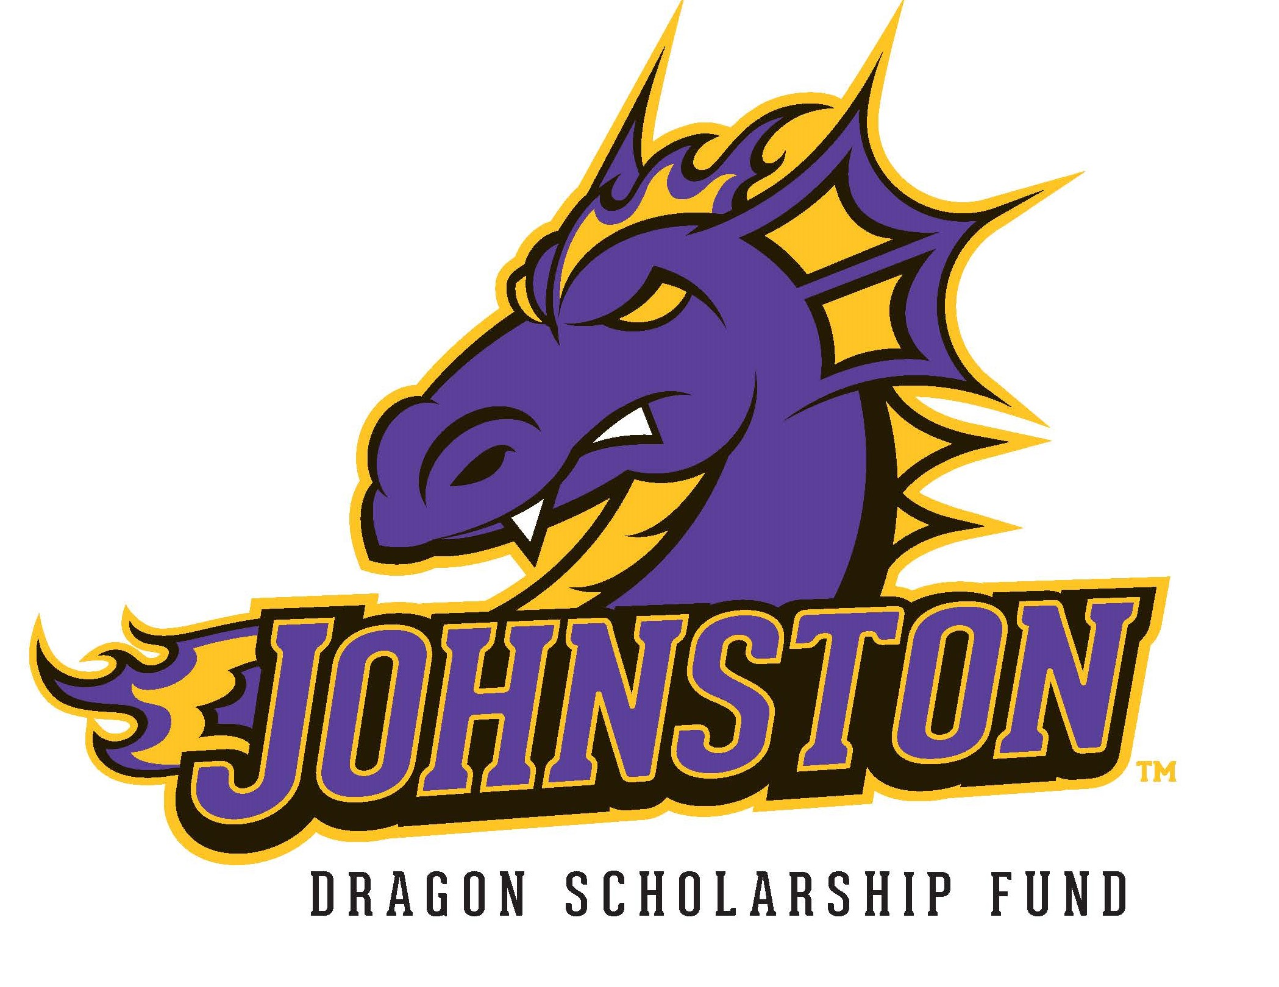

November 30, 2020

Dear Johnston High School Senior and Family,

The Dragon Scholarship Fund, Inc. is a local, volunteer organization that raises funds and awards scholarships to Johnston High School seniors prior to graduation. Our goal is to give financial assistance to every JHS senior as they continue their education beyond high school. We believe every student deserves a chance to earn a scholarship, regardless of grade point average, financial need, or ability. This letter is to notify you of the scholarship process and timeline.

Our organization is comprised of community volunteers. Through our previous Phone-a-Thon’s, inaugural online fundraising campaign, annual dinner and auction, and other fund-raising events--as well as generous support from local businesses, civic organizations, private donations and memorials--we are able to fund these scholarships each year. Scholarships are in varying amounts and students will be notified in May 2021 of the amount of their award. All students are encouraged to apply regardless of the type of higher education they plan to pursue. All application information will be used only by the awards committee. All information will be kept confidential.

You do not need to provide your academic achievements. With your consent, the Johnston High School Counseling Office will supply your GPA to be included as a part of our evaluation process.

In order to qualify for and receive a scholarship, you must carefully follow the steps listed on the
“Five Step Process” sheet included in this letter. All of the steps must be completed for qualification of a scholarship or the scholarship will be forfeited. All decisions are final.

The following dates and guidelines will help you successfully complete the application process.

December 7, 2020: The Dragon Scholarship Fund Application and Student Appraisal will be available online to complete at www.dragonsf.org under Student Scholarship Application. A link to the application will be emailed to you along with the student appraisal link via your Jdragonmail account. Beginning this year, applications and student appraisals will only be completed and submitted online.

February 1, 2021: Scholarship applications and student appraisals will both be due February 1, 2021. The scholarship application is to be submitted via email to dragonscholarshipfund@gmail.com. The student appraisal will be submitted automatically upon completion by the JHS Staff member.

NO INTERVIEWS THIS YEAR: Due to the ongoing pandemic and changes occurring rapidly the Dragon Scholarship Committee has decided not to hold scholarship interviews.

Mid-May, 2021: Seniors will be notified of their award amount and details via their non Jdragon email.

June 15, 2021: The final scholarship process form--Policy and Institution Intent Form--must be filled out online at www.dragonsf.org by this date. Without this, we won’t know which school to send your scholarship dollars.

Please direct all questions about the scholarship process to dragonscholarshipfund@gmail.com. We look forward to meeting you in the application process and wish you the best of luck with your future plans!

Sincerely,

The Dragon Scholarship Fund Scholarship Committee
dragonscholarshipfund@gmail.com

